WORKSHEET А
Museum website: http://kuskovo.ru
Virtual tour: http://vr360.ru/kuskovo/03/

Exercise 1. Read the description and find the name of the reception room. Underline appropriate words the elements of the décor and the furniture that you can see in this room. Describe the room.

The most elegant of the palace drawing rooms got its name from the bright pink color of its wall and furniture silk upholstery.

card table ● portrait of Catherine I ● musical instrument ● grandfather clock ●porcelain Chinese vase

● marble busts ● fireplace ● crystal girandole ● Flemish tapestries ● mirror in carved ●and gilded frame

●console table ● tiled stove ● parquet floor ● crystal chandelier ● portrait of Peter Sheremetev

Useful phrases
In front of you is...  To the left of the door…  On your right you can see... | The particular interest in this room is…  The room is also remarkable for…  The door leads into the next room... | The portrait in the middle shows…  The first painting on the left shows  I'd like to point out...

Exercise 2. Find the exhibit and describe it using the words.

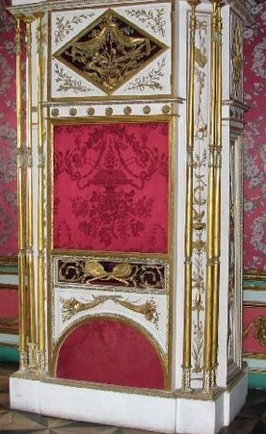
It is a which is called similar to__________________________ . It plays
The organ’s case is made from in the workshop of the
famous Pavel Spol

●Moscow carver ● musical instrument ● wood ● a barrel organ ● 18th century melodies ● Organchik ●

Exercise 3. Describe the exhibit using the words.
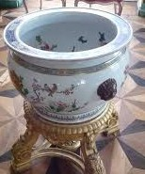
● fish ● porcelain ● vase ● aquarium ●China ● drawing inside ●
It is an

Exercise 4. Describe the portrait using the words.
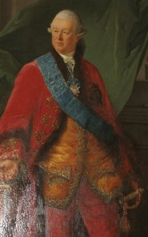
The Portrait of Peter Sheremetev, 1770-72.
This canvas is one of museum’s masterpieces painted in by French Nicholas Benjamin Delapierre. The portrait depicts of this country house. It is the portrait painted from nature. In the foreground of the picture the sitter is represented
standing elegantly dressed in with the Order of
the highest award in Russia. From Sheremetev’s .
● St Andrew ● three quarter length ● ceremonial ● artist ● oils ● collection ●
  - a red suit ● the master ● famous ●

Exercise 5. Describe the portrait using the words.

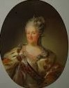
The Portrait of Catherine II, 1779.

- crown ● Empress ● half–length ● wreath laurel ● oils ● unknown artist ●
  - attributes of power ● ceremonial ● ermine mantle ●

The teacher:

