The East African Savanna

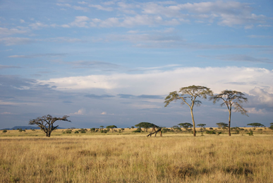
Welcome to the East African Savanna. Savanna is another name for grassland. You know you’re in grassland when there is a lot of grass around you, but not many trees or bushes. The East African Savanna has very warm weather all year round. It has two seasons: the rainy summer, and the dry winter. Grass is the most important plant growing in the savannas. This grass grows very quickly—as much as 2 cm per day!
That’s because grass is food for many animals, like elephants, zebras, gazelles, and antelope. They chew on grass all day long. It would seem that because so many animals eat the grass in the savanna every day, there wouldn’t be very much grass left after a while. But, remember that this grass grows back very quickly, so there’s usually plenty for the different animals, like zebras and antelopes, to eat!
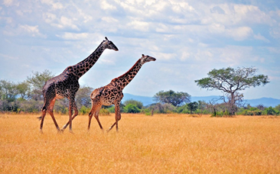
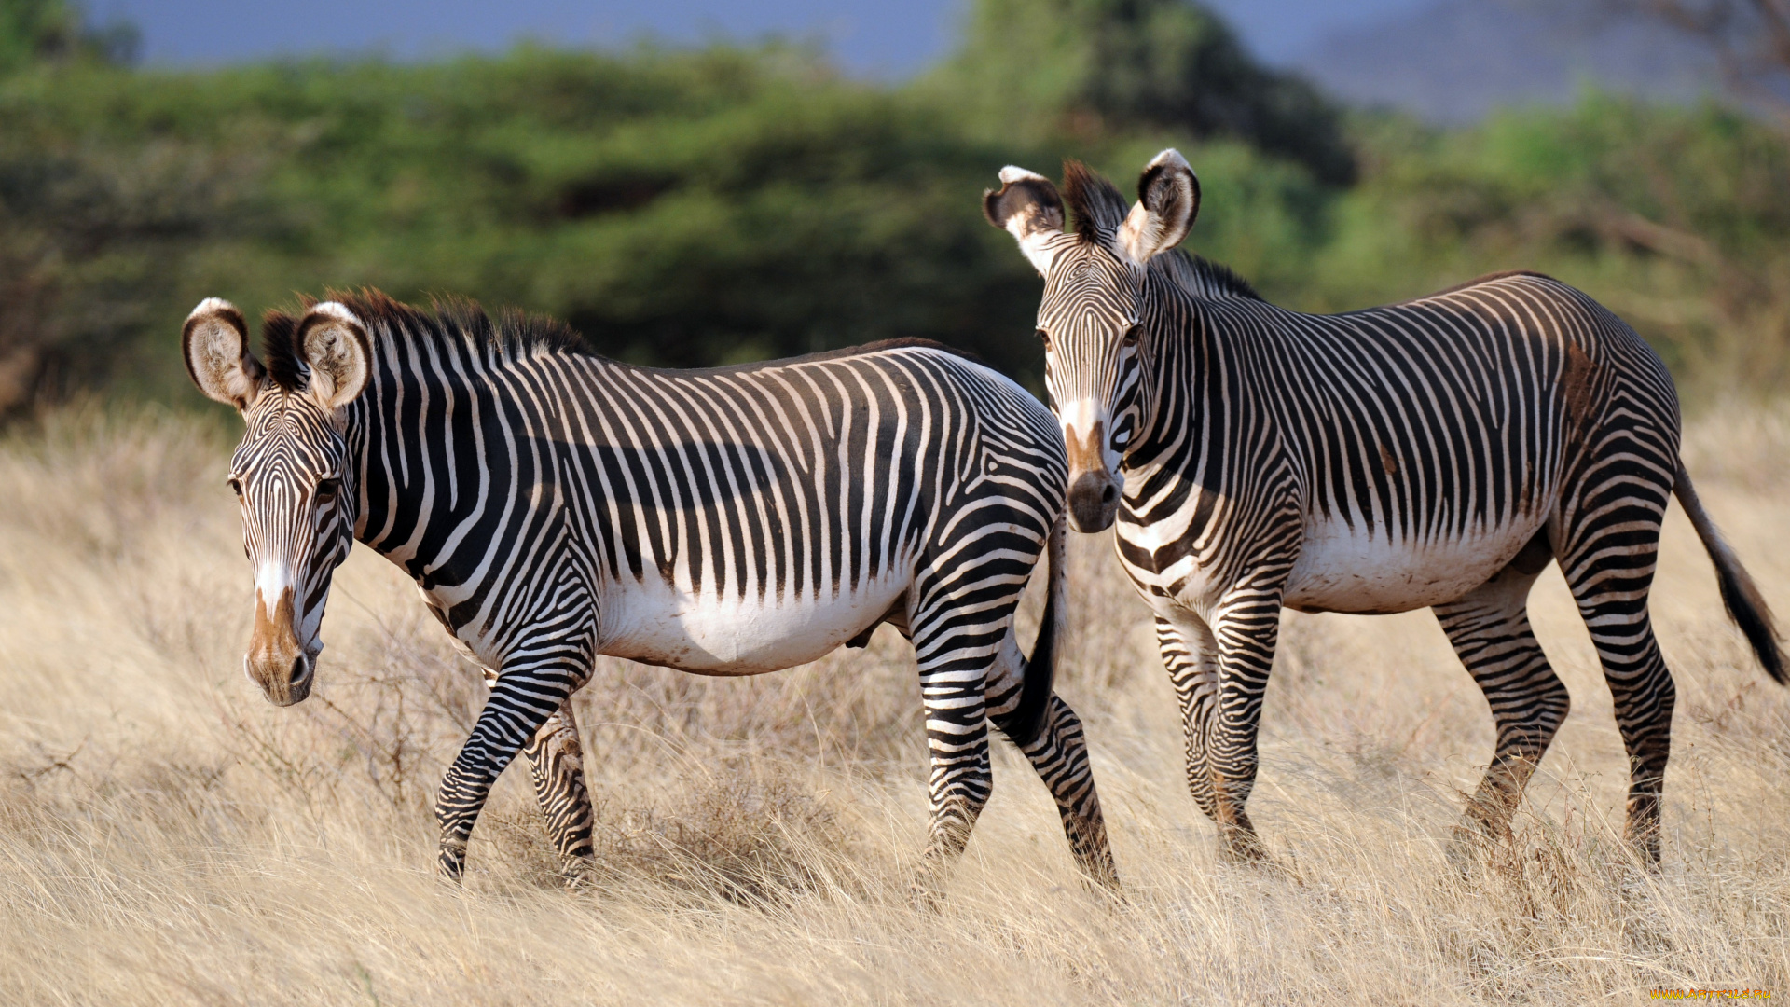
Animals living in the savanna have adapted to their habitat in many ways. Some animals, like the giraffe, have long, powerful legs so that they can quickly run away from predators, animals that hunt and kill other animals. Their long legs also help them travel long distances searching for food.
Zebras are specially adapted to living in the savanna. They have strong, long legs that make them very good at outrunning lions and other predators, and the stripes on the zebra’s legs and body don’t just make it look pretty – they camouflage the zebra against the grass so that predators can’t see it.
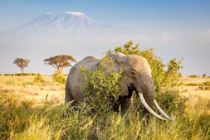
The African elephant is very big and eats up to 250 kg of trees and grasses every day! African elephants are adapted to the hot weather in the savanna. They have huge ears that they flap like fans to stay cool and keep away bugs. They also have thick skin, that protects them from branches and thorns.
Источник: «Animals and Habitats. Tell It Again!™ Read-Aloud Anthology»
New York, 1995

