Spectacled bear
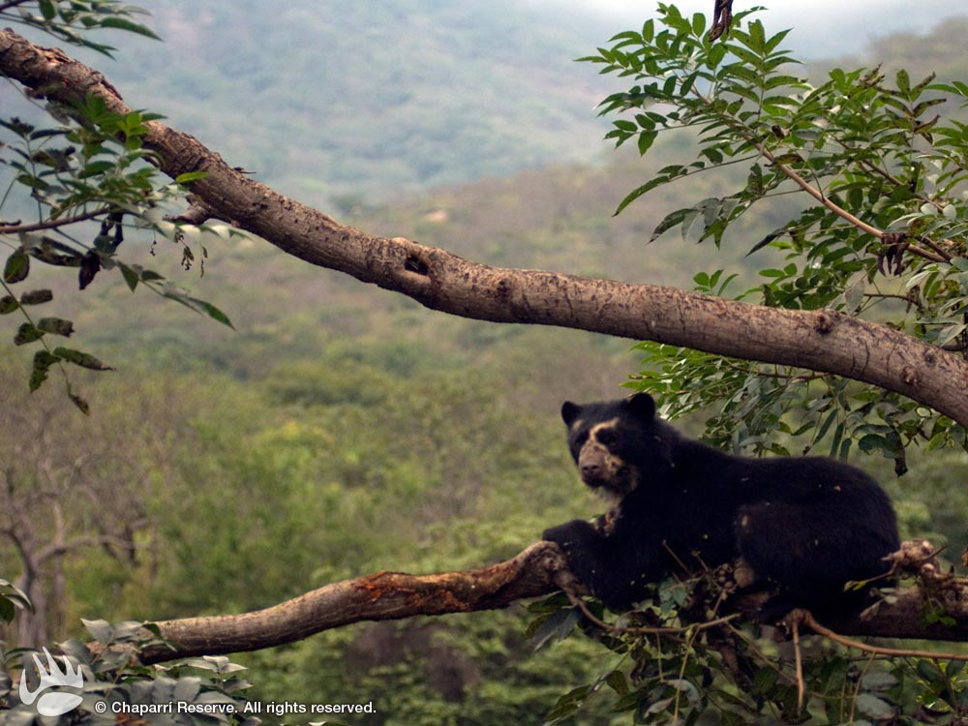
Spectacled bear lives in South America. It can be found in Venezuela, Columbia, Peru, Ecuador, Argentina and Bolivia. Spectacled bear inhabits cloud forests at high altitudes, but it can be seen in various other habitats (scrubland, grassland, humid and arid forests…) when it searches for food. Exact number of remaining spectacled bears in the wild is unknown, but it decreases rapidly. These animals could soon become endangered. Spectacled bears can reach 5 to 6 feet in length and weigh up to 340 pounds. Males are almost two times bigger than females. Body of spectacled bear is covered with black or reddish-brown fur. Patches of creamy fur can be seen on the chest, throat and around eyes. Pale marks around eyes look like spectacles, which is why these animals are called “spectacled” bears. Spectacled bear has muscular body and round head with short snout and strong jaws. Front limbs of spectacled bear are longer than hind limbs and equipped with sharp claws. Despite being large, spectacled bear is fast. Spectacled bear spends majority of time on the trees. Its diet consists of various plants, berries, honey, fruit, eggs, insects, small birds and mammals. Main predators of spectacled bears are mountain lions and jaguars. Young bears are blind until the 42nd day. They completely depend on their mother during the first few months of their life. They usually leave mother after one or two years, when they are old enough to begin independent life. Spectacled bears can survive up to 38 years in captivity. They live much shorter in the wild.
Источник:
http://animals.nationalgeographic.com/animals/mammals/spectacled-bear/

