Урок английского языка в Музее Победы для медиаклассов
People’s activities during the World War II
Рабочий лист
Introduction
Sum up the role of the Soviet Union in WWII based on what you’ve learnt in no more than 3 sentences.
Share and compare your ideas.
Task 1
Study the quotes by W. Churchill (Group 1) and F.D. Roosevelt (Group 2) on the walls of the Hall of Historical Verity. Are any of their ideas similar to yours?
Translate the quotes into English.
____________________________________________________________________________________________________________________________________________________________________________________________________________________________________________________________________________________________________________________________________________________

Use the QR-code to compare your translation to the original quotes. To what extent do the texts differ?

Group 1
Group 2
Make a list of the vocabulary from the original quotes that you lacked in your translations:
________________________________________________________________________________________________________________________________________________________________________________________________________________________________________________________________________________________________________________________________________________________________________________________________________________________

Add the vocabulary you find most useful to the Glossary.

What are the key points that Churchill and Roosevelt make in their speeches on the role of the USSR in WWII?

Task 2
Study the Soviet propaganda posters in the Hall of Historical Verity. What are their key messages?
Use the QR-code or the link below to see the American and British propaganda posters demonstrating the contribution of people of different jobs and occupations to the victory during the war. What messages do they convey?
https://drive.google.com/drive/folders/1OzbSCROGyX_MwMQaCG0c8DsbwBo7nM4H?usp=sharing

Pick one of the posters to compare and contrast with the Soviet poster of your choice. Use the following plan:
• briefly describe both posters;
• explain how these posters illustrate the role of the contribution of people of different jobs and occupations to the great victory.
• say in what way the posters are different (2 features connected with the subject of the posters);
• express your opinion on the subject of the posters.
Do the task in pairs. Listen to your partner and comment on his/her talk. Mention:
- if you would add any information;
- if you agree with the conclusion; why/why not.

Task 3
Enter the Feat of the army hall.
Read the posters on the wall and discuss the role of propaganda in winning the war.
Compare your ideas with the following passage. Complete the text by inserting the appropriate words into the gaps.
appeal / condemn / decision / vividly / being / surrendering / genuinely / aimed at

When the war with Nazi Germany broke out on 22 June 1941, the Communist Party of the USSR took a _____ to create a new organisation, which was called the Soviet Office of Political and Military Propaganda (later reformed into the Office of Propaganda on Enemy and Occupied Territories). By the end of 1941, eighteen propaganda newspapers were _____ published in the Soviet Union in various foreign languages, ten of them in German.
Even the German intelligence accepted that the Soviet propaganda was very effective. Propaganda _____ Nazi soldiers and civilians in Germany and on occupied territories did not focus on the communist ideology or religion criticism, the class structure of society, etc. The main objective was to _____ Hitler and his National Socialist German Workers Party.
The propaganda materials _____ illustrated atrocities by the Nazi troops on the occupied territories on the one hand and the strength of the Soviet Army and consequently its inevitable victory on the other hand. Among various propaganda techniques, one of the most important was an emotional _____ to ‘common’ people who were forced to fight a war that was not in their interests. Images of women and children waiting for their husbands, sons and fathers back at home were widely used. Women and children in these pictures appeared miserable and ashamed that their loved ones were fighting on the Eastern front, and these impressions came out as _____ poignant and moving.
Most of the flyers contained a pass, written in German and Russian, which could be torn off and presented to the Soviet troops when _____. In 1942, after the first German defeats, a special series of propaganda materials demonstrating the enemy's losses was launched. The propaganda message addressed to Germany's allies stressed the argument that the German fascists were using their allies' troops in the most dangerous situations and campaigns.
(from https://blogs.bl.uk/)
Add the most useful vocabulary to your Glossary.

What other function extremely important in times of war depends on the efforts of propagandists and defence correspondents?

Task 4
Study the exhibition of weapons. Find at least one weapon belonging to each of the categories:
- developed by Soviet engineers;
- captured as trophies;
- obtained through the Lend-Lease programme.
What do you know about the Lend-Lease policy?

Task 5
Watch a short video lecture by the History channel to learn more.
https://drive.google.com/file/d/1BOM5QwlB42EJNmCS5EaMUtZAIfaevZLL/view?usp=sharing
For each task 1 – 6, choose the best answer.
- The Lend-Lease Act initially regulated the conditions of weaponry provision between…
- the USA and the UK.
- the USA and the USSR.
- the UK and the USSR.

- According to the Neutrality Act, Britain…
- could not receive weapons from the US under any circumstances.
- could only get weapons from the US by paying cash and organizing transportation.
- could get weapons from the US on various terms.

- Why were some Americans against selling weapons to other countries?
- It could give unlimited power to the president.
- It would give more power to the president to participate in other countries’ wars.
- It could ruin the US economy.

- The Lend-Lease Act was devised as a way to…
- support war action without risking American citizens’ lives.
- avoid supporting any side in the war.
- earn more money for the state budget.

- As a result of signing the Act,
- only Great Britain received military support from the US.
- Great Britain, Russia and China received military support.
- a large number of countries received US military support.

- The Neutrality Act…
- prevented the USA from interfering till the end of the war.
- was cancelled when the Lend-Lease Act was signed.
- became irrelevant because of the attack on the USA.

Task 6
Group 1. Describe the pictures given. Remember to depict the action and location as well as the foreground and the background. You have 2 minutes to prepare.
Group 2. Think about the following features and find the pictures connected with them:
1) different types of troops contributing to defeating the enemy; emphasise their importance in winning the war;
2) the hardships of the civilian population during the war;
3) the cruelty of the war;
4) the heroes of the war;
5) the officers in charge;
6) the partisan detachments;
Students of the first group describe the pictures; Students of the second group match the pictures to their features and comment on them.
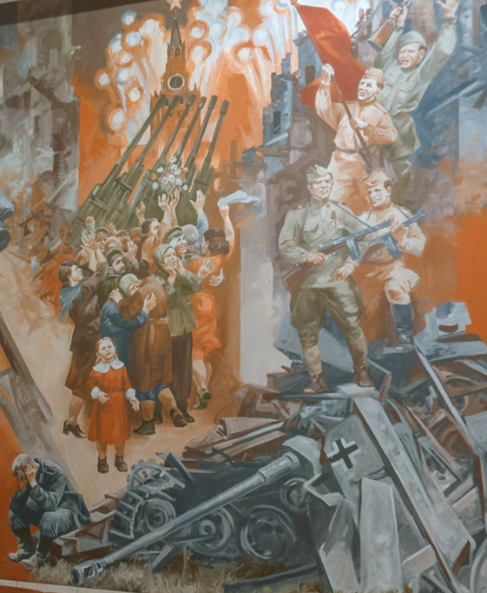
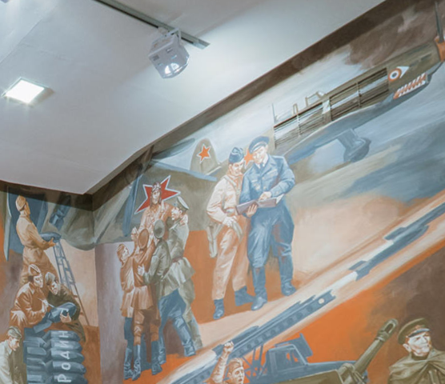
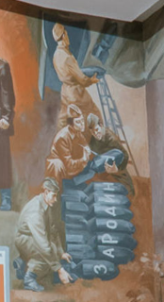

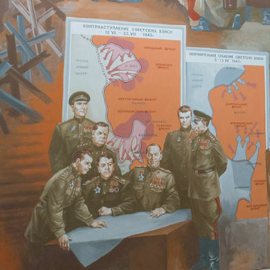
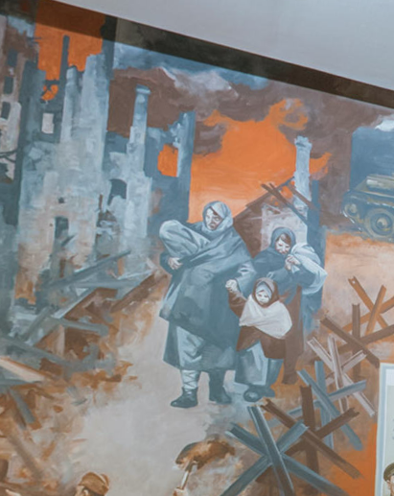
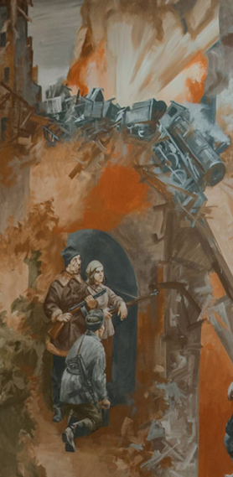

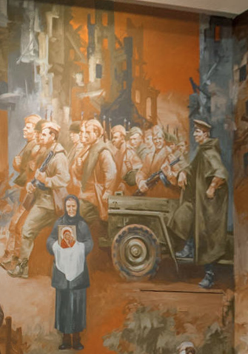
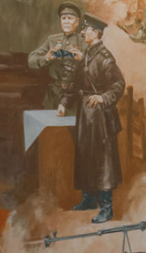
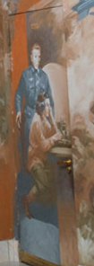
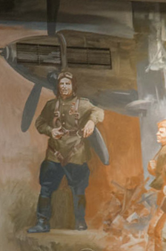

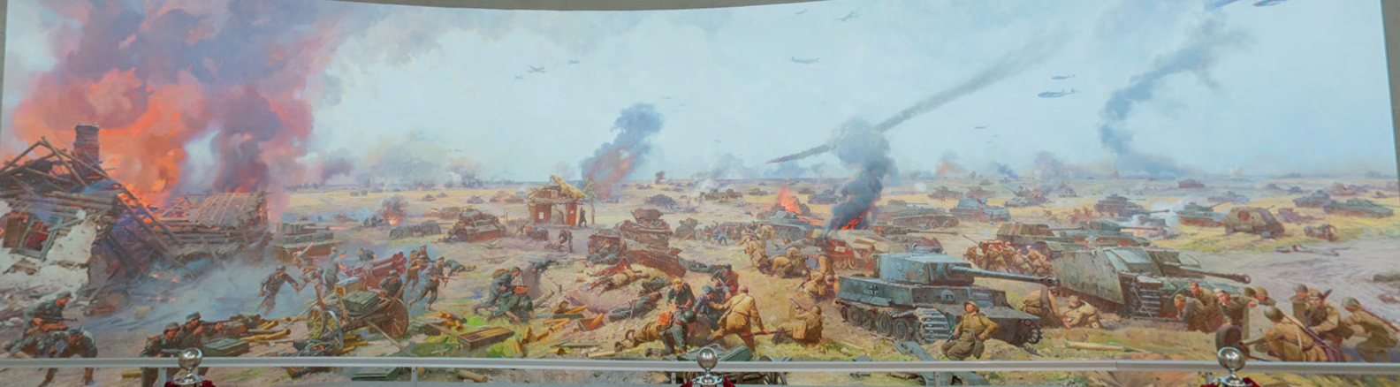

Task 7
Return to the Hall of Historical Verity.
Study the infographics titled Freedom for the West, Salvation for the East.
Look through the infographics section on the resistance movement in West European countries. Use the proper vocabulary to complete the following text.
lowest / correspondingly / largest / 3500 / 5000 / Italy / mirrors / followed

The ____________ number of people took part in the resistance movement in ____________ followed by France with ____________ people and ____________ people correspondingly. The number of people fighting in Belgium ____________ the number of people fighting in the Netherlands. The ____________ number of Soviet citizens took part in the resistance movement in Norway ____________ by Greece with figures 100 and 300 ____________.
The final production task is writing a report based on the data, which you can find in the infographics section on the resistance movement in West European countries.
The following plan is to be used:
– make an opening statement on the subject of your report;
– summarise the information by selecting and reporting the main features;
– make comparisons where relevant;
– give an overview of the economic and humanitarian support contribution to the war effort;
– draw a conclusion.
Check out an additional task in the Case files.

