WHAT IS A BIRD?
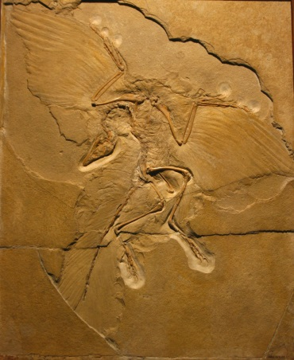
BIRDS ARE THE MOST SUCCESSFUL flying animals that have ever existed. They make up the scientific class Aves, distinguished from other animals by one feature: feathers.
Birds almost certainly evolved from small, predatory dinosaurs called theropods more than 150 million years ago. Over time, the theropods’ scales were transformed into feathers, their front legs stretched and became wings, their bony tails withered away, and their snouts and teeth were replaced by lightweight bills. Evolution made them masters of the sky, and they soon spread across the planet.

A COAT OF FEATHERS
Birds are the only animals with feathers. These are not just for flight – they also provide a warm coat to trap heat in the body. Birds are warm blooded, which means they maintain a constant internal temperature, rather than warming up and cooling down with the surroundings, as happens in reptiles.
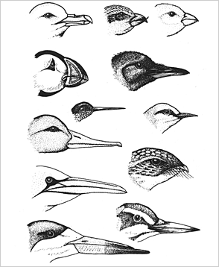
FITTING THE BILL
Bills (or beaks) evolved because they are lighter than toothed jaws and so make flying easier. They are also simpler than jaws, consisting merely of thin bone coated with the tough protein that forms human fingernails. As a result, evolution can change their shape relatively easily, giving each species a design adapted to its way of life. Flesh-eaters, for example, have hooked bills for tearing flesh.

DIGESTIVE SYSTEM
Since they have no teeth, birds must break up food inside their bodies. They have a special stomach chamber called a gizzard, with powerful muscular walls that squeeze and grind the food. Less frequent flyers swallow grit or stones to help the gizzard do its job. Many birds also have a food storage chamber, or crop, in the throat. This helps them to wolf down food quickly and then bring it up again later to feed their chicks or to lose weight when fleeing danger.
SENSES
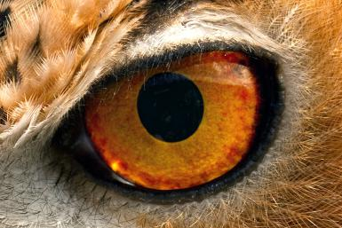
Vision is the most important sense in birds. Many can see colours invisible to our eyes or tiny details that we would need a telescope to notice. When they sleep, birds can keep one eye open and half the brain stays awake, wary for danger. Most birds have a poor sense of smell but excellent hearing. What sounds to us like a single note of birdsong might be heard by a bird as 10 separate notes.
GLOBAL DOMINATION
Flight has allowed birds to colonize almost every environment, from deserts and cities to remote islands, mountain peaks, and the freezing wastes of Antarctica. Birds can endure colder weather and thinner air than any other animals. The only habitat they haven’t conquered is the deep sea.
REPRODUCTION
While mammals carry babies inside the body, birds lay eggs, like their reptilian ancestors. But, unlike most reptiles, which simply abandon their eggs, birds care for both eggs and chicks. Usually both parents cooperate to keep the young warm, and to protect and feed them.
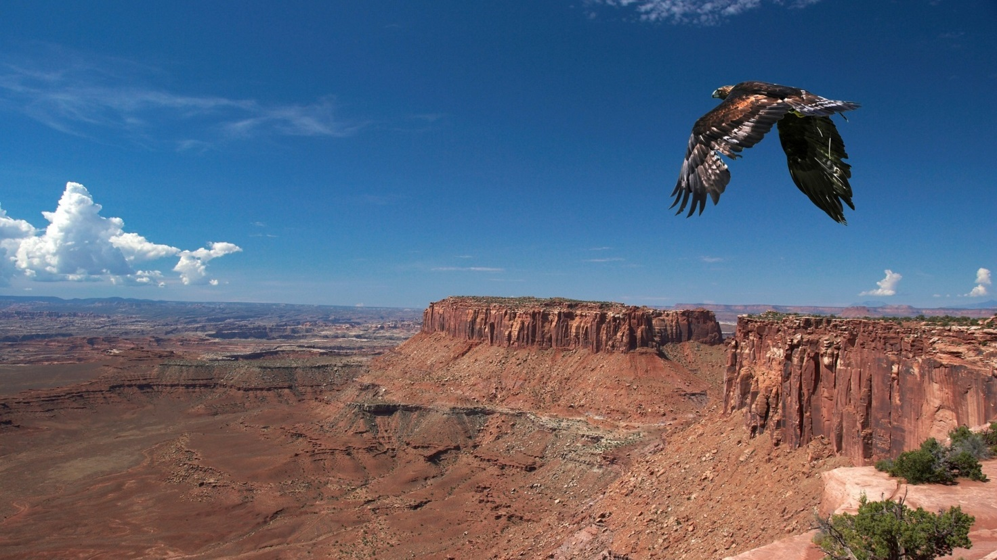
BUILT FOR FLIGHT
ALMOST EVERY PART OF A BIRD’S BODY has been shaped by evolution to meet the demands of flight. Wings and feathers are the most obvious features – they provide the «lift» to overcome gravity. Most birds also have a streamlined shape with weight concentrated in the middle for balance. The bones are riddled with hollow spaces to save on weight, and many are rigidly fused together to reduce the need for heavy joints or unnecessary muscles. The flight muscles are huge and powerful, but they need plenty of oxygen, so birds have special lungs to extract as much oxygen as possible from the air.
FEATHER LIGHT
Feathers are made of fine, lightweight fibres of keratin, the protein that coats bills. Flight feathers have a stiff central shaft, called a quill, with hundreds of side branches called barbs. The barbs bear thousands of tiny branches called barbules, which lock together to form a flat, streamlined surface.
THE BARE BONES
A bird’s skeleton has the same basic plan as a human skeleton, but the details are very different. Birds have only three “fingers” (digits), and these are fused to form a strut supporting the wing. The wing pivots at the shoulder, and the elbow and wrist can bend only horizontally to fold or extend the wing. The tail bones are fused into a stump, and sidebars on the ribs overlap to form a solid cage. An enormous bone called the keel provides an anchor for the powerful flight muscles.
ON THE WING
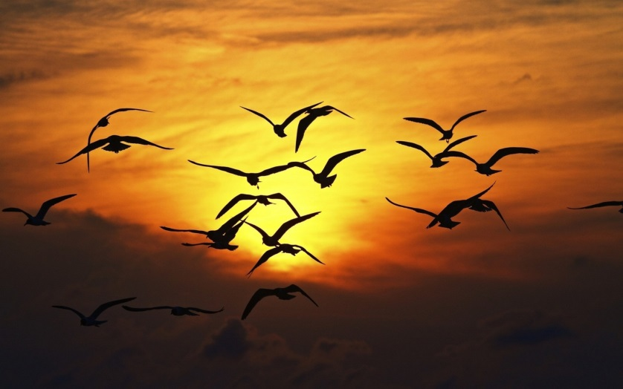
A bird’s most important feathers are its flight feathers, found on the wings and tail. Most of the lift required for flight is generated by the primary and secondary flight feathers in the outer part of the wing. There are usually 9–12 of these on each wing. Other parts of the body are covered with small «contour feathers», which give the bird a streamlined surface, or fluffy down feathers, which keep the bird warm.
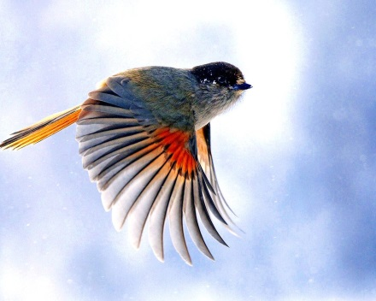
HOW WINGS WORK
Wings lift a bird in two main ways. During flapping flight, they push air backwards and down, causing the bird to move forwards and up. Once a bird has picked up speed, the wings catch the wind like sails and create higher pressure underneath, pushing the bird up.

WINGSPAN
Wings work best when air flows swiftly over them. If the air moves too slowly, turbulent whirlpools develop around the wings and they stop generating lift. The result is a stall: the bird loses its balance and tumbles. Slowflying birds, such as eagles that soar on thermals, spread out the feathers at the wingtips. This way, each feather acts as a tiny wing, generating extra lift and stabilizing the airflow.
OXYGEN SUPPLY
Birds’ lungs are far more efficient than ours. When we breathe, air flows in and out of our lungs in two directions. Our lungs don’t empty entirely, so stale air stays behind after each breath. In birds, air circulates through the lungs in one direction only, thanks to a complex arrangement of air sacs around the lungs. Fresh air continually enters the lungs, flushing out stale air and providing a rich supply of oxygen.
KEEPING CLEAN
Feathers need a lot of care. The tiny barbules that keep them flat can come unzipped. Birds run their bills through the feathers to zip the barbules back together. Many birds also rub oil from a gland in the rump into the feathers to waterproof them. Some also bathe in puddles or dust to keep the feathers in shape.
FEATHERS AND FINERY
Feathers are not just for flying – they are also for attracting attention. In the breeding season birds, unlike drably coloured mammals, flaunt brilliant colours, oversized tails, and all manner of decorations to impress the opposite sex. The showiest birds of all are males that mate with lots of partners. They contribute little to raising families, and devote all their energy to showing off. Their glossy colours and elaborate displays perform a vital function, advertising the excellence of their genes.

MASTER BUILDERS
WITH ONLY INSTINCT TO GUIDE THEM and only bills to serve as tools, birds construct nests of amazing complexity. A nest may take weeks to build and involve thousands of flights in search of suitable material. Some birds use whatever comes to hand – even string, nails, plastic bags, or old clothes. Others are much fussier. Hummingbirds build nests from spider’s silk one strand at a time, while swallows collect a certain kind of mud from the edge of puddles.
EGGS
ALL BIRDS LAY EGGS rather than giving birth to live young as mammals do. This is because birds need to keep their weight down in order to fly, so mothers must get rid of their offspring as soon as they can. An egg, therefore, serves as an external womb, containing all the nutrients that a chick will need to develop. Parents simply keep their eggs warm, protect them from predators, and wait for them to hatch. We think of eggs as fragile, but in fact they are surprisingly tough: ostrich eggs are strong enough to stand on.

FAMILY LIFE
IN SOME WAYS, THE FAMILY LIVES OF BIRDS are much like our own. More than 90 per cent of bird species are «monogamous», which means that males and females form stable couples that work together to raise a family. In some species, such as swans, couples may stay together for life. But despite the appearance of stability and harmony, family life among birds is full of hardship, deceit, and even cruelty. Birds almost always lay more eggs than will reach adulthood, and from the moment they hatch, chicks face a struggle to survive that only the strongest can win.
Источник: Ben Morgan Guide to BIRDS A Dorling Kindersley Book Dorling Kindersley Limited, 2004

