Musk-Oxen
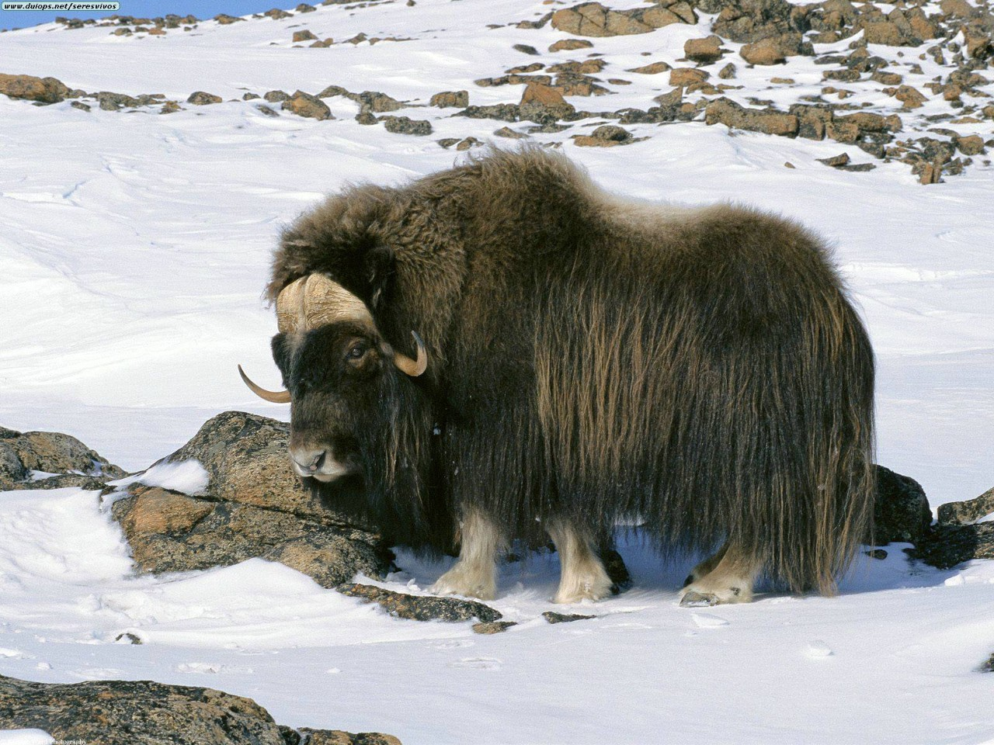
Type: Mammal
Diet: Herbivore
Average life span in the wild: 12 to 20 years
Size: Height at shoulder, 4 to 5 ft (1.2 to 1.5 m)
Weight: 500 to 800 lbs (227 to 363 kg)
Group name: Herd
Musk-oxen live in the frozen Arctic and roam the tundra in search of the roots, mosses, and lichens that sustain them. In winter, they use their hooves to dig through snow to graze on these plants. During the summer, they supplement their diet with Arctic flowers and grasses, often feeding near water.
These animals have inhabited the Arctic for many thousands of years, and their long shaggy hair is well adapted to the frigid climate. The outer hairs, called guard hairs, cover a second, shorter undercoat that provides additional insulation in winter. This undercoat falls out when temperatures climb at winter's end.
Female musk-oxen carry their calves during an eight-month pregnancy, but after birth there is little time to waste. The infants are able to keep up with their mothers and the rest of the herd within a few hours.
Musk-oxen are herd animals, and groups of two or three dozen animals are sometimes led by a single female. Herds use cooperation to deal with predation by wolves or dogs. When threatened, they “circle the wagons” and array themselves with their young in the middle and their sharp horns facing outward toward their foes. A cornered musk-ox can be a fearsome enemy, charging with its massive bulk and attempting to use its horns to deadly effect.
Such defenses are not terribly effective against human hunters, who killed great numbers of musk-oxen for their hides and meat. Today, legislation protects herds in Alaska, Norway, and Siberia, where the animals live on preserves.

Источник: http://animals.nationalgeographic.com/animals/mammals/musk-ox/

