Worksheet

Dear friends,
Are you ready to travel through time?
You are at the memorial museum of Alexander N. Scriabin. Here in the historical
center of Moscow time stands still and you can move 100 years back. Let's find the
things people were interested in and learn about the way they lived at the beginning
of the 20th century. So let’s move to the past!
As you can see this house was not built as a museum but as a residential building and
now you are the guests of the composer and pianist A.N. Scriabin.
Just think of the following: which of these famous museums were once also
residential buildings? (Underline the correct answers).
- The State Darwin Museum.
- The Memorial House Museum of Marina Tsvetaeva.
- The Museum of Cosmonautics.
Over the centuries many professions could be determined by clothing. Look at the
Scriabin's photographs in his study. What kind of education did he receive in his
youth? What was Scriabin's profession?
__________________________________________________________________________________

As you may know, Scriabin was an outstanding pianist. All musicians wear a special
outfit on stage. Find the suit in which Scriabin gave his last recital in 1915.
Take a photo of it and write its name.

Photo | Name
 | ________________________________

Furnishing his apartment, Scriabin preferred the most popular style of his time, Art Nouveau. Have a look at the pictures and try to determine the interior items in Scriabin's study that belong to this style.

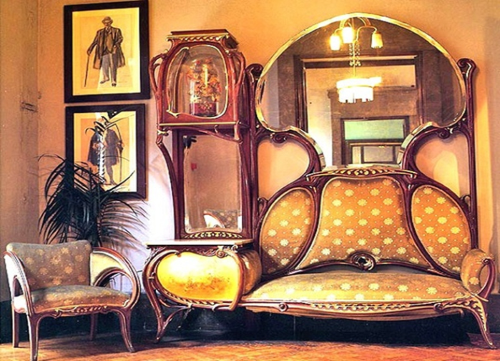 |  | 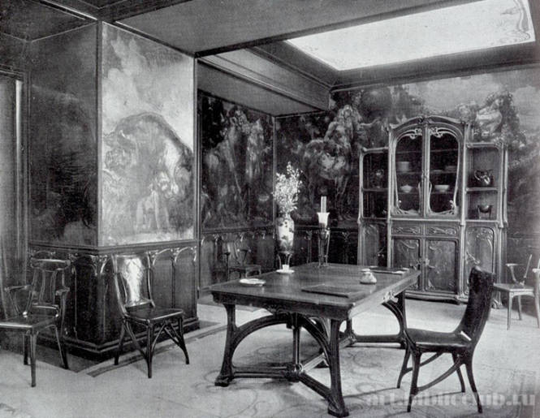
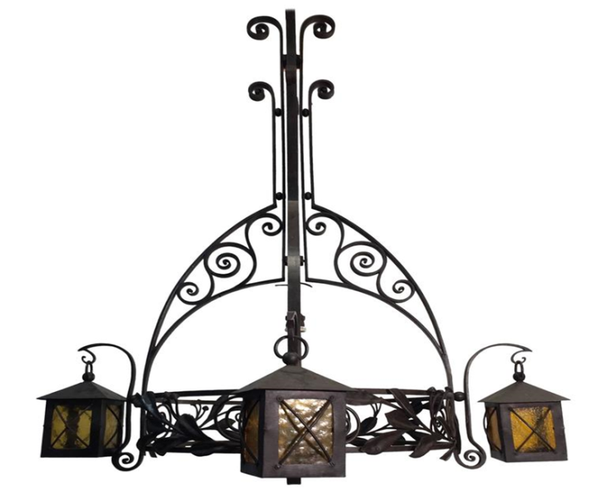 |  | 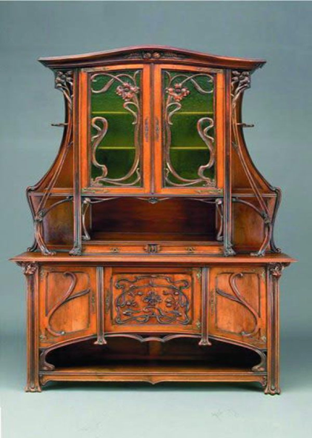

________________________________________________________________________________________________________________________________________
Try to describe this style using the correct words or phrases:
Religious subjects, ordinary, unusual, greatly influenced by ancient civilizations, floral ornament, straight lines, curved lines, classical, organic forms, in the fields of decorative art and architecture.
________________________________________________________________________________________________________________________________________________________________________________________________________________________________________________________________________________________________________________________________________________________________________________________________________________________________________________________________________________________________________________________________________________________________

Pay attention to the chandelier. In Scriabin's lifetime it was electrified. What do you
think the source of light in a chandelier was before electricity? Choose the correct
answer.

– candle;
– lamp oil;
– gas.
In the late XIX – early XX a new popular art movement emerged. It was called
Symbolism. Its main idea was an attempt to conceal the meaning behind the
symbols. The symbolists loved mystery and were fond of mysticism. Scriabin and
many of his friends were symbolists too. The composer was very keen on the
oeuvre ([ɜːv] творчество) of his friend N. Sperling. Several of his paintings are
displayed at the Scriabin's house.
Have a look at the pictures in the study and try to find those of them painted by
Sperling. Take a photo of them.

Look at the picture “Oriental Sage”. What did the artist want to convey?
Describe your impressions.
________________________________________________________________________________________________________________________________________________________________________________________________________________________________________________________________________________________________________________________________________________________________________________________________________________________________________________________________________________________________________________________________________________________________
The second picture by Sperling portrays a medieval knight. You can see an actual
historic figure who lived in the XV century. His name is Gilles de Rais. He was a
friend of the famous heroine Jeanne d'Arc. Once he began to study alchemy.
The author of the picture was well acquainted with this fact, but do the descendants still know that? The artist left a clue for those who do not know this – an alchemical
symbol. Try to find it and draw.

At the end of the XIX – early XX century the culture of the East became very
popular. Scriabin also took a great interest in Orientalism. Find items that are
associated with oriental culture in the small locker with gifts and try to determine
which countries they were brought from.
____________________________________________________________________________________________________________________________________________________________________________________________________________

In earlier times it was conventional to have a separate room for guests. Try to discern
distinctions between the drawing room and the study at the Scriabin house.
__________________________________________________________________________________________________________________________________________________________________________________________________________________________________________________________________________________________________________________________________________________________________________________________________________________________________________________________________________________________________________________________________________
There is an unusual object at the wall on the right – that is the first sound reproducing
device, a pianola. For reproducing music with the help of this device a musical
medium in the form of perforated paper would be needed. Connect the reproducing
devices of the XX century with the corresponding music media.

Pianola phonograph record
Gramophone tape / disc
Tape recorder roller with perforated paper

What do we use today to listen to music?
________________________________________________________________________________________________________________________________________
Look at the furniture in the dining room. This is another type of Art Nouveau style. At the beginning of the XX century people strived for comfort and convenience refusing excessive decor (as you saw it in Scriabin's study). Such kind of furniture was available both to the rich and the poor. Give the short description of the room.
____________________________________________________________________________________________________________________________________________________________________________________________________________________________________________________________________________________________________________________________________________________

