Interesting facts about penguins
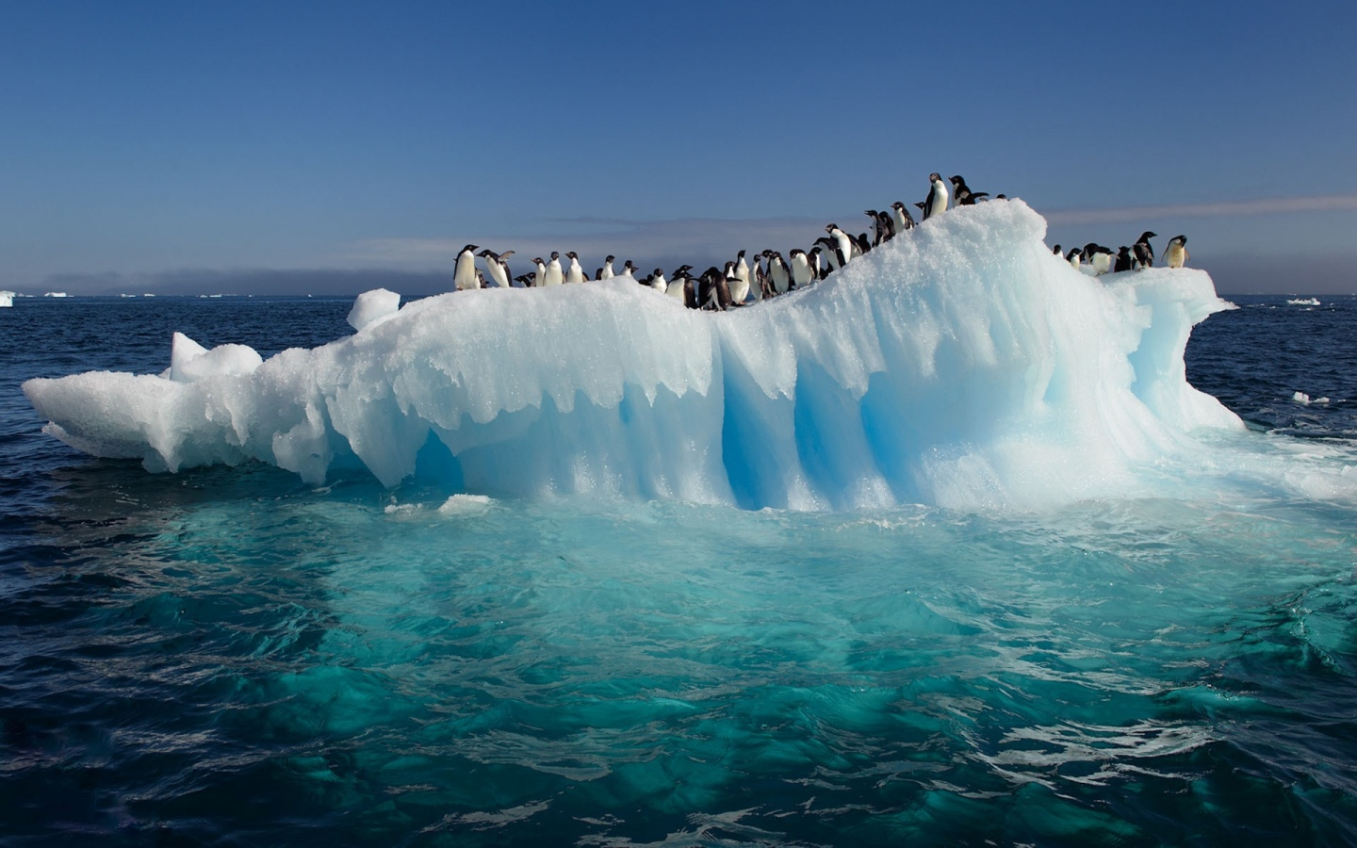
- Penguins are birds that cannot fly. They make up the scientific order Sphenisciformes and the family Spheniscidae. The name «Penguin» comes from the Welsh terms «pen» meaning head and «gwyn» meaning white.
- There are 17 species of penguin, each slightly different. All of the species live in the Southern hemisphere. Many live at the South Pole on Antarctica Some are found on the coasts of South America, the Galapagos Islands, Australia, Africa, and New Zealand. There may be as many as 100 million penguins in the world.
- Penguins have black and white feathers and they waddle when they walk. They also have a torpedo-shaped body. This shape allows them to speed through the water at speeds of 25 miles per hour.
- Penguins spend most of their time in the water searching for food. They cannot swim backwards, however. They are at home in the water as they spin, jump and dive as they play and search for food. A penguin can hold their breath under water for approximately 6 minutes.
- Penguins are warm blooded. Penguins have a layer of fat under their skin called «blubber». Overtop of this they are covered with fluffy «down» feathers and overtop of those they have their outer feathers which overlap to seal in warmth.
- Penguins eat seafood. Their main diet is fish, though they’ll also eat squid, small shrimplike animals called «krill» and crustaceans (ракообразные).
- Penguins don’t live near freshwater. Instead they drink salt water. They have a special gland in their bodies that takes the salt out of the water they drink and pushes it out of grooves in their bill, so the water they are actually drinking is filtered.
- Penguins mate for life. During the mating season penguins head for special nesting areas on the shore. The area where penguins mate, nest and raise their chicks is called a rookery.
- Leopard seals are the penguins’ main threat, but sea lions and orca whales are also predators. Some large seabirds like the Australian eagle and the Skua also threaten the penguin. Penguins also have a number of on-land predators like ferrets, cats, snakes, lizards, foxes and rats.
Источник: https://kidskonnect.com/animals/penguin/

Did you know Humboldt penguins can blush? When they get too hot (it can get up to 108 degrees (F) where they live) they have to avoid over-heating. So they flush pink on their face, wings and feet. This sheds body heat by sending blood to the bare part of their bodies.
Throughout the day, Humboldts engage in a vital activity: they preen their feathers. They gather oil from their preening gland and apply it to their feathers and the edges of the flippers. This keeps their feathers waterproof, helping insulate the birds from the cold.
Like all penguins, a Humboldt's black and white color helps camouflage it when it's in the sea. When seen from below, its white belly blends with the light cast on the ocean surface; and when seen from above, its black back blends with the darkness of the ocean depths. http://www.stlzoo.org/animals/abouttheanimals/birds/penguins/humboldtpenguin/

