Task 1
Define which of the following statements are TRUE (T), and which are FALSE (F), and you will learn the name of the smallest bird in the world.
Statements | T | F
1. Birds are the only living animals that have feathers. | H | R
2. All birds fly. | E | U
3. All birds have two wings. | M | E
4. Birds lose and replace their worn or damaged feathers. | M | D
5. All birds have thick, heavy bones that provide the structure they need to fly. | W | I
6. Birds have poor eyesight. | A | N
7. All birds lay eggs. | G | R
8. Most birds eat worms. | B | B
9. All birds migrate. | L | I
10. All birds are warm-blooded. | R | E
11. All birds sing. | R | D

Task 2
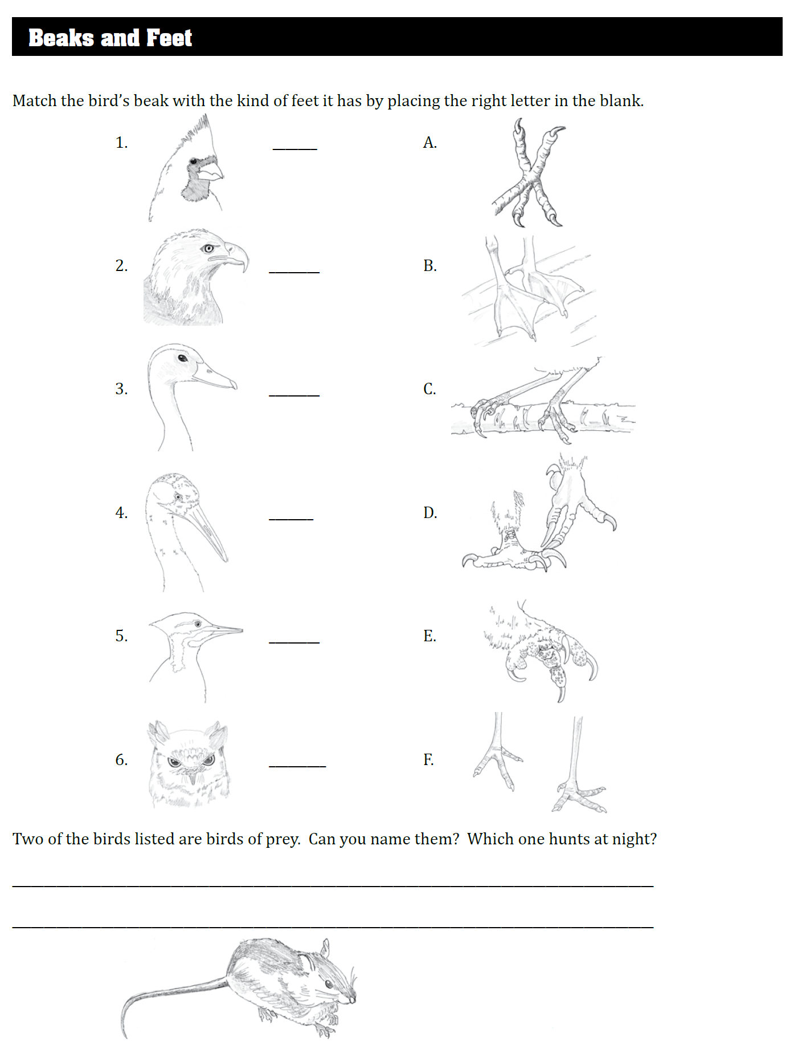
Источник: Vickie Henderson «Discover Birds. Activity Book» 2012 TN Ornithological Society and Vickie Henderson [электронный ресурс]. – Режим доступа: http://www.tnwatchablewildlife.org/files/DiscoverBirds_1_Intro.pdf

