Практико-ориентированное задание

The Three Pearls of Russian Medieval Architecture

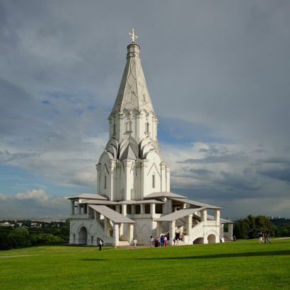
The church of the Ascension in Kolomenskoye was constructed in 1532. There is a legend that the church was commissioned by Moscow Grand Prince Vasily III as a thanksgiving to God for a long-awaited child Ivan, born in 1530. Ivan was to be an heir of Grand Prince Vasily III. There is an opinion that the church of the Ascension was the first tent-like church built of stone (bricks). It is supposed that an Italian architect Pietro Francesco Annibali took part in the construction of this amazing church. The church is 62 meters high, it looks solemn like a gigantic white pillar. In 1994 the church of the Ascension was inscribed in UNESCO’s World Heritage List.
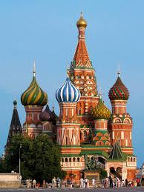
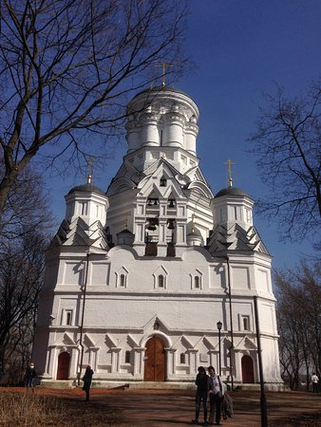
In 1547 Grand Prince Ivan was crowned in the Assumption Cathedral in the Moscow Kremlin as a first Russian Tsar. Ivan IV commissioned to build a church in the village of Dyakovo, which neighbors with Kolomenskoye. The church was consecrated in honor of the Tsar’s patron saint — John the Baptist (the Forerunner) the saint, whose name was given to the first Russian Tsar when he was baptized. The church of the Beheading John the Baptist consists of the main church building surrounded by 4 side-churches. Tsar Ivan IV used to celebrate his name day in Dyakovo. In the 16th century, Kolomenskoye and Dyakovo were the villages, located in the countryside, beyond the border of Moscow. Nowadays this locality became part of our city.
There is an opinion that the church in Dyakovo was designed by famous architects Barma and Postnik. They also constructed the world-famous Russian Cathedral on Red Square — the Cathedral of the Intercession on the Moat also known as Saint Basil’s Cathedral. This beautiful church is the real cultural symbol of Russia. The cathedral was built in 1561 to commemorate the capture of Kazan and Astrakhan. It consists of the central church surrounded by 9 side-churches. The roof of the central church resembles a tent. The Saint Basil’s Cathedral is inscribed in UNESCO’s World Heritage List. The Church of the Ascension in Kolomenskoye, the Church of the beheading John the Baptist and the Saint Basil’s Cathedral are brilliant examples of the 16th-century Russian architecture.

Read the text, look at the pictures. Use the information to answer the following questions.

- Which statement is correct?
- All these churches are constructed by Italian architects.
- The three churches are tent-like.
- All the three churches have side-churches.
- The churches were listed as UNESCO monuments.
- All the churches are built in the 16th century.

- All the churches were initially erected within Moscow’s border. Is it true or false? Explain, why.

- Name the historical figure who could be connected with the history of the three churches.

- Which peculiar features let us suppose that the Church of the Beheading of John the Baptist and Saint Basil’s Cathedral were designed by the same architects?
- A tent-roofed structure
- The central church building is surrounded by several side-churches
- Onion-shaped domes (cupola)
- Rich decorations

- Which church could Tsar Ivan IV attend once a year for the celebration of his name day?
- The Church of the Ascension in Kolomenskoye, because it was built to celebrate the Tsar’s Birthday.
- Saint Basil’s Cathedral, erected to commemorate Ivan IV’s military victories.
- The Church of the Beheading of John the Baptist, because it was dedicated to his patron saint.

