Tapirs
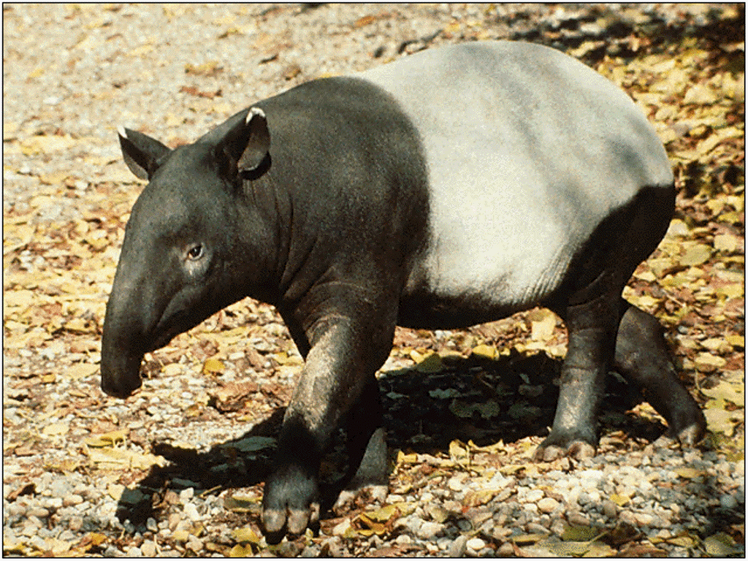
Tapirs look a little like pigs or anteaters, but they are related to horses and rhinos. These interesting animals have been around for millions of years. Their fossils have been found all over the world, but today tapirs live in only a few places. Baird’s tapir lives in Mexico and Central America. The Brazilian tapir lives in the rain forests of Brazil. Mountain tapirs live in the cold mountain areas of Northern South America, while the Malayan tapir lives in Asia.
Tapirs are peaceful herbivores. They graze alone or in small groups, eating grass and tree leaves. Their long, curved snouts help them gather leaves from high places. Jaguars, crocodiles and tigers hunt tapirs, but their biggest enemy is us. Humans hunt them for their skin and meat. All tapirs are endangered.
Tapir bodies are pear-shaped. Their fronts are narrow, and their back parts are widened.
Tapirs weigh between 500 and 700 pounds.
Tapir babies have brown and beige stripes. These stripes help camouflage them from predators.
Tapirs are good swimmers. They use their snout as a snorkel.
Tapirs can live 30 years or more.

Tapir Vocabulary
Fossils: remains of ancient animals
Herbivore: animal that eats plants
Snout: nose
Enemy: someone who is unfriendly or dangerous
Camouflage: hide
Snorkel: long tube for breathing under water

Источник: http://easyscienceforkids.com/all-about-tapirs/

