School ___________ Class________ Date ______________
Name _________________________Surname_____________________________
W O R K S H E E T В

Exercise 1: Read the description and find the name of the reception room.

The palace drawing room got its name from the carpets (tapestries) hung on the walls of the room. These depict European specimens of parks and gardens. Made in Flanders at the end of the 17th century_______________________________________________

Exercise 2: Describe the exhibit using the words.
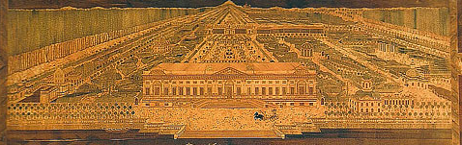 | The Note table, 1770s  It is ____________________exhibit in the museum collection.  The surface of the table is an inlaid _____________________  done of various kinds of ___________________________ and  representing _____________________________ in Kuskovo.  The work of ________________________________________ Nikifor Vasilyev. The signature of the master can be seen in a corner on the right.  ● the unique ● picture ● wood ● the park ● ●surf craftsman ●

Exercise 3: Describe the exhibit.
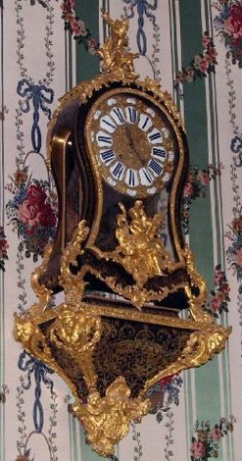 | The Wall clock, 1st half of the 18th century  ______________________________________________________  ______________________________________________________  ______________________________________________________  _____________________________________________________  ● craftsman ● workshop ● Andre Charles Boule ● tortoise-shell ●  ● is decorated with ● famous ● France ● clock case ●

Exercise 4: Describe the portrait using the words.
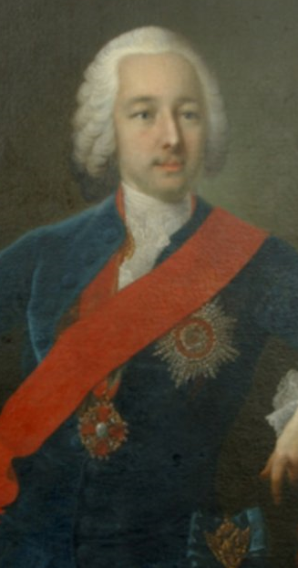 | The Portrait of Piotr Sheremetev  This canvas is one of museum’s masterpieces painted in _________ by ____________German ______________ Georg Christoph Groot. The portrait depicts the ___________________of this country house. It is the __________________ portrait painted _________________.  The sitter is represented as a charming ____________________ elegantly dressed in a___________________ with the red ribbon and the Order of _______________________. From the Sheremetev__________ .  ● the master ● blue suit ●St. Ann ● oils ● young aristocrat ● artist ●  ● famous ● from nature ● collection ●.ceremonial ●

Exercise 5 Describe the portrait
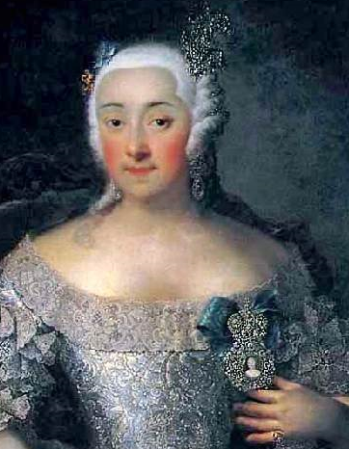 | The Portrait of Varvara Sheremeteva  ________________________________________________________  ________________________________________________________  ________________________________________________________  ________________________________________________________  ● charming ● G. C. Groot ● three quarter length ● young lady ●  ● of the master ● copy from the original ● wife ●

Exercise 6: Сhoose any picture in the Picture room. Describe the picture and offer to your friends to find it.

Useful phrases

portrait | the picture is executed  in bright (dark) tones | in the foreground
self-portrait | three quarter length | in the background
landscape | shoulder-length | to the left (right)  of the picture
still life | full-length | in the distance

