School ___________ Class________ Date ______________
Name _________________________Surname_____________________________

W O R K S H E E T А

Exercise 1: Read the description and find the name of the reception room.

The most elegant of the palace drawing rooms got its name from the bright pink color of its wall and furniture silk upholstery. _______________________________________

Exercise 2: Describe the exhibit using the words.
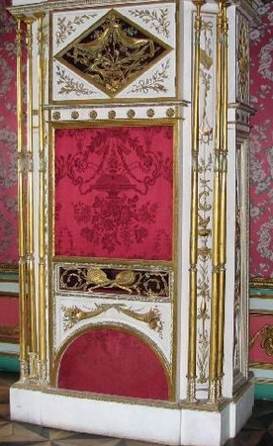I | O r g a n c h i k  It ts a musical instrument similar to a barrel organ ,  It plays 18th century melodies . The organ’s case is made from  wood in the workshop of the famous Moscow carver Pavel Spol.

Exercise 3: Describe the exhibit.
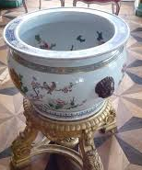 | A q u a r I u m  It is an aquarium similar to porcelain vase with drawing fish inside. Made in China.

Exercise 4: Describe the portrait using the words.
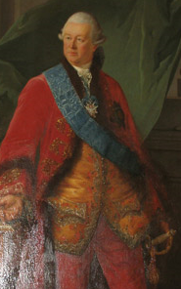 | The Portrait of Piotr Sheremetev, 1770-72.  This canvas is one of museum’s masterpieces painted in oils by  the famous French artist Nicholas Benjamin Delapierre.  The portrait depicts the master of this country house.  It is the ceremonial portrait painted from nature. In the  foreground of the picture the sitter is represented three quarter length  standing elegantly dressed in a red sui with the Order of the  St Andrew the highest award in Russia. From the Sheremetev’s  collection .

Exercise 5: Describe the portrait.
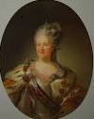 | The Portrait of Catherine II, 1779.  The portrait depicts the Empress Catherine II. It is a three quarter  length portrait painted in oils by unknown artist. It is the  ceremonial portrait with the attributes of power: the crown, the  Ermine mantle and the wreath laurel. From the Sheremetev’s  collection.

Exercise 6: Сhoose any picture in the Picture room. Describe the picture and offer to your friends to find it.
Useful phrases

portrait | the picture is executed  in bright (dark) tones | in the foreground
self-portrait | three quarter length | in the background
landscape | shoulder-length | to the left (right)  of the picture
still life | full-length | in the distance

