A Bird’s Life Cycle
A bird life begins within an egg. A special hard structure called the egg tooth forms on the baby bird’s beak to help it break the egg shell. This special tooth drops off a few days later.
A baby bird that has just hatched is called a hatchling. While the hatchling is growing in the nest and being fed by its parents we call it a nestling. When a nestling grows its flight feathers and is ready to leave the nest it takes its first flight or fledges. We call a bird that has just fledged a fledgling. A fledgling has fluffy down feathers and is often fed by its parents for several weeks more. Its flight feathers continue to grow and its wing muscles get stronger. When a fledgling or juvenile has finished growing it becomes a mature or adult bird.
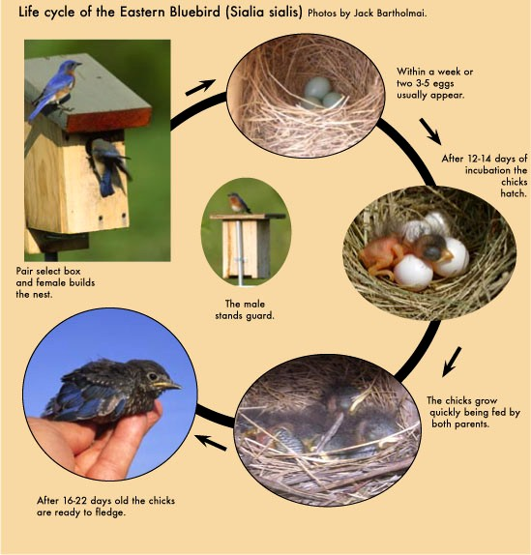
An adult bird attracts a mate, builds a nest and raises young to start the cycle all over again. Some birds migrate or travel long distances as part of their life cycle. Other birds stay in one area throughout the seasons.
Источник: Vickie Henderson «Discover Birds. Activity Book» 2012 TN Ornithological Society and Vickie Henderson http://www.tnwatchablewildlife.org/files/DiscoverBirds_1_Intro.pdf

