School ___________ Class________ Date ______________
Name _________________________Surname_____________________________
W O R K S H E E T А
Exercise 1: Culture vocabulary. Write the words under the correct picture.
● pilaster | ● coat-of-arms | ● tile | ● capital | ● candelabrum | ● porcelain
[pɪ’læstə] |  |  | [‘kæpɪtl] | [kændɪ’lɑ:brəm] | [‘poselɪn]

____________________ | _____________________ | ___________________
____________________ | 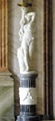  ______________________ | 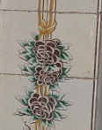  _____________________

Exercise 2: Match the two parts of the sentences below together.

Mural  Plafond  Grisaille | (French for 'grey') a term for painting, usually in shades of grey imitating of relief sculpture  a painting or other work of art executed directly on a wall /fresco, wall-painting/  (French for ‘ceiling’) monumental and decorative painting in the palace staterooms, /ceiling-picture/

Exercise 3: Culture vocabulary. Write the words under the correct picture.
● sconce | ● console | ● tapestry | ● chandelier | ● chest of drawers | ● girandole
[skɔns] | [‘kɔnsəul] | [‘tæpɪstrɪ]

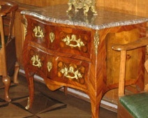  ____________________ | 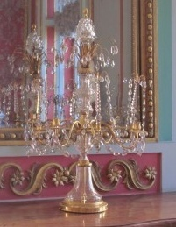  ______________________ | _____________________
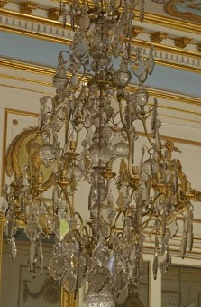  ____________________ | 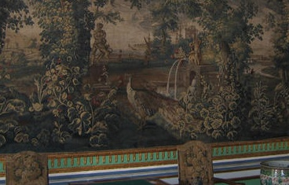  ________________________ | _______________________

Exercise 4: Write the words in the appropriate section of the table below.

● mural ● sconce ● chest of drawers ● candelabrum ● grisaille ● bureau ● plafond ● ●console ● still life ● crystal lamp ● sewing table ● self-portrait ● chandelier ●
Furniture | Lighting Devices | Painting

Exercise 5: Complete sentences with words and expressions from the box.
1. Kuskovo is ____________________________________of Count Pyotr Sheremetev.
2. Each room in the palace has its own ______________________________________
3. The museum was founded in ____________________________________________
4. Multicolored tiles stove demonstrate ______________________________________
5. The palace was not intended ____________________________________________
6. The State bedroom in the palace was built in imitation of ______________________ _____________________________________________________________in Versailles.
7. The Kuskovo palace combined ___________________________________________
8. The chandelier with crystal drops in the form of oak leaf is called ________________
9. The ballroom in Kuskovo resembles______________________________ in Versailles.
10. Monogram PS is _____________________________________________________
● the King’s chamber ● the initials in Latin of Pyotr Sheremetev
● for everyday life ●
●Hall of mirrors ● 1919 ● the European fashion and the Russian traditions ●
● name, purpose, size and color ● Leaf fall’ ● Russian traditions ●
● the summer countryside residence ●

