Humboldt Penguin
Geographical Range | Coastal regions of Peru and Chile
Habitat | Open ocean, rocky shoreline
Scientific Name | Spheniscus humboldti
Conservation Status | Threatened

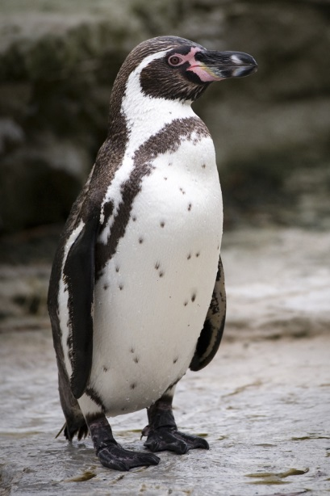

Very Current
Humboldt penguins share their name with the chilly Humboldt Current, which flows north from Antarctica along the Pacific Coast of South America, where the birds live. Both birds and current are named after the 18th-century explorer Alexander von Humboldt.

Black and White and Pink All Over
Humboldts are medium-sized penguins, averaging 28 inches long and weighing about 9 pounds. You can recognize them by the black band of feathers across their chest. Females are slightly smaller than males, but otherwise look very similar.
Humboldts have added another color to the plain black and white of other penguins: pink! They have splotchy pink patches on their face and feet, as well as the underside of their wings. Actually, the pink doesn't come from their feathers: it's the result of bare skin patches, an adaptation that helps keep the birds cool in a warmer climate.
Penguins' torpedo-shaped bodies are designed for moving efficiently through water. Humboldts can reach speeds of 30 miles per hour. They use their wings to help them swim, and their webbed feet to steer underwater. Their bones tend to be denser than those of flying birds, since the extra weight helps them dive to greater depths.

Fish on the Menu
If you don't like eating fish, you wouldn't like being a Humboldt penguin! Their favorite food is anchovetta, small fish that thrive in the cold waters off the South American coast. Unfortunately, humans also fish for anchovetta, which they harvest to make bone meal for animal feed. So Humboldts suffer from the competition posed by the numerous fishing boats that visit their home waters.
Humboldts also eat squid and crustaceans (like shrimp and krill). They don't have to drink water, since they take in seawater as they swallow their prey. But like all penguins, they have a special gland that removes salt from their bodies after they swallow saltwater.

To See in the Sea
The underwater world requires different eyesight than the one we're used to. So penguin eyes are sensitive to the colors of the sea − violets, blues, and greens. Their eyes also have a second transparent eyelid, serving as «goggles» while the animal is underwater.

They Nest in What?
Humboldts penguins have developed a unique place to lay their eggs − they dig them into the layers of dried guano (poop) left from seabirds! (Because of the dry climate, guano from generations of birds can build up many feet deep.) Sometimes they also nest in rocky crevices.
The birds breed throughout the year, though breeding seems to depend on the availability of food and nesting sites. The male arrives at a site a few days before the female and prepares the nest burrow. He uses his wings and feet to push and mold the guano into the shape he wants, then gathers soil, rocks, and sometimes grasses to finish it off.
After mating, the female lays two white eggs. Both parents take turns sitting on the eggs until they hatch, usually in about 39 days. The pair also works together to feed the chicks.
Sadly, the breeding habits of the Humboldt penguin are being disrupted by human activity. Because guano has value as a fertilizer, miners in South America harvest it down to the bare rock, leaving many coastal areas scraped clean. Humboldts are left with nothing to burrow into, so they hatch far fewer babies.

An Uncertain Life
It's not easy being a Humboldt penguin: the birds face a number of natural and man-made hazards. In the ocean, leopard seals, fur seals, sea lions, sharks, and killer whales all prey on Humboldts. On land, their eggs and chicks can fall victim to foxes, snakes, and introduced predators like cats and dogs.
Weather conditions also pose problems. When the El Nino climatic effect raises the temperature of the sea, it reduces the penguins’ food supply.
Humboldt penguins also face a number of threats from humans, due in large part to the productive areas they inhabit. Commercial fishermen are attracted to the highly fertile Pacific waters off South America, where rich nutrients support large fish populations. Their activities not only deplete the Humboldts' food source, but also kill large numbers of penguins that become entangled in fishing nets.
Humans also hunt Humboldts for food, and take eggs from breeding sites. Add to that the effects of guano harvesting, and there's little wonder these penguins are in trouble.

Hope for Humboldts
While the numbers of Humboldt penguins have been declining since the mid-19th century, many people are working to reverse that trend.
Since 1995, Chile has had a 30-year ban on the hunting and capture of Humboldts, and four of the major breeding colonies are protected. Humboldts in Peru have benefited from guano reserves, where the birds can make their nests. Guano mining in the reserves is limited, and those who do mine must sign a contract to protect the penguins. The Saint Louis Zoo has sent staff to help monitor the mining in the reserves, and is taking other conservation efforts to save these birds (see side story).

Fun Facts
- Did you know Humboldt penguins can blush? When they get too hot (it can get up to 108 degrees (F) where they live) they have to avoid over-heating. So they flush pink on their face, wings and feet. This sheds body heat by sending blood to the bare part of their bodies.
- Throughout the day, Humboldts engage in a vital activity: they preen their feathers. They gather oil from their preening gland and apply it to their feathers and the edges of the flippers. This keeps their feathers waterproof, helping insulate the birds from the cold.
- Like all penguins, a Humboldt's black and white color helps camouflage it when it's in the sea. When seen from below, its white belly blends with the light cast on the ocean surface; and when seen from above, its black back blends with the darkness of the ocean depths.
Class:Aves
Order:Sphenisciformes
Family: Spheniscidae
Источник: https://www.stlzoo.org/animals/abouttheanimals/birds/penguins/humboldtpenguin

