Worksheet 1
- Complete the sentence. Every second letter in the clue will give you the missing word.
d | o | a | r | m | n | o | i | s | t | o | h | p | o | k | l | j | o | f | g | b | y

The science that studies birds is ________________________________

2. Birds are different from other groups of animals. What makes a bird different from other animals?
1. Is it because birds can fly? Yes / No
Can other animals fly? Yes / No
What animals? ________________________________________________________
2. Is it because birds can build nests? Yes / No
Can any other animals build a nest? Yes / No
What animals?________________________________________________________
3. Is it because birds lay eggs? Yes / No
Can any other animals lay eggs? Yes / No
What animals?________________________________________________________
4. Is it because birds have a bill or beak? Yes/No
Do other animals have feathers? Yes / No
What animals? ________________________________________________________
5. Is it because birds have feathers? Yes / No
Do other animals have feathers? Yes / No
What animals?________________________________________________________
What is a bird? Give the definition.
_______________________________________________________________
- Match the words head, eye, beak/bill, wing, tail, claw, foot, breast, back, toe with the parts of the body.
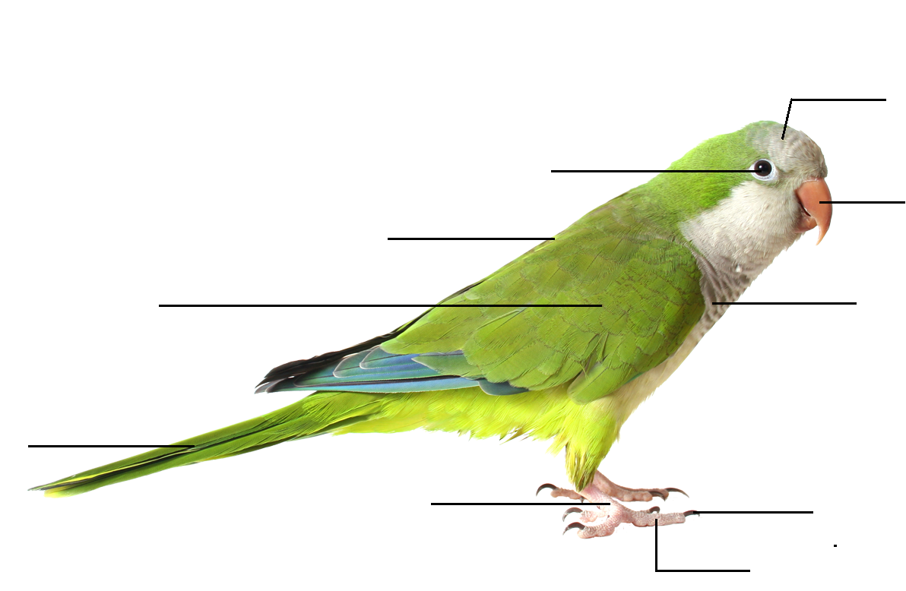
- Feet аre adapted to help birds get their food and allow them to move around when they do not fly. Look at the pictures and find the birds in the pavilion. Take photos and insert them into the chart.
 | BIRD NAME  (Russian and English) | PHOTO
Climbing foot
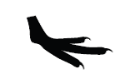
Running foot

How can bird’s feet tell about what the bird eats and where it lives?
____________________________________________________________________
- Compare two birds from the previous exercise.

SIMILARITIES

NAME_______________ NAME ___________________

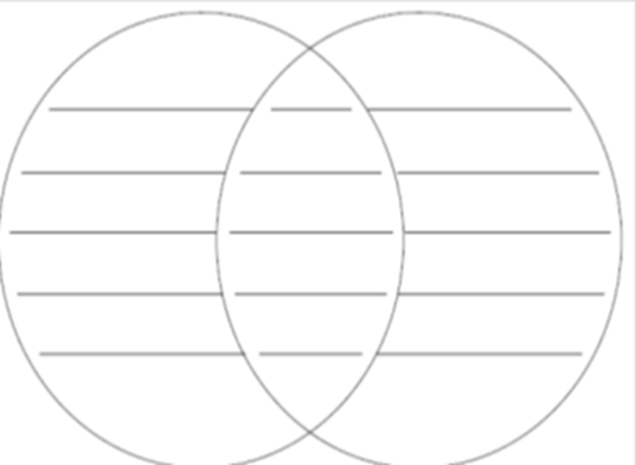

- Complete the chart by matching a colour to a bird that shares the same colour. Take photos and insert them into the chart. Give the additional information about the birds.
COLOUR | ORANGE | GREEN | INDIGO | BROWN
PHOTO
BIRD NAME
(Russian and English)
SIZE

WEIGHT

NUMBER OF YOUNG

FOOD

HABITAT

DISTRIBUTION

Where do these birds live? On the map, color the geographic range of the birds.

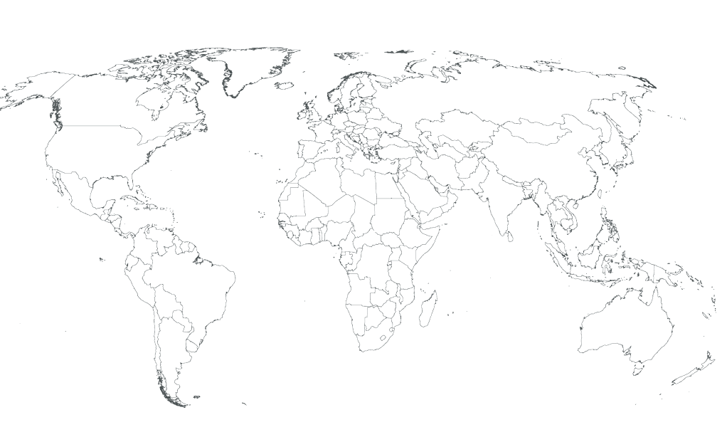

- Team up with the student from the group 2 and create your own brochure devoted to the birds of Moscow Zoo using the information from the Tasks

