Case

Look at these road signs which you can see on the roads of Britain.
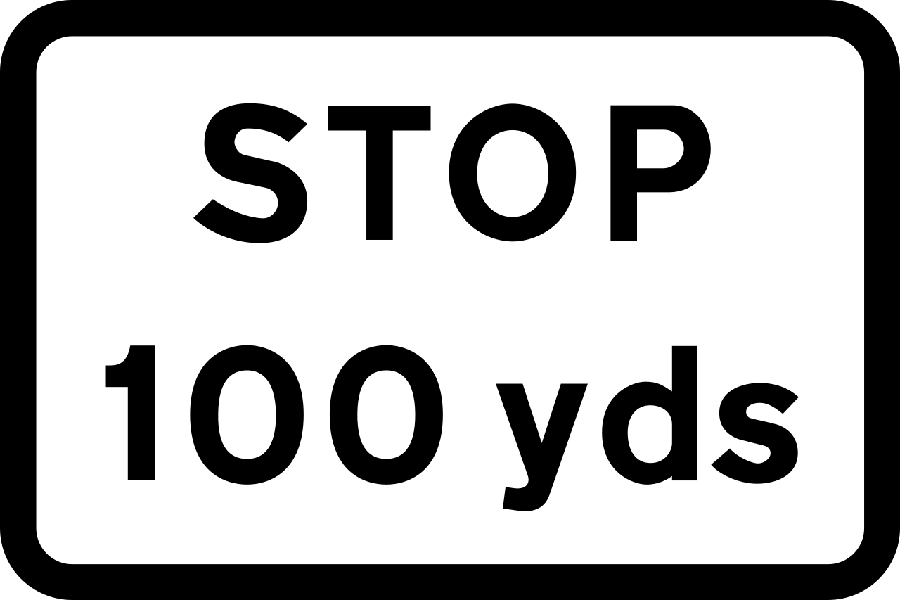

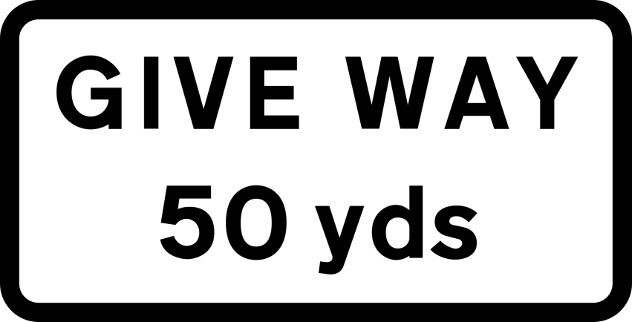
What does "yds" mean? What must the driver do when he sees these signs?
Convert 100 yards and 50 yards to metres (1 yd is 0,9144 m).
____________________________________________________________________________________________________________________________________

