Cheetah
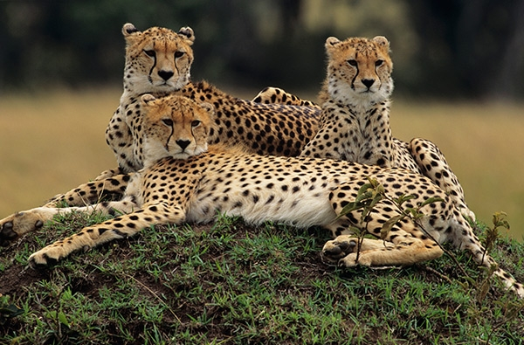
Learn more about the cheetah by reading these fun cheetah facts. Cheetahs are part of the big cat family and while they can’t climb trees, they can run faster than any other land animal. Read on for more interesting cheetah information.

Scientific Name: Acinonyx Jubatus
Class: Mammalia
Order: Carnivora
Status: Endangered
Population numbers: Estimated to be less than 10,000 remaining in the wild.
Region: Found in 23 of the 26 countries of Africa plus a small population lives in Iran. Namibia, Africa has the largest population of cheetahs. Cheetahs live on African savannas and grasslands.
The cheetah is the fastest land animal in the world. They can reach a top speed of around 113 km per hour.
A cheetah can accelerate from 0 to 113 km in just a few seconds.
Cheetahs are extremely fast however they tire quickly and can only keep up their top speed for a few minutes before they are too tired to continue.
Cheetahs are built for speed with their lean bodies, long legs, and narrow heads. Cheetahs are smaller than other members of the big cat family, weighing only 45–60 kilograms.
Cheetahs have non-retractable claws with hard pads on the bottom of their paws that give them a strong grip on the ground for running.
The cheetahs black spots help them blend into the savannas. Cheetahs have 2000 to 3000 spots. That’s A LOT of spots!
Cheetahs have black lines known as "tears" near their eyes that run down the side of their nose that help to block the sun's bright glare. These black markings are also believed to enhance their snarl when defending their territory.
Cheetahs are the only big cat that cannot roar but they make chirping sounds to communicate with each other. This sounds somewhat like a bird chirp. They can purr and usually purr most loudly when they are grooming or sitting near other cheetahs.
While lions and leopards usually do their hunting at night, cheetahs hunt for food during the day.
A cheetah has amazing eyesight during the day and can spot prey from 5 km away.
Cheetahs cannot climb trees and have poor night vision.
With their light body weight and blunt claws, cheetahs are not well designed to protect themselves or their prey. When a larger or more aggressive animal approaches a cheetah in the wild, it will give up its catch to avoid a fight.
Cheetahs only need to drink once every three to four days.

Cheetahs can live seven to ten years in the wild and up to 16 years in captivity.

Источники: http://www.sciencekids.co.nz/sciencefacts/animals/cheetah.html;
http://www.cheetahkids.com/images/Cheetah_Fast_Facts.pdf

