Worksheet
- Define which of the following statements are TRUE (T), and which are FALSE (F), and you will learn the word to complete the text.
Statements | T | F
1. Birds are the only living animals that have feathers. | P | S
2. All birds fly. | P | E
3. All birds have two wings. | N | A
4. Birds lose and replace their worn or damaged feathers. | G | R
5. All birds lay eggs. | U | R
6. Most birds eat worms. | O | I
7. All birds are warm blooded. | N | W

- Fill the gaps using the word from the previous exercise. Put the word in the plural form where it is necessary.
______________ are among the most popular of all birds. They only live in and around the South Pole and the continent of Antarctica. No wild __________ live at the North Pole. There are many different kinds of ___________. The largest ___________is called the Emperor Penguin and the smallest kind of __________ is the Little Blue __________. There are 17 different kinds of ____________ in all and none of them can fly. ___________ have to be able to survive in the some of the Earth's coldest and windiest conditions. They are great swimmers and have thick layers of fat to protect them from the bitter cold. Even in their freezing cold habitats, _______________ still have to watch out for predators such as killer whales and seals.
- Find the birds from the previous exercise in the pavilion.
Take photo of the enclosure.
- Where do the Humboldt penguins live? On the map color the geographic range of the birds.
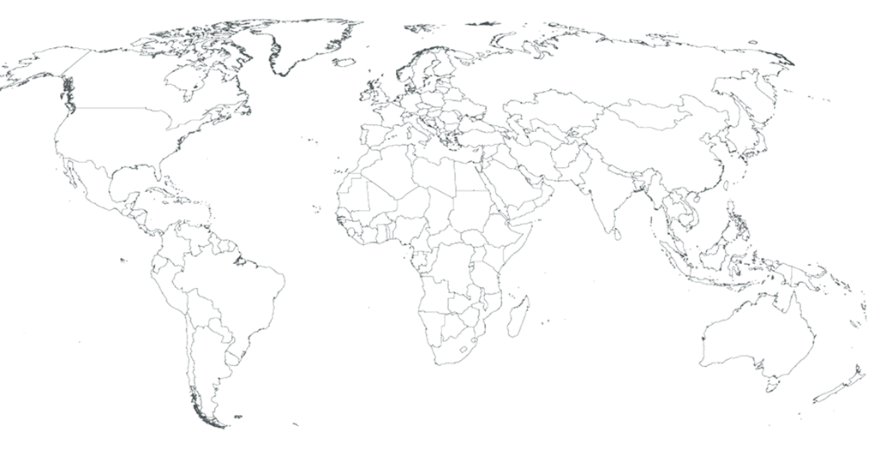
- Match the words head, eye, flipper, webbed foot, beak, claw, tail, neck, belly with the parts of the body.

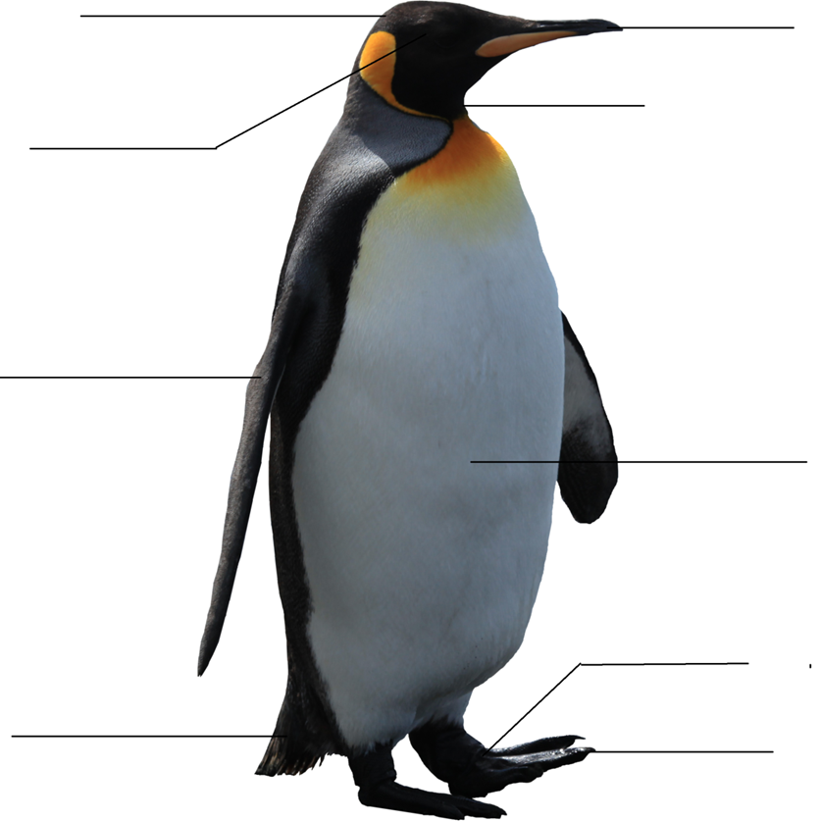

- To complete the life cycle of the penguin put the photos in correct order:
______________________________________________________________
1 | 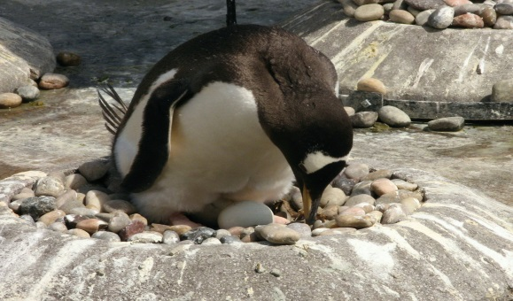
2 | 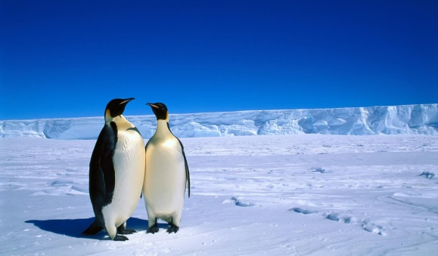
3 | 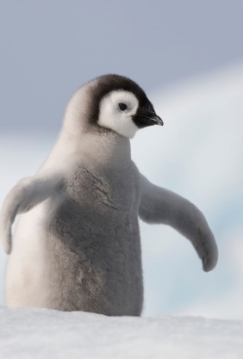
4 | 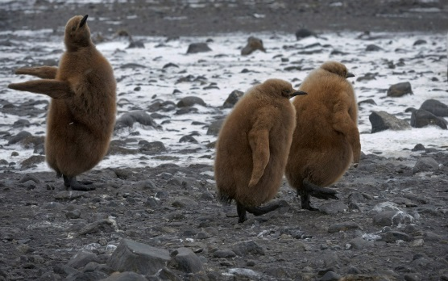
5 | 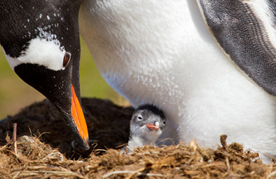
6 | 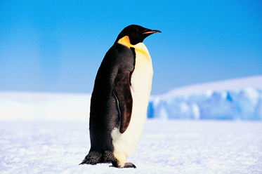

- a) Draw the map of the penguin’s enclosure on the grid below. Show landmarks like the land space, the pool for swimming and bathing, paths, rocks, nest boxes, caves, hiding places and etc.

b) Answer the questions.
How does the enclosure design allow the Penguins to show natural behaviour?
___________________________________________________________________
How does the enclosure design allow for good viewing for the visitors?
____________________________________________________________________
- Do the task.
How many penguins can you see?___________________________________
Pick a penguin to observe in the enclosure. Give your penguin a name. ____________________________________________________________________
Observe your penguin for 10 minutes. Every 2 minutes record the time and write down what your penguin is doing. You can use the following verbs: swim, sit, fight, sleep, build a nest, jump, eat, preen, toboggan, rest, vocalize.

Time | Observation (What is the bird doing?)

How does this penguin interact with other penguins?
________________________________________________________________________________________________________________________________________
- The penguins have a number of features that are adaptations.
- Why do the penguins have torpedo-shaped body?
_________________________________________________________________
- Why do the penguins have wings modified as flippers?
__________________________________________________________________
- Why do the penguins have webbed feet?
__________________________________________________________________
- Why do penguins have black backs and white bellies?
__________________________________________________________________
- What do the penguins eat?
Tick the right photo.

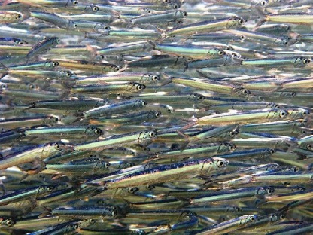 |  |  | 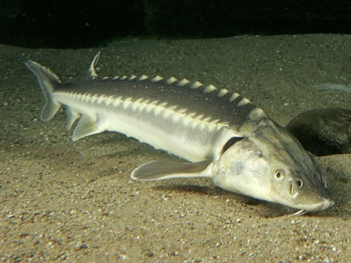 |  |  | 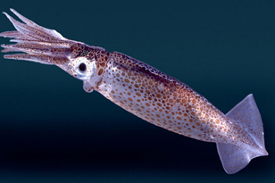
 | anchovies |  |  | sturgeon |  |  | squid
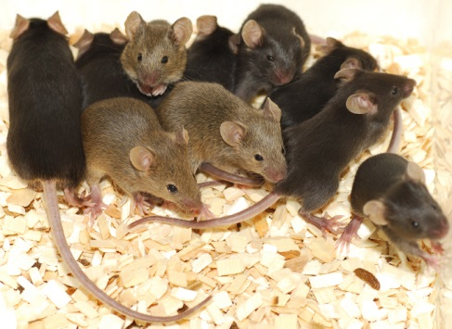 |  |  | 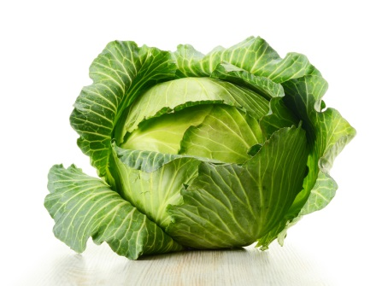 |  |  | 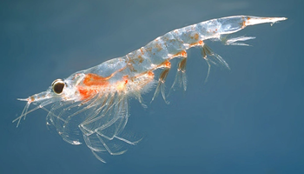
 | mice |  |  | cabbage |  |  | krill

- Fill in the chart given below with the information about the Humboldt Penguin
Scientific Name | Aptenodytes forsteri
Name | Emperor Penguin | Humboldt Penguin
Image | 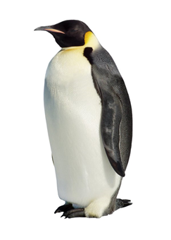
Height | 115 cm
Weight | 30 kg
Diet | krill, fish and squid
Special markings | dark black feathers on head
Number of young | one
Geographical Range | Antarctica
Habitat | the ice or in the surrounding waters of Antarctica

- Compare two penguins from the previous exercise.
________________________________________________________________________________________________________________________________________________________________________________________________________________________________________________________________________________

- Match the words leopard seal, polar bear, killer whale, sea lion, giant petrel with the right photo.
Do all of these predators hunt the penguins? If not why?
________________________________________________________________________________________________________________________________________

1. | 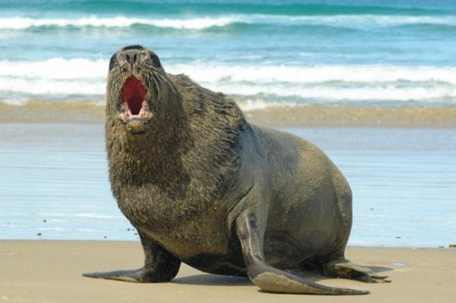
2. | 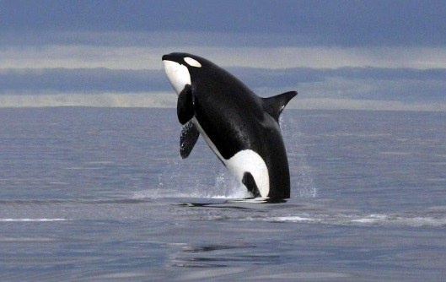
3. | 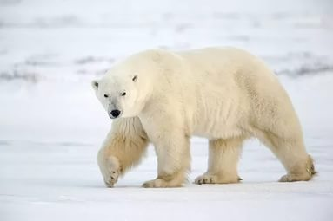
4. | 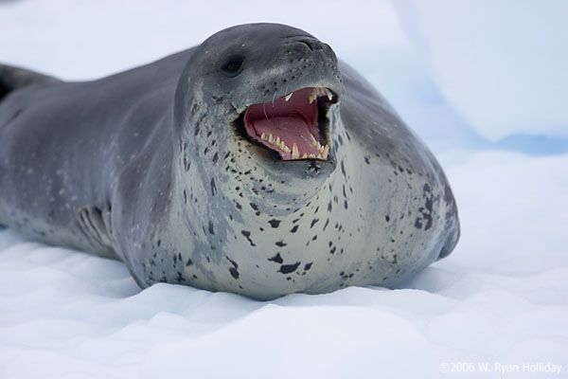
5. | 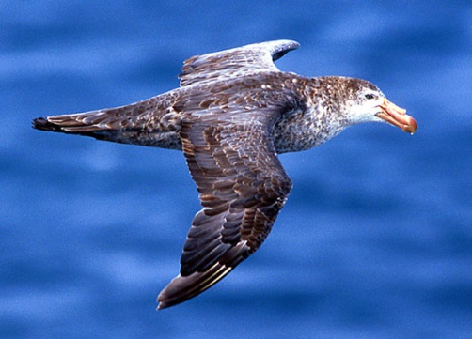

- Using the information of the worksheet create the calendar «The year of the penguins».

