The Penguin Life Cycle
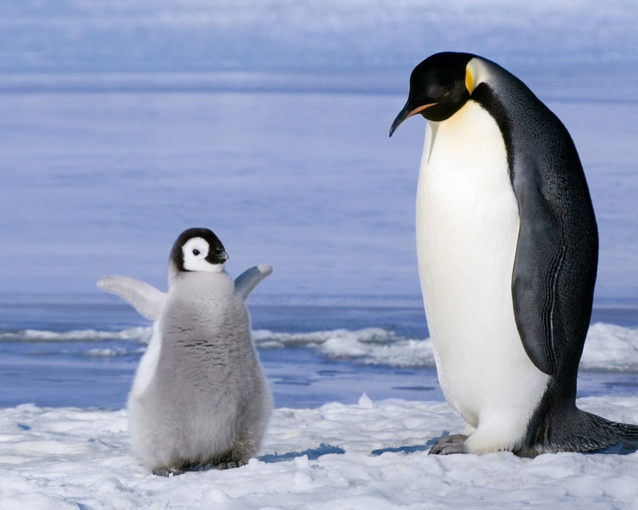
Most penguins breed every year in the spring or summer. Courtship is a time when the male penguins try to impress the females. The work to win a mate begins with trumpeting. The male swings his head and struts around an area he has chosen as a nest site. Then he calls out loudly and might flap his flippers to attract attention from the females. After he has a female’s attention, both male and female penguins perform a type of dance. It is called a mutual display. Both penguins bob and stretch their necks while calling out noisily. The final stage of courtship is known as bowing. At least one of the penguins bends its beak toward the other bird’s feet or the nest site. Male penguins will sometimes offer small rocks or other nesting materials as gifts. The penguins will also groom or preen each other. Together, the penguins build a nest made of pebbles, stones, plants, or form holes in the ground. One or two eggs are laid soon after the female chooses her mate. In order to hatch, the eggs must be kept warm. This process is called incubation. Some species take turns incubating the eggs. Once a chick is ready to hatch, it chips away at the shell with its beak. Hatching is difficult work and can take up to three days. When the chick hatches, it is covered by brown, black, white, or gray down. Penguin chicks are not waterproof. They rely on their parents to hunt for food in the water. A penguin parent swallows and digests its catch. Then it regurgitates the food for the little penguin. Adults recognize and feed only their own chick. Parents are able to identify their chick by its distinctive call. Between 7 weeks and 14 months, the chick grows adult feathers. Then it can care for itself. If a chick survives until adulthood, it will probably live a total of 15 to 20 years.
Источник: Tammy Kennington «Penguins», Cherry Lake Publishing, USA

