Let’s talk about the war

Фамилия, Имя ___________________________________________________________________

Схема движения группы:

Зал Полководцев (The Hall of Commanders) – Зал Памяти и Скорби (The Hall of Memory and Sorrow) – Зал Исторической Правды (The Hall of Historical Truth) – Диорама «Курская битва» (The “Battle of Kursk” Diorama).

Зал Полководцев (The Hall of Commanders)

№ 1. The Hall of Commanders displays busts of military leaders (sculpted by Zurab Tsereteli) and their biographies.
Read the marshals' biographies and match the headings with the names of the commanders. One heading is extra. Complete the table.

1. He graduated from a military school and academy and commanded the Leningrad Front.
2. He took part in the liberation of Prague and received the Hero of a Foreign Country award.
3. He graduated from a military school and successfully fought against Japan.
4. He took part in WWI and WWII and commanded the Victory Parade in 1945.
5. He took part in many wars and was decorated with three Orders of Victory.
6. He received the Hero of the USSR award four times.
7. He was responsible for providing military advice to a foreign country.

Zhukov Georgi Konstantinovich  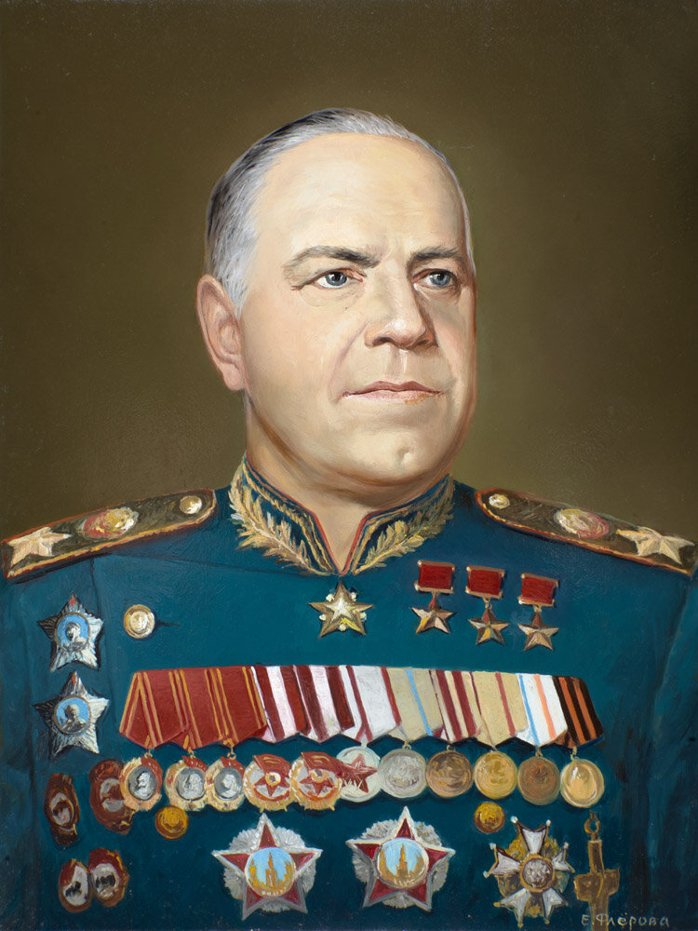 | 6 | Vasilevskiy Aleksandr  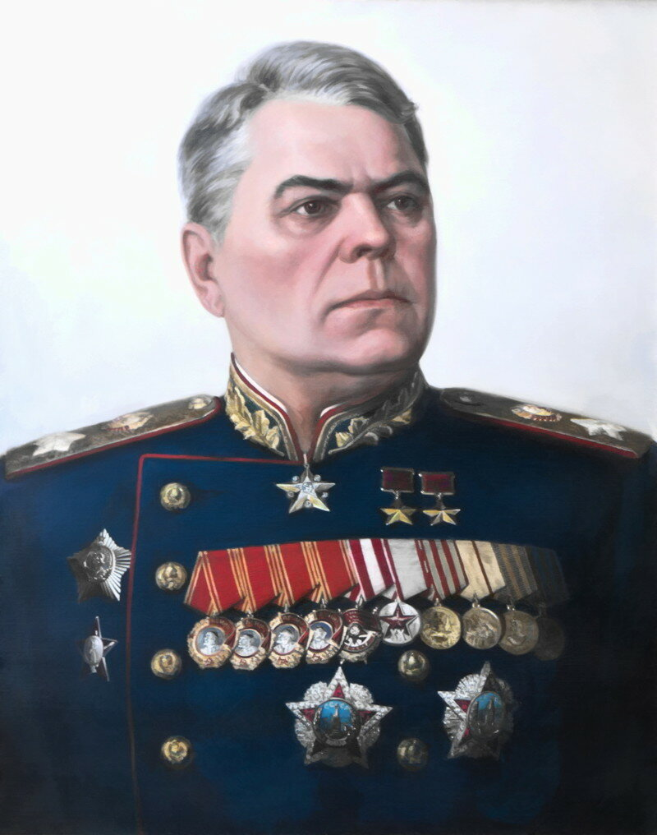  Mikhailovich | 3
Koniev Ivan  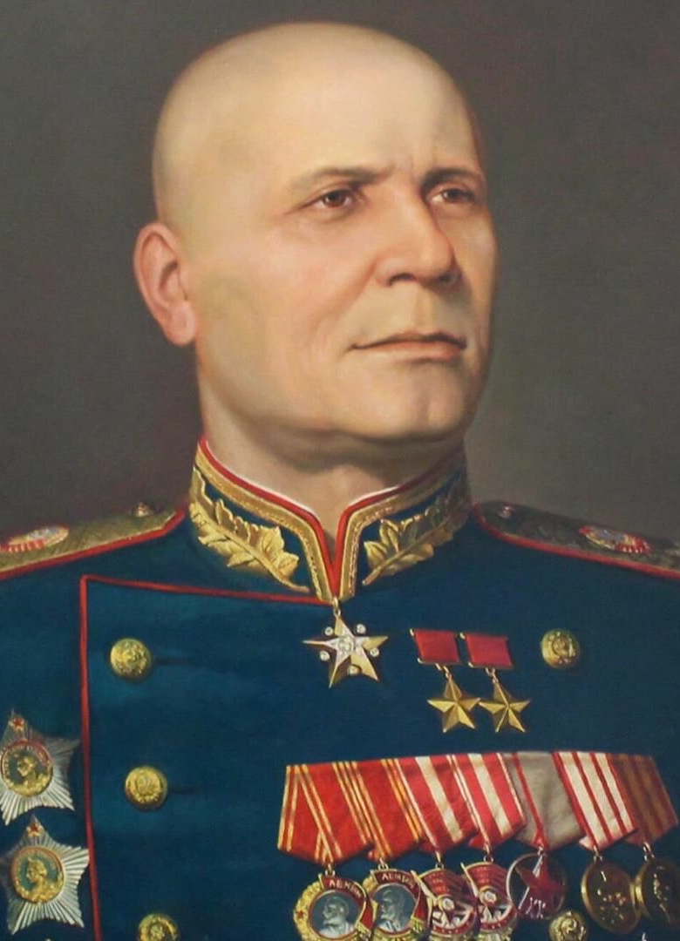  Stepanovich | 2 | Govorov Leonid  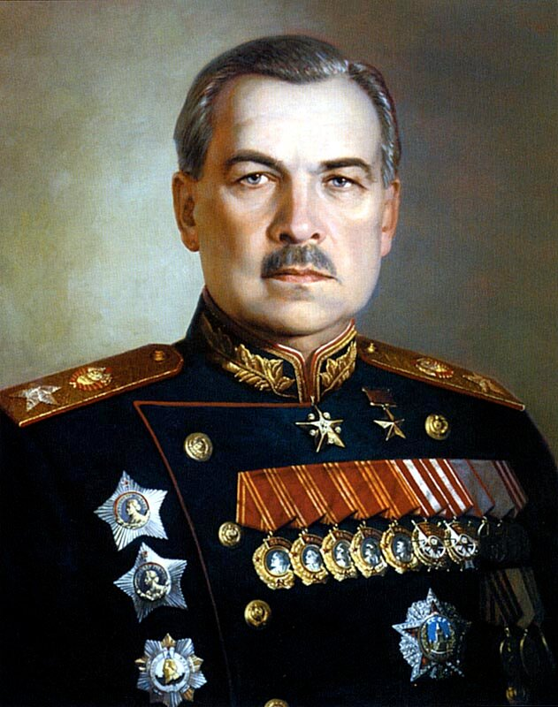  Aleksandrovich | 1
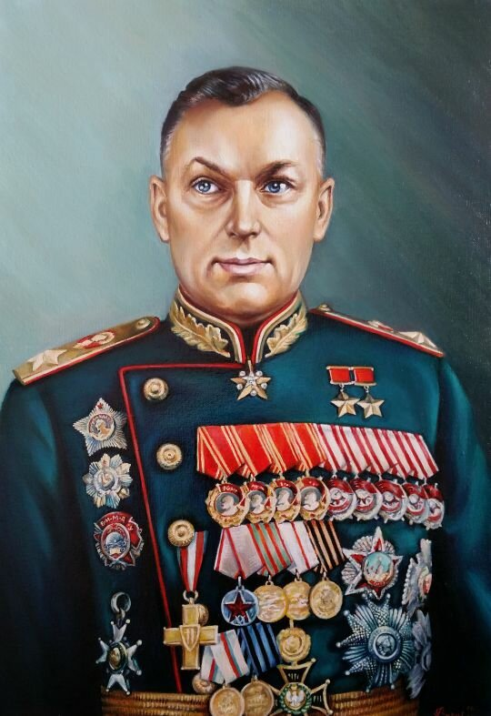  Rokossovsky Konstantin Konstantinovich | 4 | 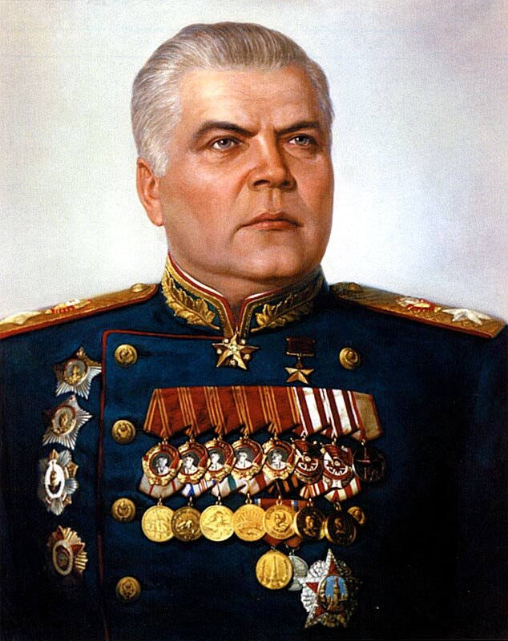  Malinovsky Rodion Yakovlevich | 7

Зал Памяти и Скорби (The Hall of Memory and Sorrow)

№ 2. Read the text about the Hall of Memory and Sorrow. Use the word at the end of each line to form a new word that fits into the gap.

1 | The Hall immortalizes almost 27 million Soviet PEOPLE who perished defending our Motherland in the years of the Great Patriotic War 1941–1945. | PERSON
2 | The sculptural composition in the Hall is named “Sorrow”. The image of the woman symbolizes all the mothers, WIVES, sisters and daughters | WIFE
3 | mourning for their husbands, brothers and sons KILLED in the war. | KILL
4 | The sculptures ARE CARVED from Koyelga white marble mined in the Urals, Chelyabinsk region. The author of this piece of art is the sculptor, Hero of Socialist Labor People’s Artist of the USSR, L.E. Kerbel. | CARVE
5 | The showcases exhibit the “Books of Memory” with the names of soldiers who perished fighting for the Motherland, DIED in hospitals, | DIE
6 | went missing, as well as those who lost THEIR lives in captivity during the war. | THEY
7 | Under the ceiling there are 2,600,000 bronze pendants with crystal “tears” SYMBOLIZING sorrow for the perished. | SYMBOLIZE

№ 3. Look through the collection of weapons in the images. Find them in the museum exhibition and write their names in English.

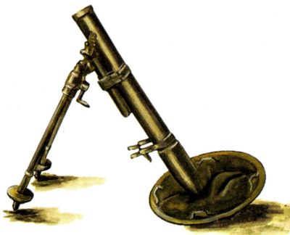 | 120-mm regimental mortar (PM-38, model of 1938)
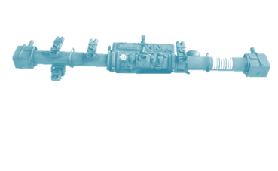 | Artillery rangefinder (KDO Mod.40 w/Sd.Anh 52)
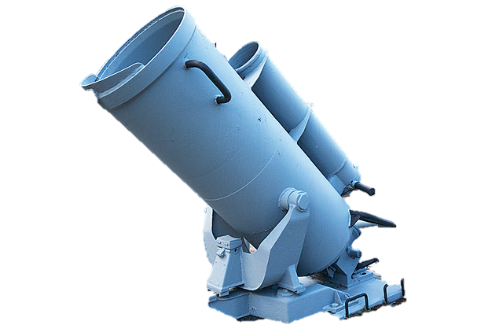 | Anti-submarine mortar with a depth charge
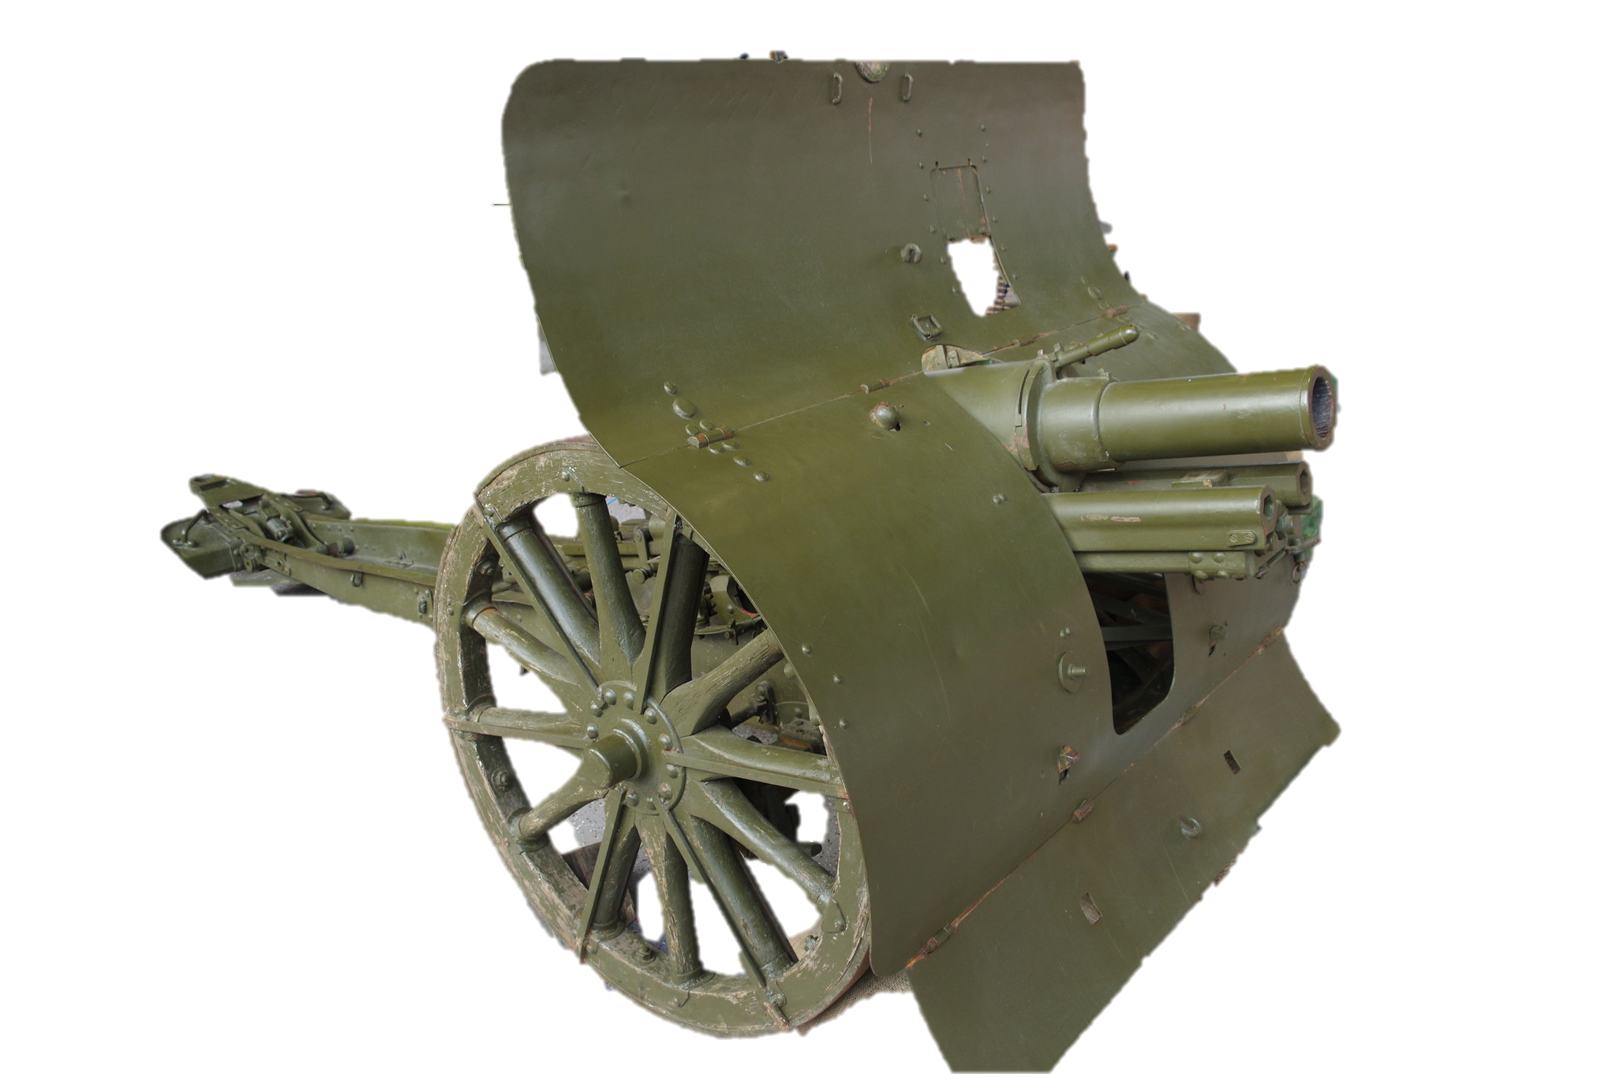 | 76-mm mountain gun M1909 with a limber
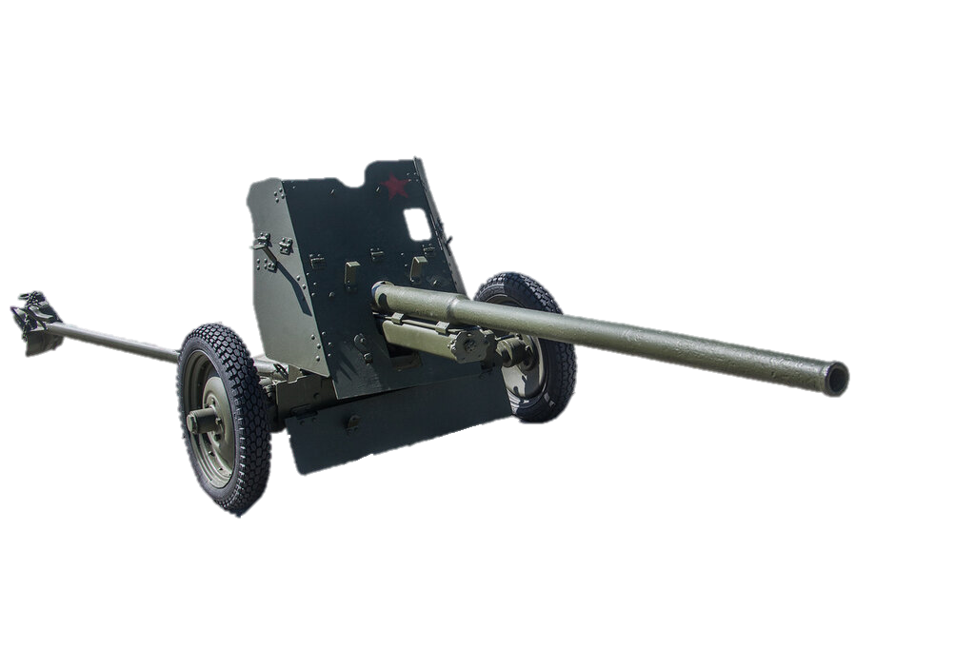 | 45-mm anti-tank gun M42, (model of 1942)

Зал Исторической Правды (The Hall of Historical Truth)

№ 4. In 2018 the president of Russia, Vladimir Putin, sent greetings to the participants and guests of the opening ceremony for the Hall of Historical Truth at the Victory Museum.

Read the text “Feat of the Army”. Use the word at the end of each line to form a new word that fits into the gap.

1 | “The country must have its heroes, and people must know them. These have to be a guiding REFERENCE, | REFER
2 | an example through which today’s GENERATION could be brought up and raise their children.” Vladimir Vladimirovich Putin | GENERATE
3 | The “Feat of the ARMY” exhibition of the Victory Museum is dedicated to all people who toiled for the future victory shoulder to shoulder during | ARM
4 | the four WARTIME years and spared no effort on the frontline as well as in the rear. | WAR
5 | COMMANDERS and soldiers defending their military positions to the last bullet, partisans fighting the enemy in occupied territories, doctors and nurses saving the wounded, all who took up arms… | COMMAND
6 | Each of them SEPARATELY and all of them together were bringing the Great Victory closer. | SEPARATE

№ 5. Look through the poster “The Red Army Liberation Mission” and compare the losses of the Red Army during the liberation of several European and Asian countries.

Fill in the gaps with the words and numbers from the box to complete the description of the chart.

China, Czechoslovakia, Korea, Norway, Poland, 691, 26000, 140000
Looking at the figures, we can see that the largest number of people, 600,000, were killed defending Poland, followed by Hungary with 140,000 and Czechoslovakia with 139,000. The lowest number of casualties, 691, occurred during the liberation of Korea. China witnessed almost the same number of casualties as Yugoslavia.
The battles for Norway and Austria took as many as 3,500 and 26,000 lives, respectively.

Диорама «Курская битва» (The “Battle of Kursk” Diorama)

№ 6. Group 1. Describe the pictures given. Remember to depict the action and location as well as the foreground and the background. You have 2 minutes to prepare.
Group 2. Think about the following features and find the pictures connected with them:
1) different types of troops contributing to defeating the enemy; emphasise their importance in winning the war;
2) the hardships of the civilian population during the war;
3) the cruelty of the war;
4) the heroes of the war;
5) the officers in charge;
6) the partisan detachments.
Students of the first group describe the pictures; Students of the second group match the pictures to their features and comment on them.
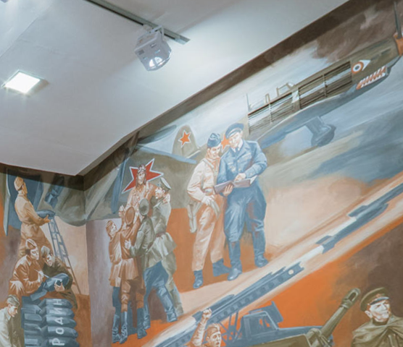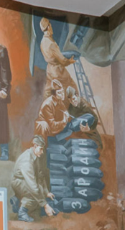

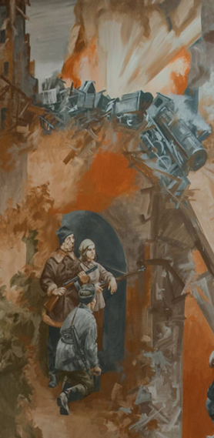
- Everybody knows that aviation played a great role during the war. It helped the land forces to feel safer. In this picture you can see a group of war pilots who are busy equipping their planes for battle. The officers in charge are discussing the flight plan. Some pilots are writing patriotic words on the shells which they are going to use to strike the enemy. The words are “For the Motherland!” These words gave many soldiers the courage to attack the enemy by reminding them that they were saving their relatives and friends.

- In this picture you can see members of a partisan detachment destroying bridges to prevent the Nazis from transporting tanks, soldiers and ammunition. Partisans risked their lives helping the army to move forward. But for their deeds, there would have been far more casualties in the army.

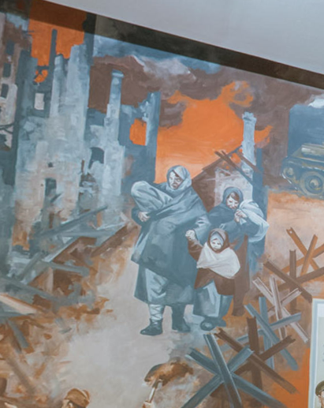

- In the picture you can see refugees who lost their homes during the war. It is well known that the civilian population suffered as much as those in the armed forces. Women and children left their homes and lived in forests or earth huts. But they wrote letters to their husbands, sons and brothers, trying to cheer them up. Such letters helped soldiers to overcome all the hardships of the war. In the background you can see buildings in ruins. This was a usual sight after battles. It took decades to restore houses and return to a peaceful life.
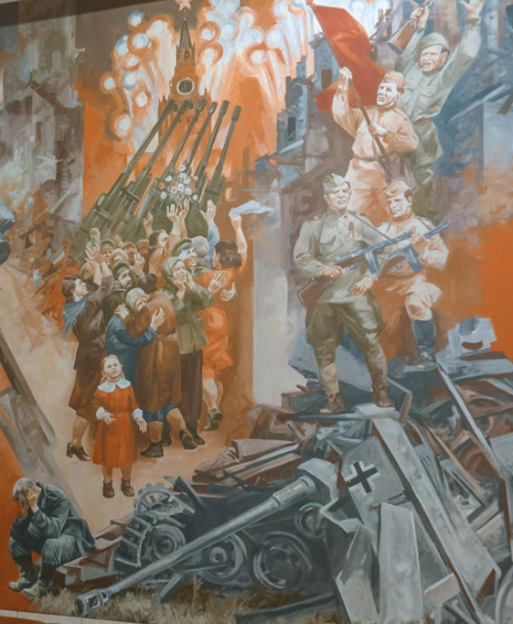

- In this picture you can see a historical moment celebrating the victory of The Battle of Kursk. In the foreground you can see the of Moscow’s Kremlin and colourful fireworks to celebrate the victory. The picture symbolizes the unity of the country and mutual happiness.
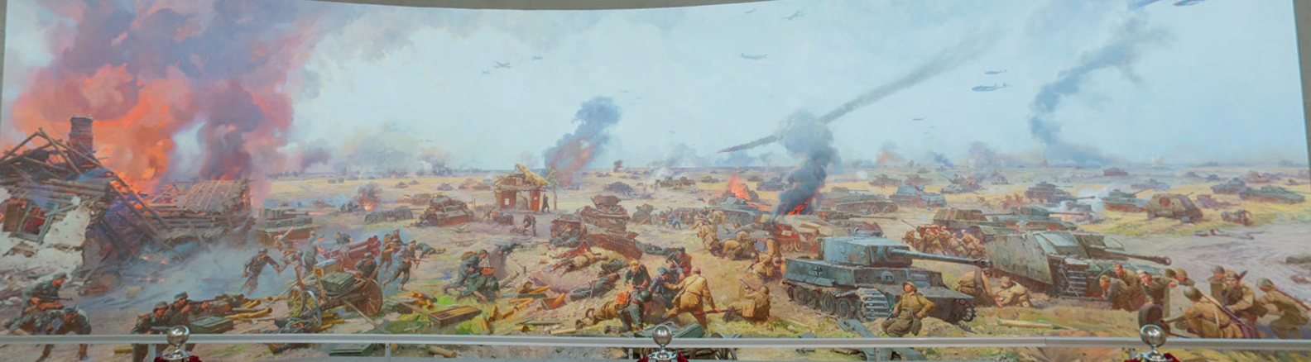

- In this picture you can see a battlefield near Kursk. Here took place a famous tank battle. You can see scattered machine guns and tanks. It is possible to see one of the legendary T-34 tanks which played a great role during the war. We can also see combat lifesavers risking their lives to rescue a wounded soldier. In the sky you can see planes which contributed to the victory. Thanks to the cooperation of all types of forces, it was possible to defeat the enemy.

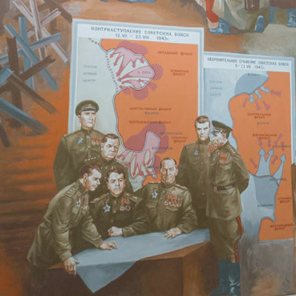

- In this picture you can see a group of officers discussing an important battle near Kursk. They are wearing a special uniform. We can see that they are decorated with many orders and medals. Some of them have a Hero of the Soviet Union star. They look thoughtful but determined. They have already received important information on the Nazis’ plans. In the background you can see maps which show the location of armies and fronts. Soviet officers did all they could to win a great victory.
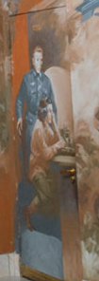

- In this picture you can see an intelligence agent and a Morse code transmitter. The name of the intelligence agent is Kuznetsov. He looks very worried, as it was important for him to send the information as soon as possible. He is a legendary person who managed to learn secret information about the Nazis’ plans to attack. Thanks to his feat it was possible to win the Battle of Kursk, because the Nazi attack was expected. The contribution of intelligence agents was enormous, as they helped to find out the enemy’s plans.
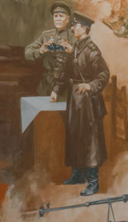

- Look at this picture. In the foreground you can see two officers. They look worried and concentrated. They are wearing special uniforms. One of them is wearing a Soviet military tunic while the other is wearing a uniform jacket. They both have peaked caps on their heads. The man in a military tunic is holding binoculars to watch the enemy.

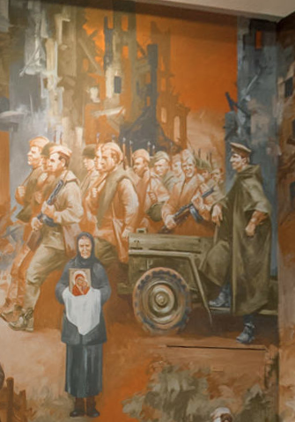

- Look at this picture. In the foreground you can see an elderly woman with an icon. She is meeting soldier-liberators. She is wearing dark clothes consisting of a long dress, a jacket and a kerchief traditional for Russian women of that time. Such women inspired soldiers to defend the Motherland. They also tried to save soldiers by praying for them. In the background you can see a group of soldiers advancing in rows. They are wearing Soviet military uniforms and are holding weapons. They look brave and strong. You can also see their officer in charge. He looks very concentrated.

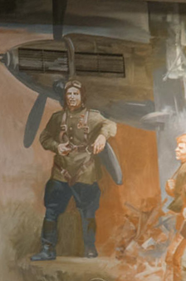

- Look at this picture. In the foreground you can see a pilot. He is wearing a special uniform consisting of a Soviet military tunic, an aviation helmet and a special harness. In the background you can see an airplane. It is obvious that the pilot is very skilled and has taken part in many battles. Victory in the Great Patriotic War would have been impossible without the enormous role of aviation.
Case
Imagine that you are a soldier. You have just received a letter from Pioneers from Smolensk. Here is part of the letter:
We are helping our parents to work at plants and restore ruined houses. We are also trying to do our best to study well. We knitted these mittens for you. We hope they will remind you of your home.
Will you tell us about the last battle you took part in?
Write a letter to the Pioneers and tell them about your feelings after the Battle of Stalingrad. Tell them about your pride, frustration and the bitterness of the losses.

