Case task. Most of the British football clubs have nicknames besides their official names. Match the nicknames with the football clubs. Fill in the table.
Nicknames: The Blues, the Peacocks, the Bluebirds, the Gers, the Swans, the Tigers, the Gunners.
Football Club | Nickname
Arsenal
Chelsea
Glasgow Rangers
Cardiff City
Leeds United
Swansea
Hull City

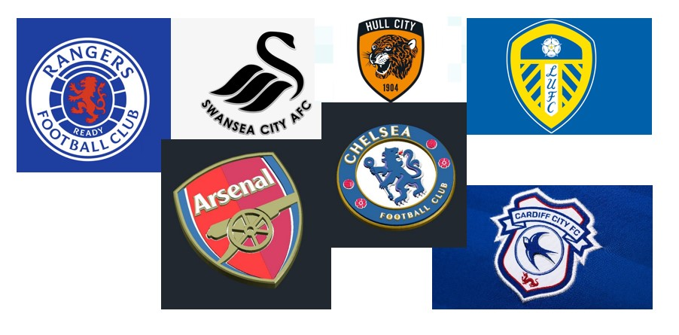
Visit
to check your answers.

