WORKSHEET
Museum website: http://kuskovo.ru
Virtual tour: http://vr360.ru/kuskovo/03/

Exercise 1. Culture vocabulary. Write the words under the correct picture.

- pilaster | - coat-of-arms | - tiled stove | - capital | - candelabrum | - porcelain ●
[pɪ’læstə] |  |  | [‘kæpɪtl] | [kændɪ’lɑ:brəm] | [‘poselɪn]
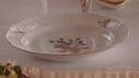
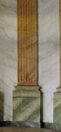
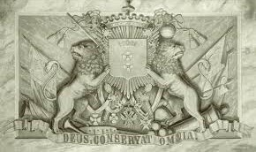
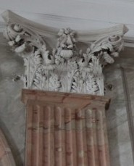
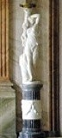
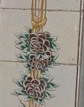
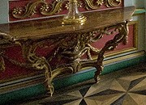
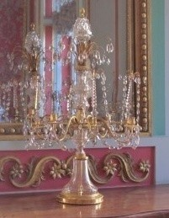
- sconce | - console | - tapestry | - chandelier | - chest of drawers | - girandole
[skɔns] | [‘kɔnsəul] | [‘tæpɪstrɪ] | [ˌʃændɪˈlɪə] | [tʃest ɔf ʹdrɔ:z ] | [ʹdʒırəndəʋl]
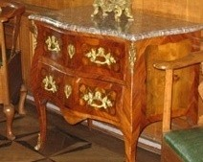

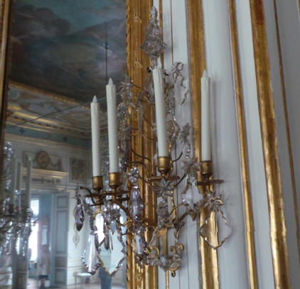
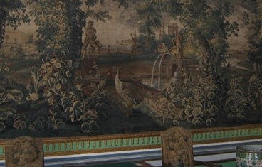
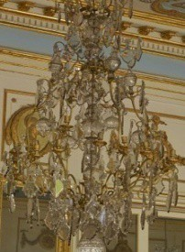
Exercise 2. Match the two parts of the sentences below together.
(French for 'grey') a term for painting, usually in shades of grey imitating of relief sculpture
a painting or other work of art executed directly on a wall
/fresco, wall-painting/
(French for ‘ceiling’) monumental and decorative painting in the palace staterooms, /ceiling- picture/
Mural
Plafond Grisaille

Exercise 3. Сhoose any picture in THE PICTURE ROOM. Describe the picture and offer to your friends to find it.
_____________________________________________________________________________________________________________________________________________________________________________________________________________________________________________________________________________________________________________________________________________________________________________________________________________________________________________________________________________________________________________________________

Useful phrases
still life | in the foreground | the picture is executed in bright (dark) tones
landscape | in the background | three quarter length
portrait | in the distance | shoulder-length
self-portrait | to the left (right) of the picture | full-length

Exercise 4. Read the description and find the name of the reception room.
The magnificent white and gold decoration and the silver mirrors on the walls resemble the Hall of Mirrors in Versailles and give this room its name

The artistic decor in the room includes:

Lighting Devices:
Painting:
Other:

