A Masterpiece of World Architecture

Фамилия, Имя
____________________________________________________________________

Схема движения группы:

на площади около церкви Вознесения Господня – церковь Вознесения Господня (внешний осмотр) – подклет церкви Вознесения Господня (притвор) – подклет церкви Вознесения Господня (подцерковье).

На площади около церкви Вознесения Господня. In the square near the Church of the Ascension.
Задание № 1.
In the square near the Church of the Ascension, there are many architectural landmarks and information plaques with basic facts about the structures.
Read the information plaques near the buildings and match the sentences with the names of the architectural landmarks. One sentence is extra. Complete the table.

1. This household structure was built in the 17th century and was used for storing well water and distributing it to people.
2. This structure was built by the order of Moscow Grand Prince Vasily III.
3. This church was the last to be built in the square.
4. It is a round building with no corners. It was built in place of a more ancient wooden church.
5. This building was constructed in the 19th century during the reign of Emperor Alexander I.
6. This building served as the main entrance to the Tsar’s courtyard.

Church of the Ascension  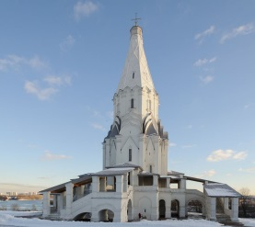 | 2 | St. George Сhurch  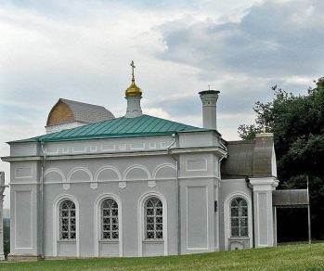 | 3
Bell tower  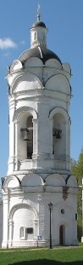 | 4 | Water tower  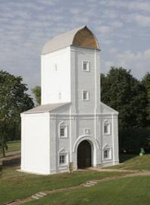 | 1
The Front Gate  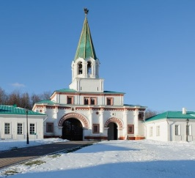 | 6 | Palace pavillion  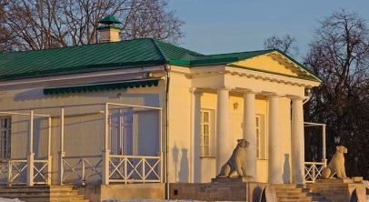 | 5

Церковь Вознесения Господня (внешний осмотр). The Church of the Ascension (external examination).

Задание № 2.
Read the text about the Church of the Ascension and complete the scheme below the text.

The main monolithic part of the church built of large bricks includes the ground floor, a tetragon above it, an octagon, a tent roof and a dome drum surmounted with a small dome and a cross. The connection between the lower part of the church and the upper octagonal part is disguised with rows of triple ‘kokoshniks’ (decorations that resemble a Russian woman’s headdress). The walls of the octagon are decorated with pilasters while the pointed triangular arches adorn the walls of the tetragon, all creating the impression that the entire building is striving upwards. The main element of the church and its chief compositional innovation is the tent – the elongated multi-faceted pyramid rising up into the skies. The skillfully calculated proportions of the tent, massive and light at the same time, are emphasized with a net of white stone diamond-shaped beads.

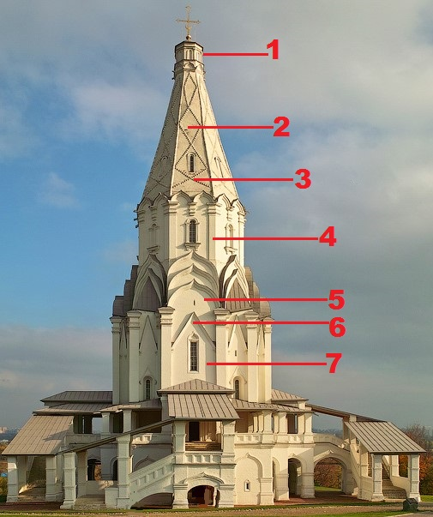 | To complete the scheme use the following words:  Diamond-shaped beads, drum, kokoshnik, pilaster, pointed triangular arch, tent, tetragon.  1. ________Drum ________.  2. ________Tent__________.  3. _Diamond-shaped beads_.  4. ________Pilaster _______.  5. _______ Kokoshnik _____.  6. _Pointed triangular arch _.  7. _______Tetragon_______.

Подклет церкви Вознесения Господня (притвор). The Ground floor of the Church of the Ascension (narthex).
Задание № 3.
Read the text about the ground floor of the church. Use the word at the end of each line to form a new word that fits into the gap.

The ground floor of the church was not used for church services; there are no _traces_ of ancient burials either. | TRACE
When the Grand Princes _visited__ Kolomenskoye, it was used to store the princes’ treasury. | VISIT
Later the ground floor __was used___ for household purposes: to store liturgical implements and ancient icons. | USE
In the 20th century, it became a space for storing the numerous white stone details saved from destroyed buildings and _ brought_ to Kolomenskoye by the order of the museum’s first director Peter Baranovsky. | BRING
During the restoration works, the floors _were renovated_; the inner walls and the vaults underwent partial re-facing. | RENOVATE
Fortunately, most of the genuine interior details have survived so that we can imagine what the church _looked_ like in older times before its facade was painted white. | LOOK
The solemn-looking combination of the dark-red brick and the white stone decor elements _is_ astonishing. | BE

Подклет церкви Вознесения Господня. The Ground floor of the Church of the Ascension.
Задание №4.

Explore two parts of the ground floor. Complete the plan of the ground floor.

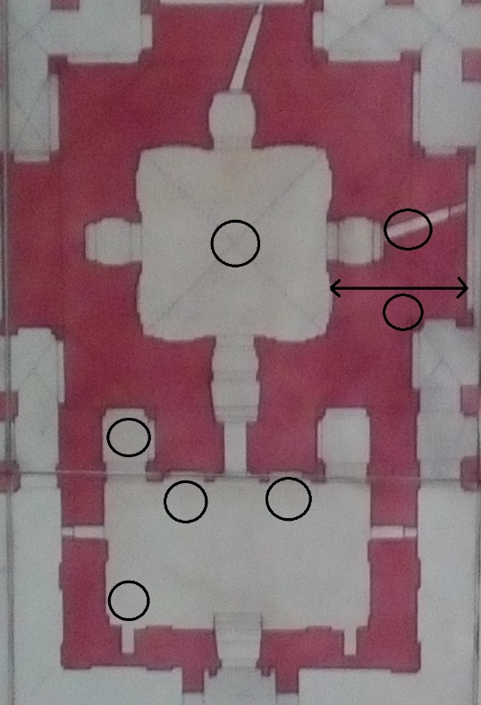  7  6  3  5  4  2  1 | Read the description of the plan. Each item in the list has a number. Write the correct numbers in the empty circles on the plan.  1. Showcase with archaeological finds.  2. Deep fissure-like window.  3. 10-foot wall thickness.  4. Miraculous icon of Our Lady.  5. Floor probing.  6, 7. Measurements and plans of the 19th century architects.

Подклет церкви Вознесения Господня (подцерковье). The Ground floor of the Church of the Ascension (room under the church).

Задание № 5.
Read the text about archaeological finds displayed in the showcase. Use the word at the end of each line to form a new word that fits into the gap.

The fragments of white stone ___carving___ in the showcase were used to decorate the church. | CARVE
However, they crumbled from the facades of the building at various ___historical____ epochs. | HISTORY
A lot of white stone or limestone was used to decorate the Church of the __Ascension____. | ASCEND
Despite its high cost, white stone was one of the favourite materials of Russian __builders__ and architects. | BUILD
By the end of the 15th century, European and Russian masters started to switch to more _practical__ brick building. | PRACTICE
However, white stone was ___commonly___ used to build foundations and ground floors as well as to create elements of architectural decor. | COMMON
Masters could __easily__ process wet limestone: they cut, turned and dressed it working it up into a needed shape. | EASY
Eventually, the material would become fragile and __mushy__ under the influence of external factors. | MUSH

Задание № 6.
А. Compare the main decorative elements of the Church of the Ascension presented on the right with the images given on the left. Match the images with the correct corresponding elements of the Church of the Ascension. Explain your choice.

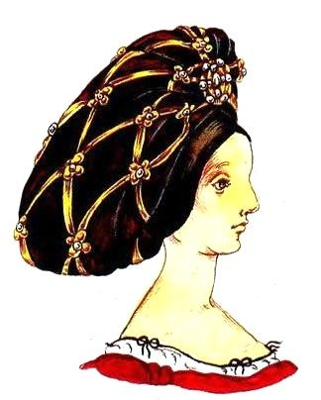 |  | Acanthus  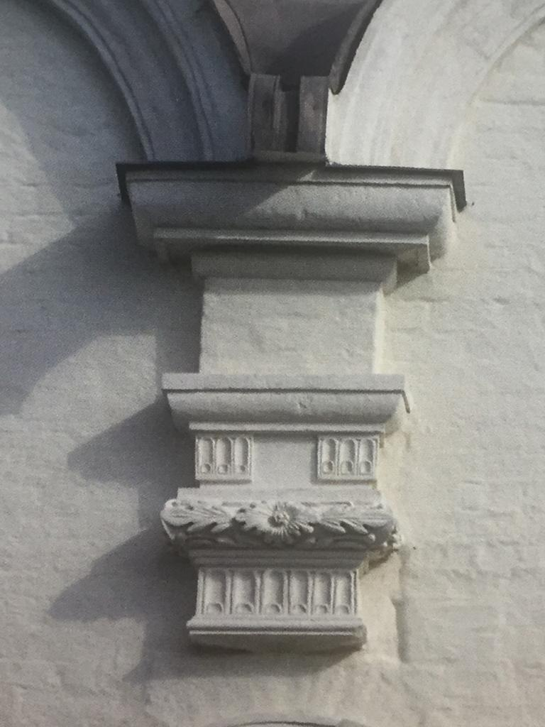
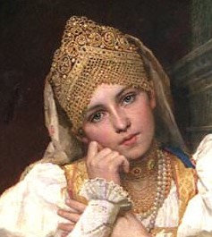 |  | Gothic gable  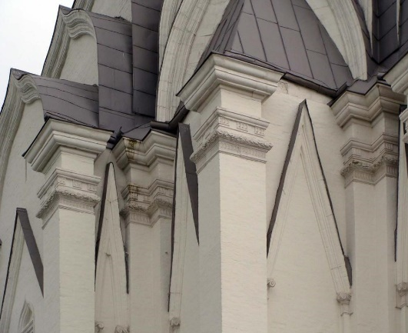
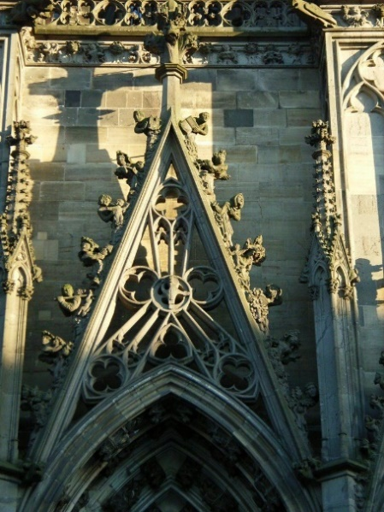 |  | Diamond-shaped beads  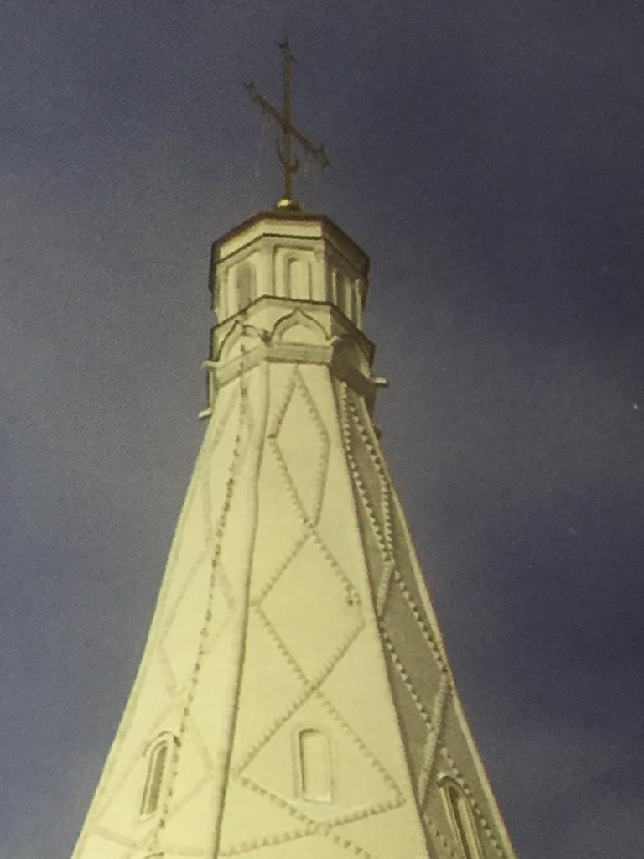
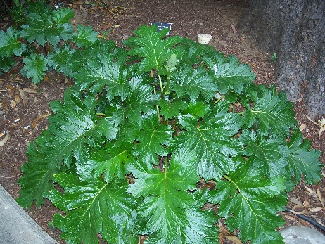 |  | Kokoshniks  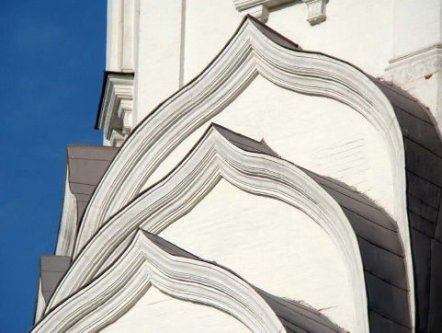
Ответы: 1 – C, 2 – D, 3 – B, 4 – A.

В. Make sentences using architectural terms given in this table and verb forms
«to look like», «to resemble», «to be similar».

Примеры ответов:
- Diamond-shaped beads look like a medieval European (Renaissance) headdress.
2. Kokoshniks resemble a traditional Russian headdress (costume).

C. Make sentences using topical vocabulary in this table and grammatical construction «to be borrowed from».

Acanthus  Gothic gable  Kokoshniks  Diamond-shaped beads | To be borrowed from | European architecture  Nature  Russian costume  Renaissance headdress

Примеры ответов:
1. Such an element of European architecture as acanthus was borrowed from nature as a widespread Mediterranean plant.

D. Fill in the gaps with the correct terms.
«Architectural and style features»
Russian architecture | Renaissance | Gothic
Kokoshniks | Acanthus | Gothic gable
 | Diamond-shaped beads

Задание № 7.

Use your imagination!

Imagine you are archeologists. Recently you found valuable artefacts, which are demonstrated at this exhibition. Work in groups:

Group 1
– identifies what items are made of;
– uses phrases «I suppose…», «It seems to me…».

Примеры ответов:
- I suppose these piles are made of wood.
- It seems to me pottery is made of clay.
- I suppose the white stone carving is made of natural white stone.
- I suppose this ring toy is made of clay.
- It seems to me pin is made of metal.
- I suppose this key is made of metal.
- It seems to me this bracelet is made of bronze.

Group 2
– takes a guess what this thing is for;
– uses the phrase «It was intended …» and keywords given in the right column.

Примеры ответов:
- The oak piles were intended for construction.
- The pottery was intended for use as household utensils.
- The white stone carving was intended for decoration.
- The ring toy was intended for amusement.
- This pin was intended for fixation.
- This key was intended for safety.
- The bronze bracelet was intended for use as women’s jewelry.

Topical vocabulary

Artefacts | Function and purpose
oak piles  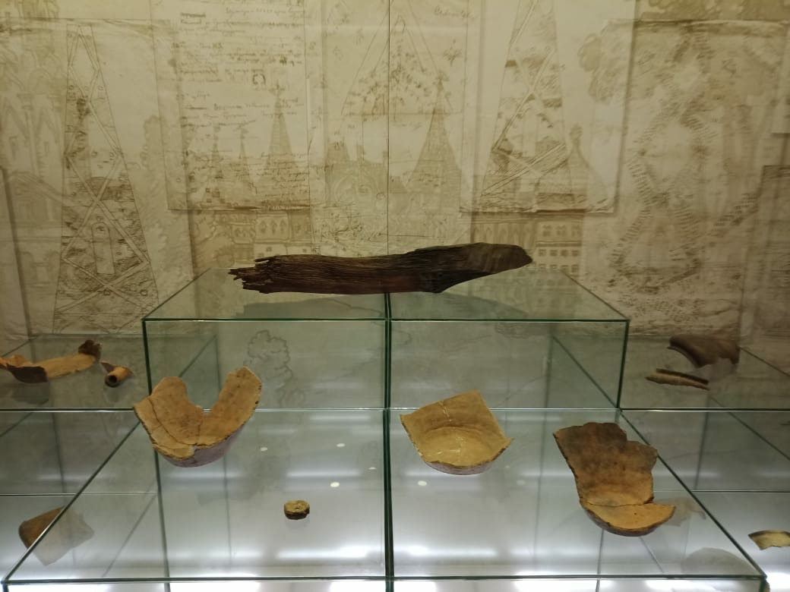 | Construction
pottery  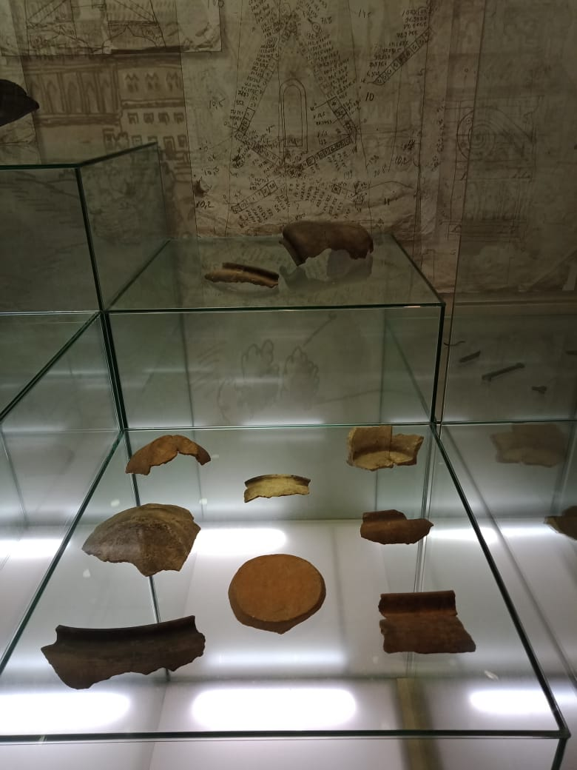 | Decoration
white stone carving  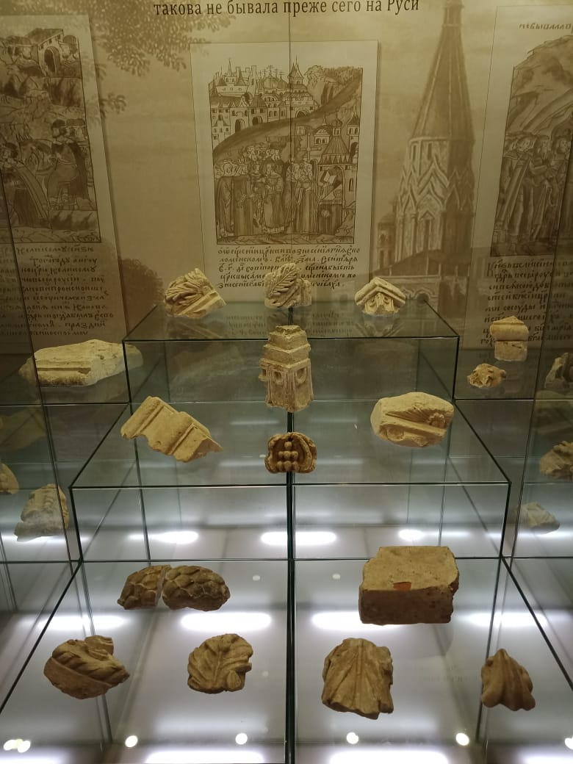 | Household utensils
ring toy  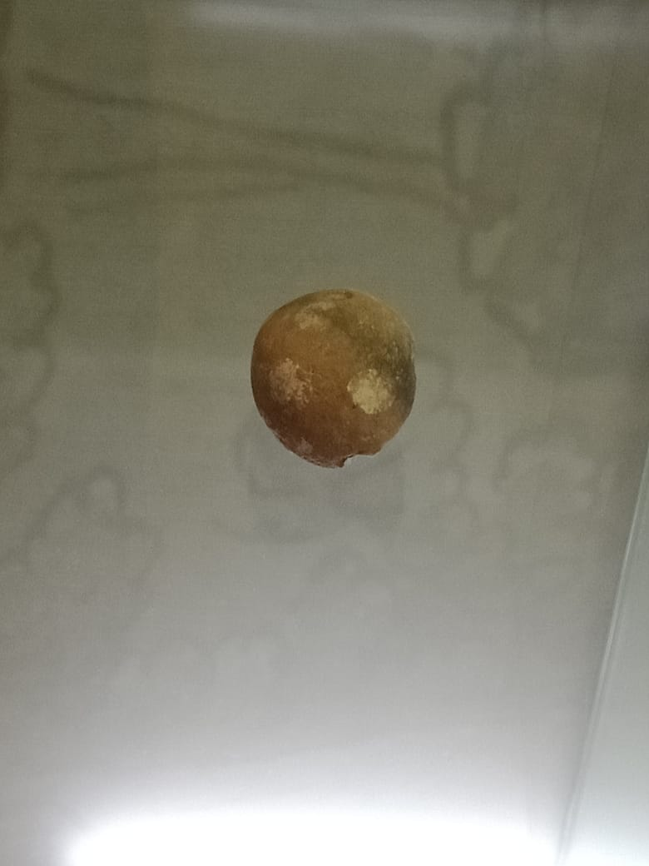 | Women’s jewelry
pin | Аmusement
Key  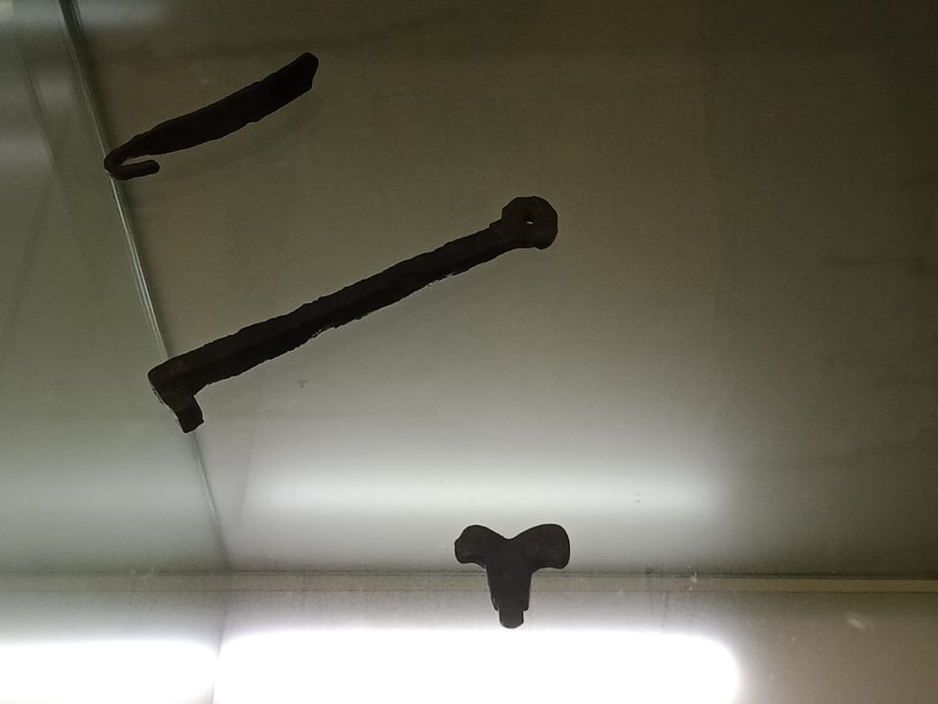 | Fixation
bronze bracelet  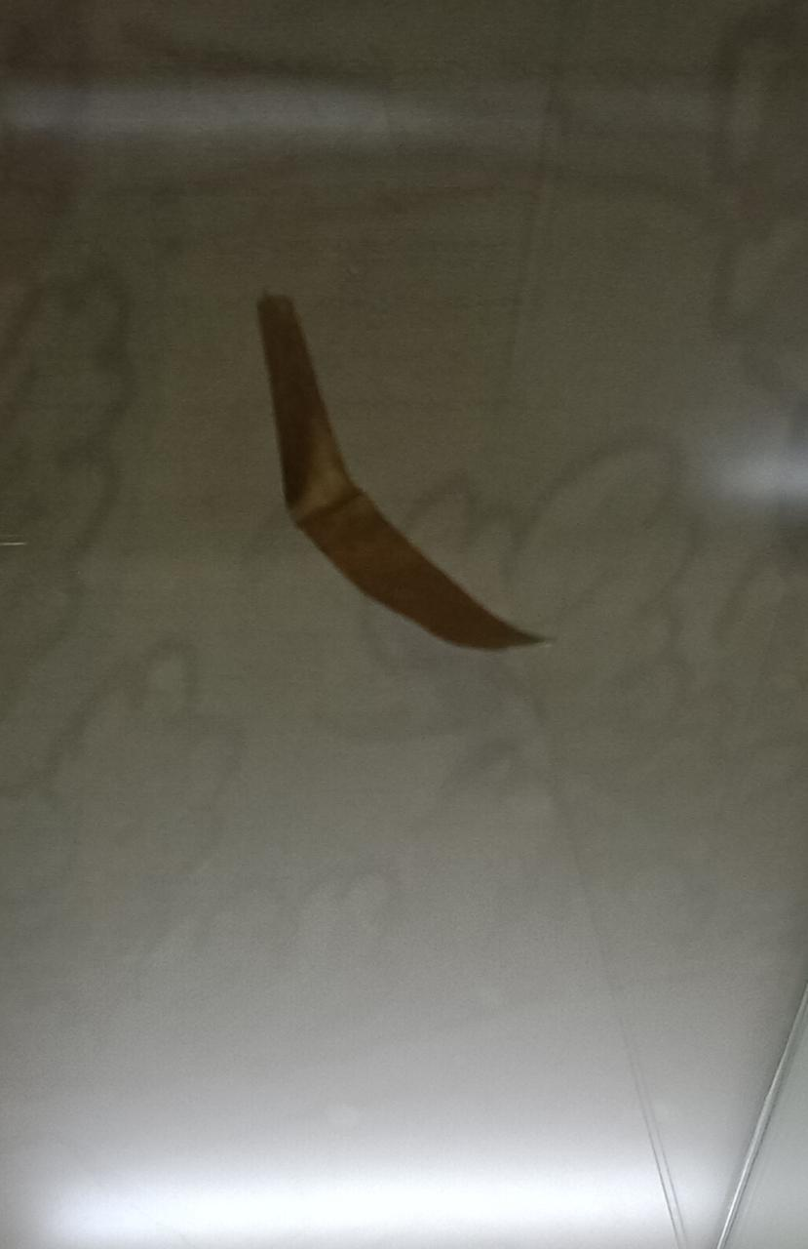 | Safety

Задание № 8.

Use your imagination!

You are in the church narthex. Imagine you are architects. There are floor and wall probings. Work in groups:
Group 1
– talks about traditional building materials of medieval architecture using the following phrases: «It’s composed of…», «It consists of…», «It comprises …», «It’s filled with», «It’s combined with», «It’s built from».

Пример:
- The wall consists of red bricks and decorative elements made of white stone.

Group 2
– talks about the specifics of the foundation using the following phrases «It’s composed of…», «It consists of…», «It comprises …», «It’s filled with», «It’s combined with», «It’s built from».

Пример:
1. The floor is composed of white-stone blocks.

Topical vocabulary

Wall probing  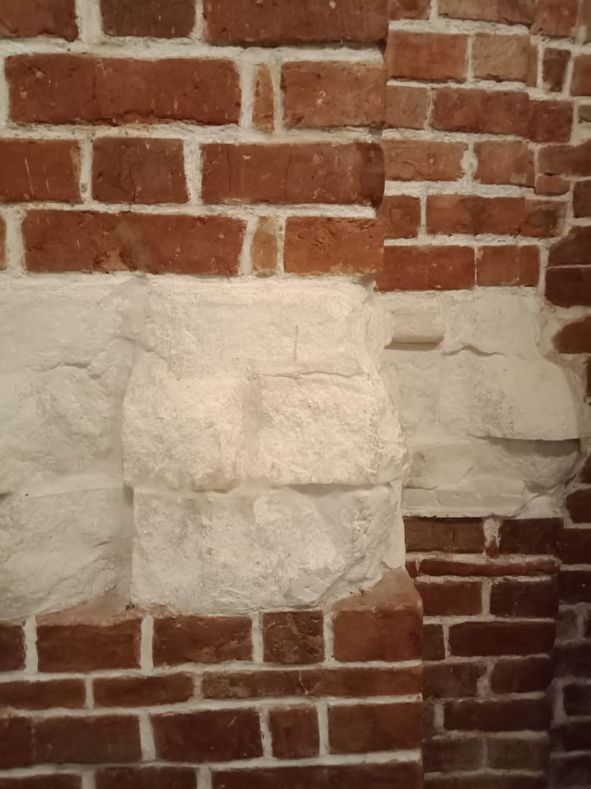 | Floor probing  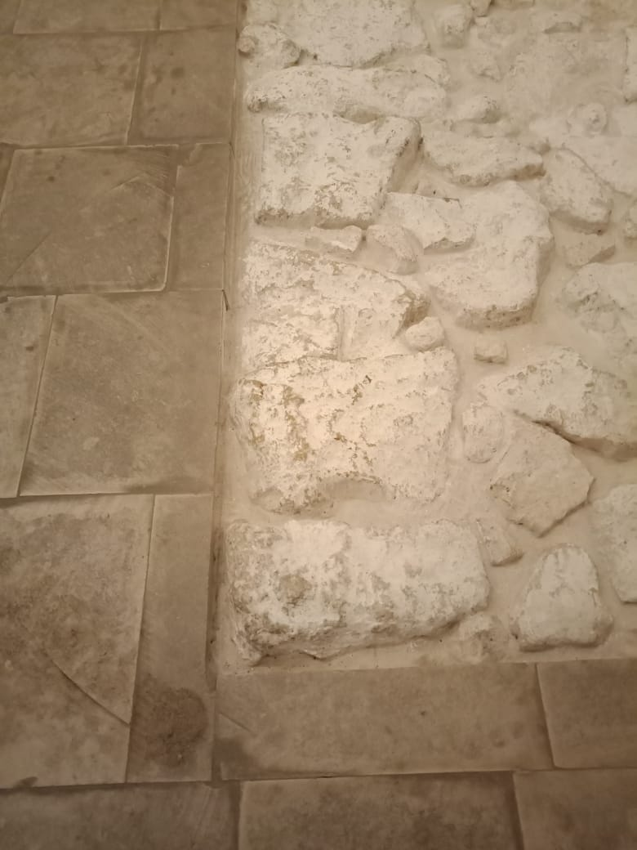
white stone | white-stone blocks
red bricks | whitewash solution
mixed layings «opus mixtum»

Задание № 9.
Study the advertisement.

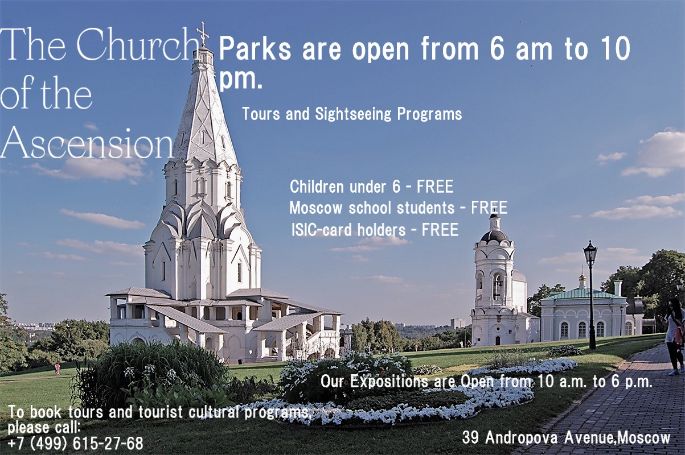

You are considering visiting the “Kolomenskoye” Museum-reserve and you'd like to get more information. In 1.5 minutes you are to ask five direct questions to find out the following:
- location of the museum;
- discounts for children;
- working hours;
- the most popular exhibit in the museum;
- tours that they have.
You have 20 seconds to ask each question.

Используя рисунок, ученики устно выполняют задание, схожее
с аналогичными заданиями формата ОГЭ.

Задание 10.
Look at the pictures. In 1.5 min. be ready to compare and contrast them:

- give a brief description of the photos (sights, location);
- say what the pictures have in common;
- say in what way the pictures are different;
- describe architectural features that these buildings have in common;
- say how the churches could be connected with historical figures (for example, Tsar Ivan the Terrible).

You should speak for not more than 2 minutes (12–15 sentences). You have to talk continuously.

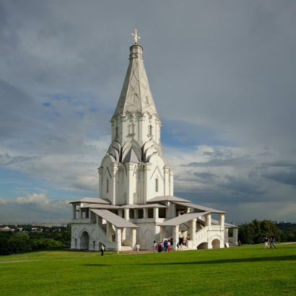  The Church of the Ascension, Kolomenskoye Museum-Reserve | 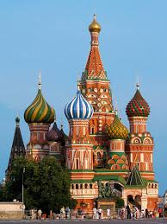  The Cathedral of the Intercession/Saint Basil's Cathedral, Red Square

Vocabulary: to be listed in UNESCO World heritage, to have a tent-like roof, side-chapel, to be consecrated, brick, the 16th century.

Данное задание сходно с аналогичными заданиями формата ОГЭ. Ученику предлагается сравнить объекты, представленные на двух рисунках. В помощь обучающимся дан список слов и речевых оборотов, которые можно использовать при ответе.

Задание 11.
The Three Pearls of Russian Medieval Architecture
The church of the Ascension in Kolomenskoye was constructed in 1532. There is a legend that the church was commissioned by Moscow Grand Prince Vasily III as a thanksgiving to God for a long-awaited child Ivan, born in 1530. Ivan was to be an heir of Grand Prince Vasily III. There is an opinion that the church of the Ascension was the first tent-like church built of stone (bricks). It is supposed that an Italian architect Pietro Francesco Annibali took part in the construction of this amazing church. The church is 62 meters high, it looks solemn like a gigantic white pillar. In 1994 the church of the Ascension was inscribed in UNESCO’s World Heritage List.
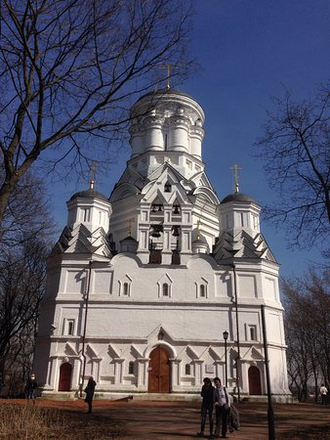
In 1547 Grand Prince Ivan was crowned in the Assumption Cathedral in the Moscow Kremlin as a first Russian Tsar. Ivan IV commissioned to build a church in the village of Dyakovo, which neighbors with Kolomenskoye. The church was consecrated in honor of the Tsar’s patron saint — John the Baptist (the Forerunner) the saint, whose name was given to the first Russian Tsar when he was baptized. The church of the Beheading John the Baptist consists of the main church building surrounded by 4 side-churches. Tsar Ivan IV used to celebrate his name day in Dyakovo. In the 16th century, Kolomenskoye and Dyakovo were the villages, located in the countryside, beyond the border of Moscow. Nowadays this locality became part of our city.
There is an opinion that the church in Dyakovo was designed by famous architects Barma and Postnik. They also constructed the world-famous Russian Cathedral on Red Square — the Cathedral of the Intercession on the Moat also known as Saint Basil’s Cathedral. This beautiful church is the real cultural symbol of Russia. The cathedral was built in 1561 to commemorate the capture of Kazan and Astrakhan. It consists of the central church surrounded by 9 side-churches. The roof of the central church resembles a tent. The Saint Basil’s Cathedral is inscribed in UNESCO’s World Heritage List. The Church of the Ascension in Kolomenskoye, the Church of the beheading John the Baptist and the Saint Basil’s Cathedral are brilliant examples of the 16th-century Russian architecture.

Read the text, look at the pictures. Use the information to answer the following questions.

- Which statement is correct?
- All these churches are constructed by Italian architects.
- The three churches are tent-like.
- All the three churches have side-churches.
- The churches were listed as UNESCO monuments.
- All the churches are built in the 16th century.

- All the churches were initially erected within Moscow’s border. Is it true or false? Explain, why.
It is false, because in the 16th century Kolomenskoye and Dyakovo were the villages, located in the suburbs of Moscow.

- Name the historical figure who could be connected with the history of the three churches.
Tsar Ivan IV (the Terrible)

- Which peculiar features let us suppose that the Church of the Beheading of John the Baptist and Saint Basil’s Cathedral were designed by the same architects?
- A tent-roofed structure
- The central church building is surrounded by several side-churches
- Onion-shaped domes (cupola)
- Rich decorations

- Which church could Tsar Ivan IV attend once a year for the celebration of his name day?
- The Church of the Ascension in Kolomenskoye, because it was built to celebrate the Tsar’s Birthday.
- Saint Basil’s Cathedral, erected to commemorate Ivan IV’s military victories.
- The Church of the Beheading of John the Baptist, because it was dedicated to his patron saint.

