Capybaras

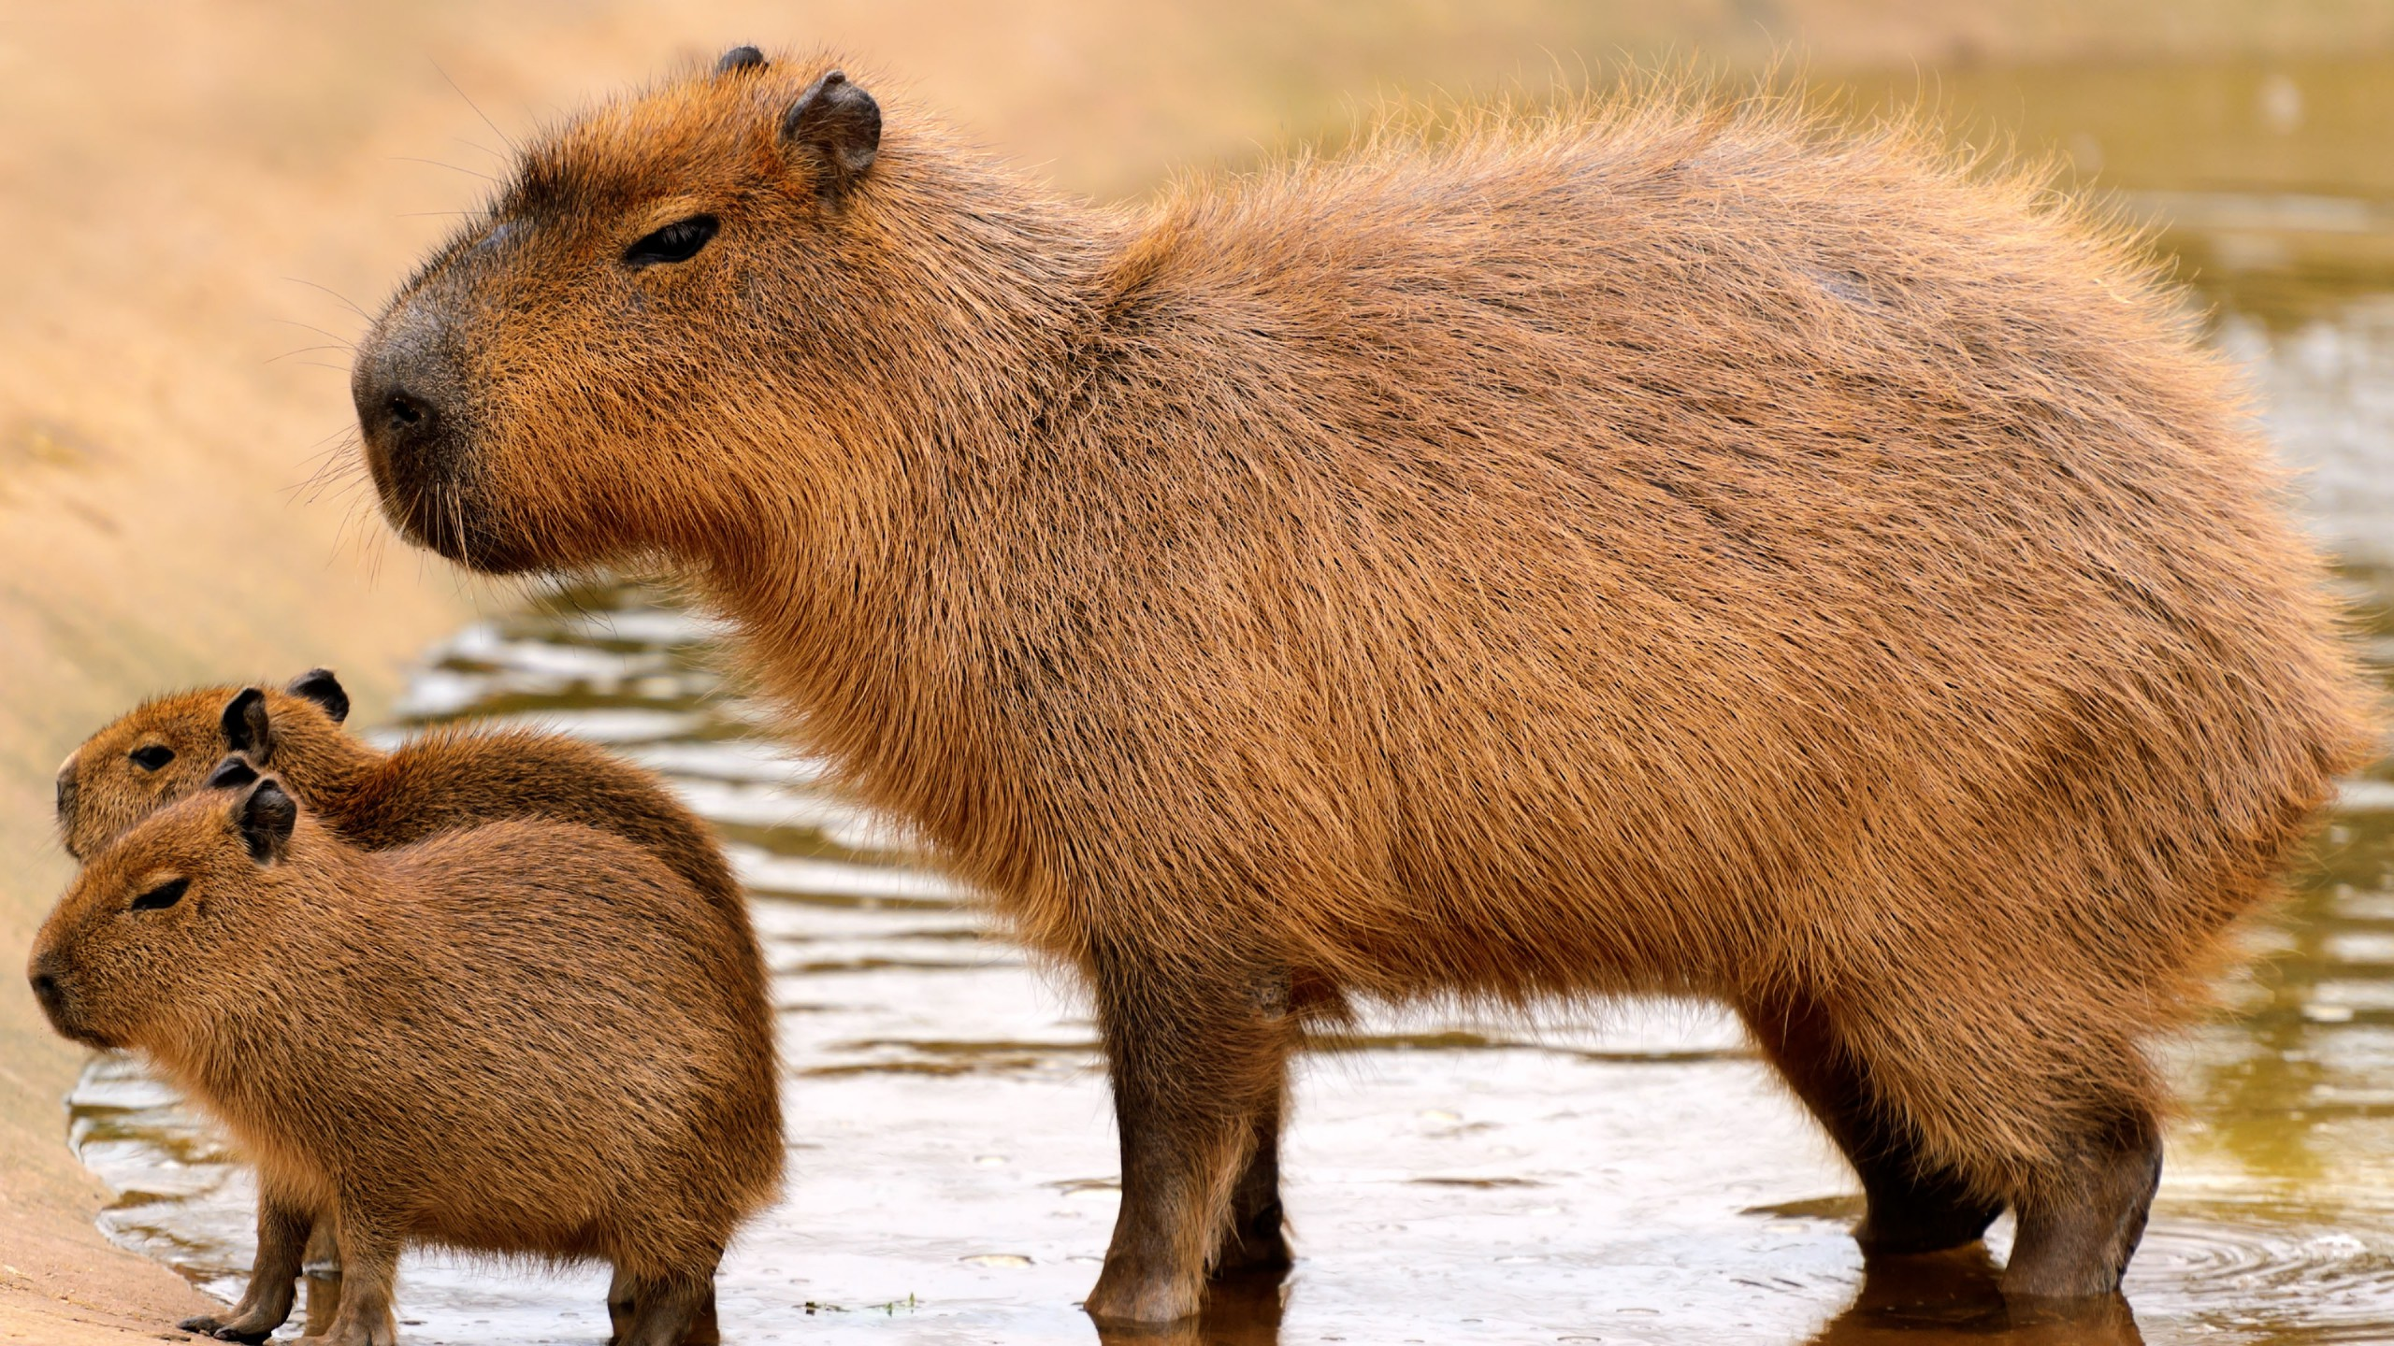
Capybaras are the world’s largest rodents.
Capybaras are found in every country in South America apart from Chile. They are also found in Central America. Capybaras are semi-aquatic, and spend much of their time in or around water. They live in swampy, marshy grassland areas, and woods and forests next to rivers and lakes. Capybaras are herbivores, which mean they only eat plants. They eat water plants and grasses.
Capybaras look a little like overgrown guinea pigs, which is no surprise: the animals are closely related.
Capybaras have big, barrel-shaped bodies with rather square heads. Their long, thick hair is varying shades of golden or reddish-brown. The capybara’s fur helps to retain heat and dries quickly after it leaves the water. The capybara’s sharp incisors (front teeth) never stop growing. The capybara’s eyes, nose and mouth are located near the top of its head. This allows it to see and breathe while the rest of its body is under water. Capybaras have other adaptations for a semi-aquatic life. While diving, capybaras can press their ears flat against their heads to prevent water getting in. They can stay underwater for up to five minutes. Capybaras also have slightly webbed feet with big claws. This helps them not only to swim but also to walk on the slippery rainforest floor.
Capybaras weigh up to 35 kilograms.
Capybaras live in groups of 10–20 and they are very social.
Capybaras communicate with whimpering, clicking, purring and barking noises.
In the wild, capybaras live for around 8–10 years.
Источник: http://www.activewild.com/capybara-facts/

