How does it work?
A lesson in Gas Transmission museum
Пояснение: работа с глоссарием проводится без опоры на экспонаты музея. Задания 1.1, 1.2 выполняются на территории уличной экспозиции, для иллюстрации используется газотурбинный двигатель НК-12СТ; Задания 2.1, 2.2, 3.1, 3.2 выполняются в зале «Технологии» на втором уровне музея. Для выполнения заданий 2.1, 2.2 используется макет «Транспорт и распределение газа». Для выполнения заданий 3.1, 3.2 используются интерактивная модель «Очистка газа», макет шарового крана и анимированный макет «Осевой компрессор газовой турбины».
Glossary
Students work individually. The task is supposed to take up to 5 minutes
Study the words and their definitions
engine, n – a machine with moving parts that uses fuel to produce movement
gas line, n – a very large tube, often underground, through which gas can flow for long distances
pipe, n – a tube that carries liquid or gas from one place to another
pump, v – to force liquid or gas to move somewhere
fuel, n – a substance such as oil, gas, coal or wood that produces heat or power when it is burned
deposit, n – a layer of a metal or another substance that has formed in soil or rock
pressure, n – the force that a liquid or gas produces when it presses against an area
compress, v – to press something into a smaller space
Complete the sentences with the words from the glossary
1. The machine will _compress_ the gas until it turns into liquid.
2. It's the second largest oil _deposit_ found in the last decade.
3. Water was leaking from the _pipe_.
4. My car engine is making strange noises; I need a mechanic to have a look at it.
5. The heart _pumps_ blood through the arteries around the body.
6. Apply _pressure_ to the cut to stop the bleeding.
7. Today's vehicles use two kinds of _fuel_ − petrol and diesel.
8. Special care is required when laying _gas lines_ across roads and railways.

Task 1.1 Read the text and fill in the gaps in the scheme with the following words:
Divide the students into 3 groups. Allow them to discuss and compare their answers. The task is supposed to take up to 5 minutes
propelling nozzle intake turbine compressor propeller combustion chamber

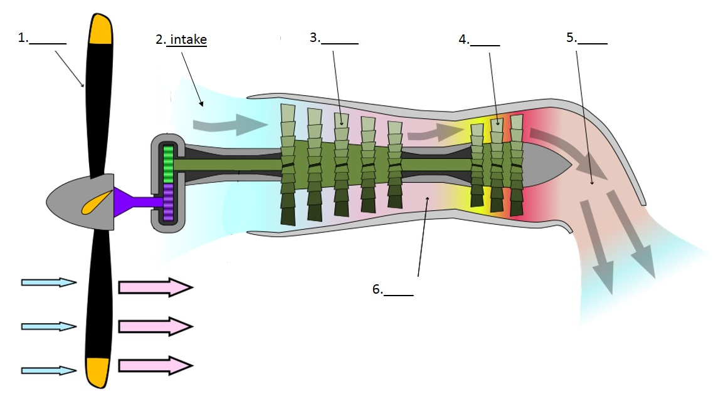
Keys: 1 – propeller, 2 – intake, 3 – compressor, 4 – turbine, 5 – propelling nozzle, 6 – combustion chamber
The Kuznetsov NK-12 is a Soviet turboprop engine of the 1950s. It was designed by the Kuznetsov design bureau (also known as OKB – 276). NK in the name of the engine stands for Nikolai Kuznetsov, the chief designer of the bureau. NK-12 is the most powerful turboprop engine that has ever entered service.
In 1974, the engine was adapted for gas transportation, so that it could power the gas pump. The Natural gas transported through the gas lines could be used as fuel for the pump, so no extra fuel source was required.
This is how the turboprop engine operates. First, the air from the atmosphere is drawn inside the compressor through the intake. Then, the compressed air is channeled into the combustion chamber, where it mixes with fuel. The fuel-air mixture burns inside the chamber, consequently releasing hot combustion gases. Afterwards, the gases expand through the turbine, generating energy. Some of the energy is used to drive the compressor, but most of it powers the propeller. After the gases pass through the turbine, they keep expanding in the propelling nozzle until they exhaust to atmospheric pressure.
Task 1.2 Read the text again and underline all the passive forms. Explain why they are used in this text. The task is supposed to take up to 3 minutes
Task 2.1 Study the gas transportation scheme and put the paragraphs into the correct order. Pay attention to the linkers in bold
Students continue working in groups. The task is supposed to take up to 5 minutes
Keys: 1 – A, 2 – F, 3 – H, 4 – C, 5 – E, 6 – B, 7 – G, 8 – I, 9 - D
- After gas has been extracted from a deposit, it still needs to find its way to cities, villages, factories and power stations. The most common way gas is delivered to customers is via gas line pipes.
- When gas is compressed, its temperature rises. High temperature gas can spoil the equipment; that is why it needs to be cooled. Moreover, gas goes through additional purification at compressor stations.
- Subsequent to purification and dehydration, gas goes to the main gas pipeline, where it moves through the pipes of 1,4 meters in diameter, experiencing pressure of 75 atmospheres.
- Eventually, any gas line ends with a gas distribution station, where gas pressure is reduced. Besides, at a GDS gas is also treated, dehydrated and odorized (specific smell is added to gas).
- As gas moves through a gas line, its pressure lowers due to the friction force between different layers of the gas, as well as between the gas and the pipe itself. In order to keep the pressure at a constant level, compressor stations are constructed along the pipeline.
- However, before gas is pumped through the pipes, it needs to be processed. It is purified from admixtures that can spoil the equipment.
- Obviously, the demand for gas changes depending on the season. In winter, more gas is needed than in summer. Consequently, extra amounts of gas need to be kept somewhere to be put to use later, when needed.
- Apart from being purified, gas is also dehydrated, as excessive moist causes formation of hydrates, ice-like substances that can clog the pipes.
- For instance, gas can be stored in underground storage facilities, such as salt caverns and porous beds of sandstone.
Task 2.2 Sort the linkers from the text into the columns according to their functions. The task is supposed to take up to 3 minutes

1 | 2 | 3 | 4 | 5 | 6 | 7
Contrasting ideas | Giving reasons | Explaining the purpose | Explaining consequences | Adding information | Giving examples | Sequencing ideas
however | as  due to | in order to | that is why  consequently | also  apart from  as well as  moreover | for instance  such as | after  before  subsequent to  eventually
Таблица 1
Task 3.1 Study the scheme and decide which of the mechanisms in the room it describes
Task 3.2 Use the schemes and the functioning models of the mechanisms to describe how they work. Use passive forms and linkers in your answer
Students continue working in groups. Each group gets one scheme to describe. Allow 10 minutes for preparation and 15 minutes for presentation (5 minutes for each group)

Group 1. Cyclone Separator | Group 2. Ball valve
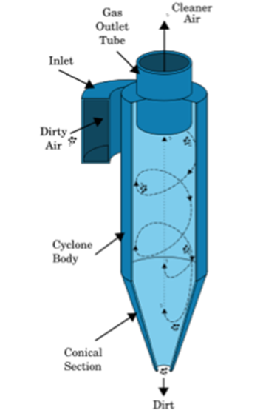 | 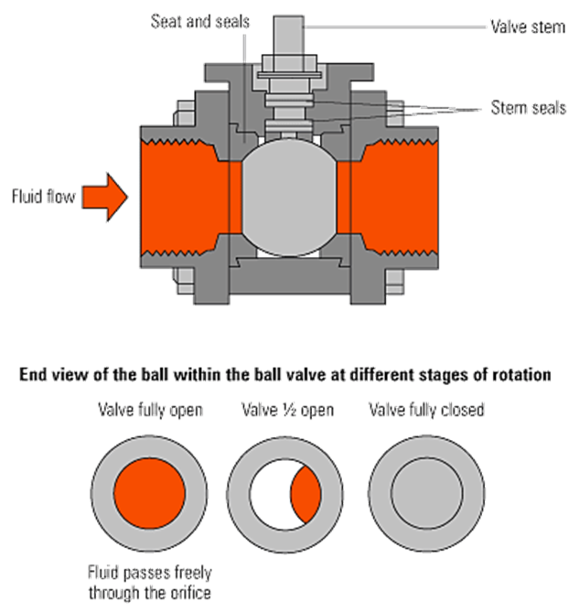
Group 3. Axial flow compressor

