Worksheet 2
- This is a map of the world. Mark the areas where the animals from the worksheet can be found in the wild.
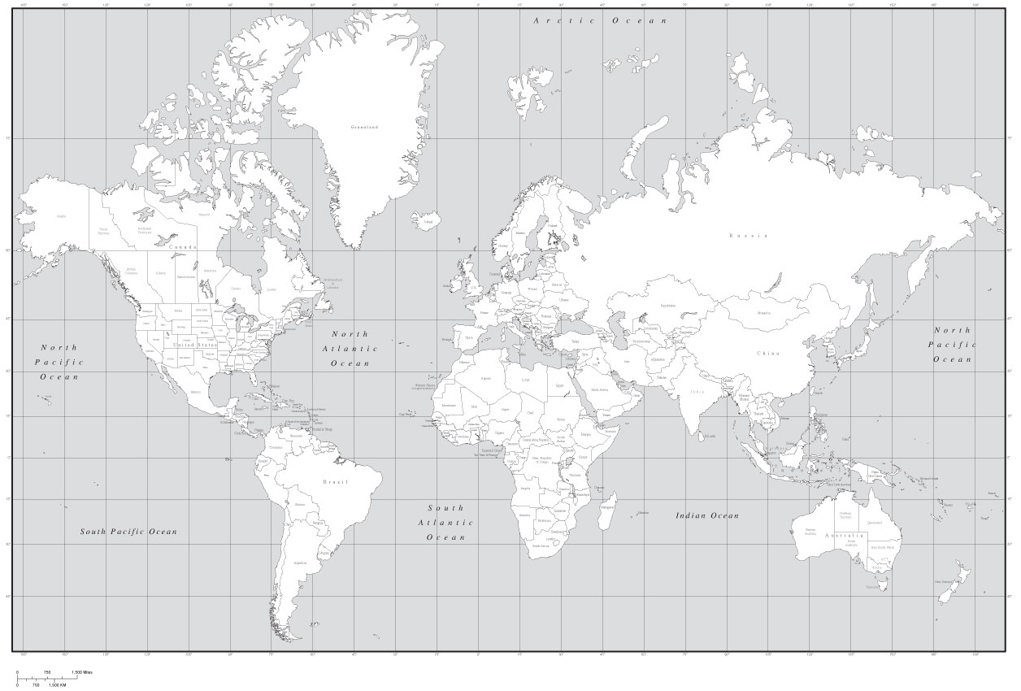
http://www.travelsworlds.com/wp-content/uploads/2014/03/world-map-black-and-whiteblack-white-world-map-with-countries-us-states-and-canadian-x3obqa0o.jpg
- Cheetahs
- Match the words head, eye, ear, nose, back, front leg/foreleg, hind leg, tail, paw, claw with the parts of the body.
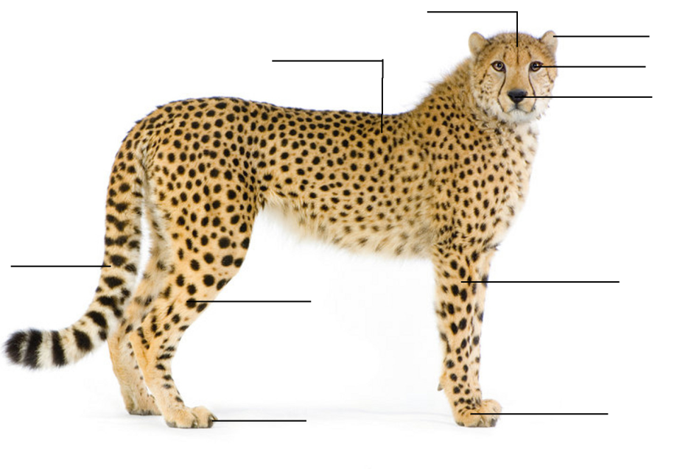
- Write 5 words that characterize cheetahs.
____________________________________________________________________________________________________________________________________________________________________________________________________________
- What colors does a cheetah have on its body?
____________________________________________________________________________________________________________________________________________________________________________________________________________
- Why does a cheetah have spots? _____________________________________________________________________________________________________________________________________________________________________________________________
- Take some photos of the cheetah.

- What is the cheetah doing during your visit?
____________________________________________________________________________________________________________________________________________________________________________________________________________________________________________________________________________________________________________________________________________________

- Musk oxen
- What animal family does the musk ox belong to? _______________________________________________________________
- Do musk oxen sleep standing up or lying down?
___________________________________________________________________
- What do they eat? Does this make them carnivores or herbivores? Explain.
___________________________________________________________________
- Do musk oxen migrate or stay year-round in one place?
___________________________________________________________________
- What is special about the musk ox’s fur?
____________________________________________________________________
- Do they stay in groups or do they like to be by themselves?
____________________________________________________________________
- When predators attack, how do they defend themselves?
____________________________________________________________________
- Look at the musk oxen, read the description, find the mistakes and correct them.
Musk oxen are short-haired animals with a very long tail. They don’t have horns. They are 60 сm high and weigh about 100 kg. Cows are bigger than bulls. Musk oxen are found in South America and Africa.
________________________________________________________________________________________________________________________________________________________________________________________________________________________________________________________________________________
- Tapirs
- Observe the tapirs at the exhibit and take photos.

- Even though tapirs look very similar to pigs, they are actually related to _______________________________________________________________
Tapirs are________________, they eat grasses, aquatic plants, leaves and fruits
of low-growing shrubs.
Tapirs use their flexible ______________ (proboscis) almost like a finger, to
pluck vegetation from low hanging trees and shrubs.
Tapirs are good divers and__________________________________________.
Main predators of tapirs include_____________________________________.
- What are the tapirs doing during your visit?
____________________________________________________________________________________________________________________________________________________________________________________________________________________________________________________________________________________________________________________________________________________

- Classify each animal as a consumer: herbivore [ˈhɜːbɪvɔː]( травоядное), carnivore [ˈkɑːnɪvɔː] (плотоядное животное ), omnivore [ˈɒmnɪvɔː] (всеядное животное )
herbivore | carnivore | omnivore

- Animal cinquain

Use the lines below to write a cinquain poem about the animal you like most of all.

_______________
(1 word — an animal)

_______________ _______________
(2 words that describe it)

_______________ _______________ _______________
(3 words expressing action)

_______________ _______________ _______________ _______________
(4 words telling what you feel about it)

_______________
(sum up with 1 word)

- Using the photos and the information from the worksheets make “Animal fact book”.

