Урок английского языка в Музее Победы для педагогических классов
People’s activities during the World War II
Case
Visit the English version of the Museum’s website.
https://victorymuseum.ru/for-visitors/museum-for-china/en/
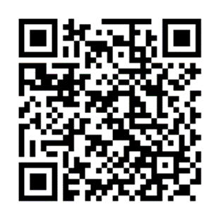
Use the information provided to answer the following email you received from your English-speaking friend Debby.
From: Debby@mail.uk
To: Russia_friend@ege.ru
Subject: The Victory Museum
…I’m really looking forward to my trip to Moscow! I’m especially interested in visiting the Victory Museum. How can I learn about the battles of the Great Patriotic War in the museum? Is there any information on the weaponry used during WWII? I’m going to travel with my parents and my 7-year-old brother. Will we be able to go on a guided tour?
By the way, I’ve decided to become a guide…

Write an email to Debby. Use the information leaflet below to answer her questions. Ask three questions about her future profession.
Write 100 – 140 words. Remember the rules of email writing.
