How does it work?
A lesson in Gas Transmission museum
Glossary
Study the words and their definitions
engine, n | – a machine with moving parts that uses fuel to produce movement
gas line, n | – a very large tube, often underground, through which gas can flow for long distances
pipe, n | – a tube that carries liquid or gas from one place to another
pump, v | – to force liquid or gas to move somewhere
fuel, n | – a substance such as oil, gas, coal or wood that produces heat or power when it is burned
deposit, n | – a layer of a metal or another substance that has formed in soil or rock
pressure, n | – the force that a liquid or gas produces when it presses against an area
compress, v | – to press something into a smaller space

Complete the sentences with the words from the glossary
- The machine will ________ the gas until it turns into liquid.
- It's the second largest oil ________ found in the last decade.
- Water was leaking from the ________.
- My car ________ is making strange noises; I need a mechanic to have a look at it.
- The heart ________ blood through the arteries around the body.
- Apply ________ to the cut to stop the bleeding.
- Today's vehicles use two kinds of _________ − petrol and diesel.
- Special care is required when laying ________ across roads and railways.

Task 1.1 Read the text and fill in the gaps in the scheme with the following words:
propelling nozzle intake turbine compressor propeller combustion chamber

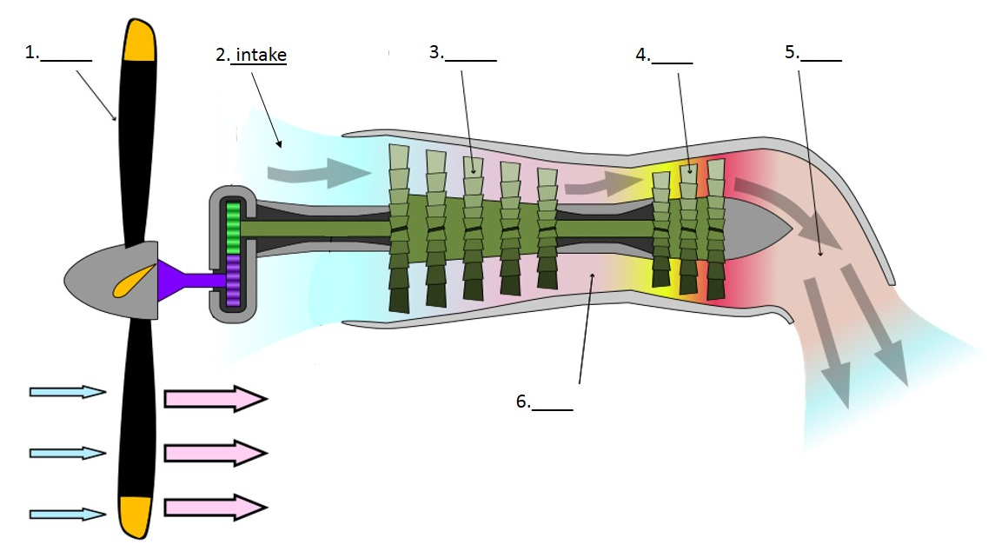

The Kuznetsov NK-12 is a Soviet turboprop engine of the 1950s. It was designed by the Kuznetsov design bureau (also known as OKB – 276). NK in the name of the engine stands for Nikolai Kuznetsov, the chief designer of the bureau. NK-12 is the most powerful turboprop engine that has ever entered service.
In 1974, the engine was adapted for gas transportation, so that it could power the gas pump. The Natural gas transported through the gas lines could be used as fuel for the pump, so no extra fuel source was required.
This is how the turboprop engine operates. First, the air from the atmosphere is drawn inside the compressor through the intake. Then, the compressed air is channeled into the combustion chamber, where it mixes with fuel. The fuel-air mixture burns inside the chamber, consequently releasing hot combustion gases. Afterwards, the gases expand through the turbine, generating energy. Some of the energy is used to drive the compressor, but most of it powers the propeller. After the gases pass through the turbine, they keep expanding in the propelling nozzle until they exhaust to atmospheric pressure.
Task 1.2 Read the text again and underline all the passive forms. Explain why they are used in this text

Task 2.1 Study the gas transportation scheme and put the paragraphs into the correct order. Pay attention to the linkers in bold
- After gas has been extracted from a deposit, it still needs to find its way to cities, villages, factories and power stations. The most common way gas is delivered to customers is via gas line pipes.
- When gas is compressed, its temperature rises. High temperature gas can spoil the equipment; that is why it needs to be cooled. Moreover, gas goes through additional purification at compressor stations.
- Subsequent to purification and dehydration, gas goes to the main gas pipeline, where it moves through the pipes of 1,4 meters in diameter, experiencing pressure of 75 atmospheres.
- Eventually, any gas line ends with a gas distribution station, where gas pressure is reduced. Besides, at a GDS gas is also treated, dehydrated and odorized (specific smell is added to gas).
- As gas moves through a gas line, its pressure lowers due to the friction force between different layers of the gas, as well as between the gas and the pipe itself. In order to keep the pressure at a constant level, compressor stations are constructed along the pipeline.
- However, before gas is pumped through the pipes, it needs to be processed. It is purified from admixtures that can spoil the equipment.
- Obviously, the demand for gas changes depending on the season. In winter, more gas is needed than in summer. Consequently, extra amounts of gas need to be kept somewhere to be put to use later, when needed.
- Apart from being purified, gas is also dehydrated, as excessive moist causes formation of hydrates, ice-like substances that can clog the pipes.
- For instance, gas can be stored in underground storage facilities, such as salt caverns and porous beds of sandstone.

Task 2.2 Sort the linkers from the text into the columns according to their functions.

1 | 2 | 3 | 4 | 5 | 6 | 7
Contrasting ideas | Giving reasons | Explaining the purpose | Explaining consequences | Adding information | Giving examples | Sequencing ideas
Task 3.1 Study the scheme and decide which of the mechanisms in the room it describes

Group 1. Cyclone Separator | Group 2. Ball valve
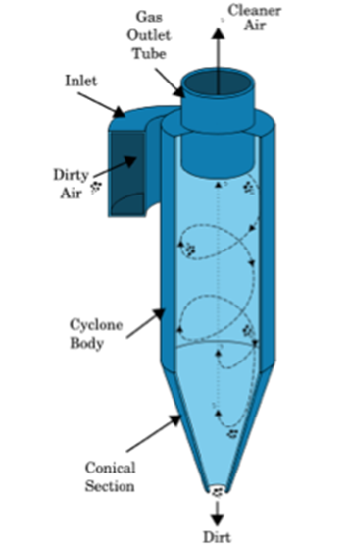 | 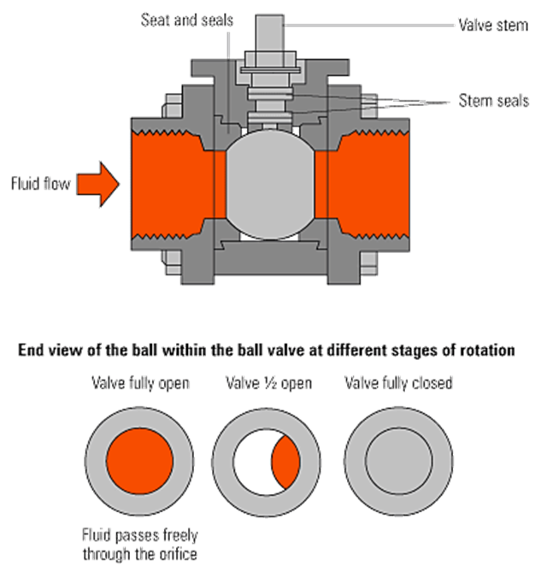
Group 3. Axial flow compressor

Task 3.2 Use the schemes and the functioning models of the mechanisms to describe how they work. Use passive forms and linkers in your answer

