Урок английского языка в Музее Победы для медиаклассов
People’s activities during the World War II
Рабочий лист для учителя

Introduction
Start in the Hall of Historical Verity
Ask the students to sum up the role of the Soviet Union in WWII based on what they have learnt in no more than 3 sentences, share and compare their ideas.
Hand out students’ worksheets and glossary templates (the latter is optional but could be used to ensure noting the vocabulary and/or structures that will later be used in the final production of the written work).
Task 1
Move on to the wall with the quotes by W. Churchill and F.D. Roosevelt in the Hall of Historical Verity.
Ask the students if any of their ideas are similar to the ones expressed in these quotations.
Organize work in 2 groups. Each prepares a rough translation of one of the quotes and then compares it to the original text.
Suggest students make a list of the vocabulary from the original quotes that they lacked in their translations and add the vocabulary they find most useful to the Glossary.
Group 1

Group 2
Follow-up discussion:
What are the key points that Churchill and Roosevelt make in their speeches on the role of the USSR in WWII?

Task 2
Go to the cases containing the Soviet propaganda posters in the Hall of Historical Verity. Discuss their key messages.
The students use the QR-code or the link below to see the American and British propaganda posters demonstrating the contribution of people of different jobs and occupations to the victory during the war. Discuss what messages they convey.
https://drive.google.com/drive/folders/1OzbSCROGyX_MwMQaCG0c8DsbwBo7nM4H?usp=sharing
Organize work in pairs. Each student picks one of the posters to compare and contrast with the Soviet poster of their choice. The following plan is used:
• briefly describe both posters;
• explain how these posters illustrate the role of the contribution of people of different jobs and occupations to the great victory.
• say in what way the posters are different (2 features connected with the subject of the posters);
• express your opinion on the subject of the posters.
The student’s partner comments on the talk mentioning:
- if they would add any information;
- if they agree with the conclusion; why/why not.

Task 3
Read the posters on the wall and discuss the role of propaganda in winning the war.
The students compare their ideas with the following passage. They complete the text by inserting the appropriate words into the gaps.
When the war with Nazi Germany broke out on 22 June 1941, the Communist Party of the USSR took a decision to create a new organisation, which was called the Soviet Office of Political and Military Propaganda (later reformed into the Office of Propaganda on Enemy and Occupied Territories). By the end of 1941, eighteen propaganda newspapers were being published in the Soviet Union in various foreign languages, ten of them in German.
Even the German intelligence accepted that the Soviet propaganda was very effective. Propaganda aimed at Nazi soldiers and civilians in Germany and on occupied territories did not focus on the communist ideology or religion criticism, the class structure of society, etc. The main objective was to condemn Hitler and his National Socialist German Workers Party.
The propaganda materials vividly illustrated atrocities by the Nazi troops on the occupied territories on the one hand and the strength of the Soviet Army and consequently its inevitable victory on the other hand. Among various propaganda techniques, one of the most important was an emotional appeal to ‘common’ people who were forced to fight a war that was not in their interests. Images of women and children waiting for their husbands, sons and fathers back at home were widely used. Women and children in these pictures appeared miserable and ashamed that their loved ones were fighting on the Eastern front, and these impressions came out as genuinely poignant and moving.
Most of the flyers contained a pass, written in German and Russian, which could be torn off and presented to the Soviet troops when surrendering. In 1942, after the first German defeats, a special series of propaganda materials demonstrating the enemy's losses was launched. The propaganda message addressed to Germany's allies stressed the argument that the German fascists were using their allies' troops in the most dangerous situations and campaigns.
(from https://blogs.bl.uk/)
The most useful vocabulary can be added to the Glossary.
Follow-up discussion:
What other function extremely important in times of war depends on the efforts of propagandists and defence correspondents?

Task 4
Students study the exhibition of weapons to find at least one weapon belonging to each of the categories:
- developed by Soviet engineers;
- captured as trophies;
- obtained through the Lend-Lease programme.
Find out what they know about the Lend-Lease policy.
Task 5
Students use the link to watch a short video lecture by the History channel to learn more about the Lend-Lease policy and work on their listening skills.
https://drive.google.com/file/d/1BOM5QwlB42EJNmCS5EaMUtZAIfaevZLL/view?usp=sharing
For each task 1 – 6, choose the best answer.
- The Lend-Lease Act initially regulated the conditions of weaponry provision between…
- the USA and the UK.
- the USA and the USSR.
- the UK and the USSR.
- According to the Neutrality Act, Britain…
- could not receive weapons from the US under any circumstances.
- could only get weapons from the US by paying cash and organizing transportation.
- could get weapons from the US on various terms.
- Why were some Americans against selling weapons to other countries?
- It could give unlimited power to the president.
- It would give more power to the president to participate in other countries’ wars.
- It could ruin the US economy.
- The Lend-Lease Act was devised as a way to…
- support war action without risking American citizens’ lives.
- avoid supporting any side in the war.
- earn more money for the state budget.
- As a result of signing the Act,
- only Great Britain received military support from the US.
- Great Britain, Russia and China received military support.
- a large number of countries received US military support.
- The Neutrality Act…
- prevented the USA from interfering till the end of the war.
- was cancelled when the Lend-Lease Act was signed.
- became irrelevant because of the attack on the USA.

Task 6
The “Battle of Kursk” Diorama.
Group 1. Describe the pictures given. Remember to depict the action and location as well as the foreground and the background. You have 2 minutes to prepare.
Group 2. Think about the following features and find the pictures connected with them:
1) different types of troops contributing to defeating the enemy; emphasise their importance in winning the war;
2) the hardships of the civilian population during the war;
3) the cruelty of the war;
4) the heroes of the war;
5) the officers in charge;
6) the partisan detachments.
Students of the first group describe the pictures; students of the second group match the pictures to their features and comment on them.
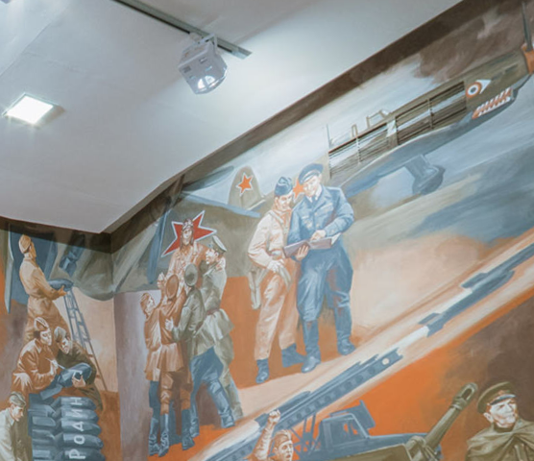
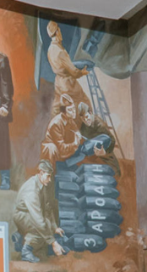

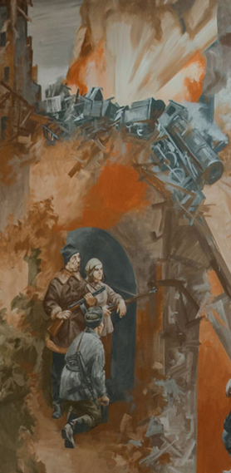
- Everybody knows that aviation played a great role during the war. It helped the land forces to feel safer. In this picture, you can see a group of war pilots who are busy equipping their planes for battle. The officers in charge are discussing the flight plan. Some pilots are writing patriotic words on the shells which they are going to use to strike the enemy. The words are “For the Motherland!” These words gave many soldiers the courage to attack the enemy by reminding them that they were saving their relatives and friends.

- In this picture, you can see members of a partisan detachment destroying bridges to prevent the Nazis from transporting tanks, soldiers and ammunition. Partisans risked their lives helping the army to move forward. But for their deeds, there would have been far more casualties in the army.
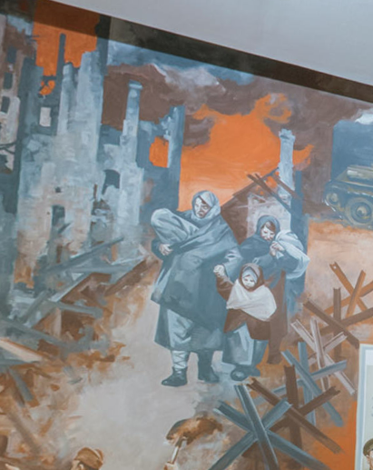

- In the picture, you can see refugees who lost their homes during the war. It is well known that the civilian population suffered as much as those in the armed forces did. Women and children left their homes and lived in forests or earth huts. But they wrote letters to their husbands, sons and brothers, trying to cheer them up. Such letters helped soldiers to overcome all the hardships of the war. In the background, you can see buildings in ruins. This was a usual sight after battles. It took decades to restore houses and return to a peaceful life.
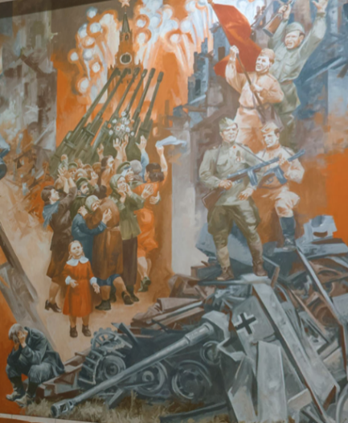

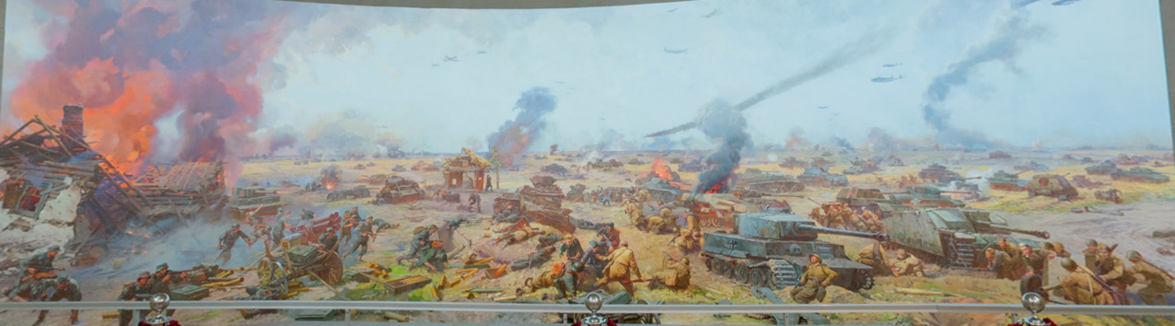
- In this picture, you can see a historical moment celebrating the victory of The Battle of Kursk. In the foreground, you can see the walls of Moscow’s Kremlin and colourful fireworks to celebrate the victory. The picture symbolizes the unity of the country and mutual happiness.

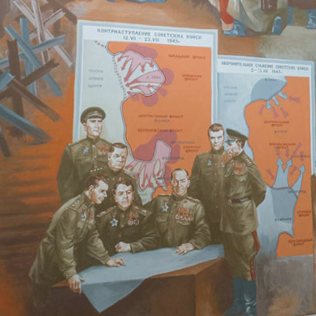
- In this picture, you can see a battlefield near Kursk. Here a famous tank battle took place. You can see scattered machine guns and tanks. It is possible to see one of the legendary T-34 tanks which played a great role during the war. We can also see combat lifesavers risking their lives to rescue a wounded soldier. In the sky, you can see planes that contributed to the victory. Thanks to the cooperation of all types of forces, it was possible to defeat the enemy.

- In this picture, you can see a group of officers discussing an important battle near Kursk. They are wearing a special uniform. We can see that they are decorated with many orders and medals. Some of them have a Hero of the Soviet Union star. They look thoughtful but determined. They have already received important information on the Nazis’ plans. In the background, you can see maps that show the location of armies and fronts. Soviet officers did all they could to win a great victory.
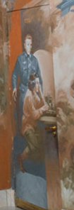

- In this picture, you can see an intelligence agent and a Morse code transmitter. The name of the intelligence agent is Kuznetsov. He looks very worried, as it was important for him to send the information as soon as possible. He is a legendary person who managed to learn secret information about the Nazis’ plans to attack. Thanks to his feat, it was possible to win the Battle of Kursk, because the Nazi attack was expected. The contribution of intelligence agents was enormous, as they helped to find out the enemy’s plans.
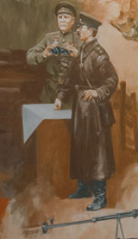

- Look at this picture. In the foreground, you can see two officers. They look worried and concentrated. They are wearing special uniforms. One of them is wearing a Soviet military tunic while the other is wearing a uniform jacket. They both have peaked caps on their heads. The man in a military tunic is holding binoculars to watch the enemy.
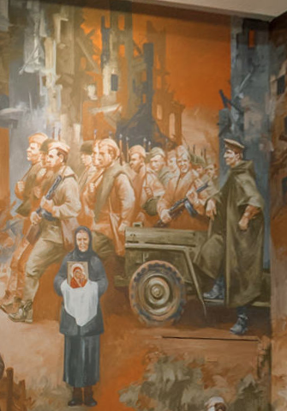

- Look at this picture. In the foreground, you can see an elderly woman with an icon. She is meeting soldier-liberators. She is wearing dark clothes consisting of a long dress, a jacket and a kerchief traditional for Russian women of that time. Such women inspired soldiers to defend the Motherland. They also tried to save soldiers by praying for them. In the background, you can see a group of soldiers advancing in rows. They are wearing Soviet military uniforms and are holding weapons. They look brave and strong. You can also see their officer in charge. He looks very focused.

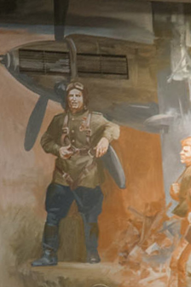

- Look at this picture. In the foreground, you can see a pilot. He is wearing a special uniform consisting of a Soviet military tunic, an aviation helmet and a special harness. In the background, you can see an aeroplane. It is obvious that the pilot is very skilled and has taken part in many battles. Victory in the Great Patriotic War would have been impossible without the enormous role of aviation.

Task 7
Return to the Hall of Historical Verity.
Students study the infographics titled Freedom for the West, Salvation for the East.
They look through the infographics section on the resistance movement in West European countries. They use the proper vocabulary to complete the following text.
The largest number of people took part in the resistance movement in Italy followed by France with 5000 people and 3500 people correspondingly. The number of people fighting in Belgium mirrors the number of people fighting in the Netherlands. The lowest number of Soviet citizens took part in the resistance movement in Norway followed by Greece with figures 100 and 300 correspondingly.
The final production task is writing a report based on the data, which you can find in the infographics section on the resistance movement in West European countries.
The following plan is to be used:
– make an opening statement on the subject of your report;
– summarise the information by selecting and reporting the main features;
– make comparisons where relevant;
– give an overview of the economic and humanitarian support contribution to the war effort;
– draw a conclusion.
It is recommended to assess the content (points covered, completeness), style and register (neutral or formal, appropriate linking), structure (paragraphs, logic and cohesion) and language (appropriate and correctly used vocabulary and grammar, spelling and punctuation).
Кейс
The students are to write an email letter using the information from the English version of the Museum’s website.
https://victorymuseum.ru/for-visitors/museum-for-china/en/
The task is as follows.
Use the information provided to answer the following email you received from your English-speaking friend Debby.
From: Debby@mail.uk
To: Russia_friend@ege.ru
Subject: The Victory Museum
…I’m really looking forward to my trip to Moscow! I’m especially interested in visiting the Victory Museum. How can I learn about the battles of the Great Patriotic War in the museum? Is there any information on the weaponry used during WWII? I’m going to travel with my parents and my 7-year-old brother. Will we be able to go on a guided tour?
By the way, I’ve decided to become a defence correspondent…

Write an email to Debby. Use the information leaflet below to answer her questions. Ask three questions about her future profession.
Write 100–140 words. Remember the rules of email writing.
The assessment is based on the National State Examination criteria.
Объём высказывания соответствует поставленной задаче: 90–154 слова
1. Решение коммуникативной задачи (Содержание) | Аспект 1. Ответ на вопрос 1 (упомянуты диорамы и панорамы музея)
 | Аспект 2. Ответ на вопрос 2 (упомянуты экспозиции на открытом воздухе)
 | Аспект 3. Ответ на вопрос 3 (упомянута экскурсия «Weapon of Victory»)
 | Аспект 4. Три вопроса о будущей профессии заданы
 | Аспект 5. Нормы вежливости соблюдены: благодарность за полученное письмо; надежда на последующие контакты
 | Аспект 6. Стилевое оформление выбрано правильно: обращение, завершающая фраза, подпись автора в соответствии с неофициальным стилем
 | ИТОГОВЫЙ БАЛЛ (максимальный балл – 2)
2. Организация | Логичность
 | Деление на абзацы
 | Средства логической связи
 | Обращение на отдельной строке
 | Завершающая фраза на отдельной строке
 | Подпись на отдельной строке
 | ИТОГОВЫЙ БАЛЛ (максимальный балл – 2)
3. Языковое оформление текста. ИТОГОВЫЙ БАЛЛ (максимальный балл – 2)*
*2 балла: орфографические и пунктуационные ошибки практически отсутствуют (допускается 1–2 лексико-грамматические ошибки И/ИЛИ 1–2 орфографические и пунктуационные ошибки).
1 балл: 3–4 лексико-грамматические ошибки И/ИЛИ имеется 3–4 орфографические и пунктуационные ошибки.
0 баллов: 5 и более лексико-грамматических ошибок И/ИЛИ орфографических и пунктуационных ошибок.
Кейс 2 (углубленный уровень)
This task is suitable for those aspiring to deal with journalistic or media-related translation. The students use the QR-code or the link below to see the text.
https://drive.google.com/file/d/1SLjLM6-lO3zOjnfSpeiRvicwg0TBdd61/view?usp=sharing

The students need to read an article on the Battle of Stalingrad and choose a passage for translation into English. Their work on the translation can be based on the following plan.
- Analyze the text:
- which grammar structures will you need to use?
- Which words and phrases do you need to look up?
- Are there any style and register peculiarities?
- Make a glossary of necessary vocabulary.
- Write a draft of the translation.
- Do error correction.
- Exchange translations with your peers, assess each other’s works and provide feedback. Consult with your English teacher. Edit the translation based on your peers’ and teacher’s recommendations.
Possible ways of organizing work and presenting results:
- All students translate the same passage. A contest for the best translation is organized.
- The whole article is divided equally among the students. The ultimate goal is to get a consistent translation of the article.
- All students translate the same passage. A contest for the best translation is organized.
- The whole article is divided equally among the students. The ultimate goal is to get a consistent translation of the article.

