Cheetahs
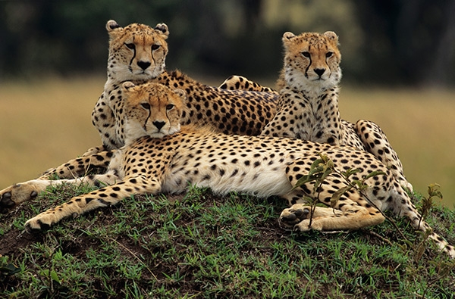
The cheetah is the world’s fastest land mammal. They live in eastern, central, and southwestern Africa, as well as a small portion of Iran. Wide nostrils and large lungs combined with a powerful heart and strong arteries provide more oxygen to their muscles. Their small body frame is lightweight and aerodynamic. With long legs cheetahs can cover 7 m in one stride. Camouflaged against the tall grasses, they quietly sneak up until they are confident of the attack. Their claws, which do not fully retract, grip the ground like cleats. Once they reach their target, they use their front paw to trip the prey, which include antelope, wildebeest calves, and hares. Then they strangle the animal with a bite and drag it to a hiding spot before another predator, such as a lion, leopard, or hyena, steals it. Unlike most cats, they have terrible night vision, which is why they hunt during the day. They also cannot climb trees. Female cheetahs give birth to around three cubs at a time. In the first few weeks, she moves the cubs from den to den, hiding them while she goes out hunting. At this point, they are very vulnerable to predators such as large eagles, lions, hyenas, and baboons. Young cubs grow a thick yellow-gray coat on their backs called a mantle. The mantle protects the cub from the sun and rain and helps camouflage it in the shadows. The mantle starts disappearing when the cub is around three months old and thins to a mane at around two years. The cubs that survive start following their mother at around 6 weeks. They practice hunting though play with each other. After a year and a half, their mother leaves them to breed again. But the male offspring often stay together for life, forming a group called a coalition. Coalitions are beneficial because they help male cheetahs gain territory.
Источник: http://www.animalfactguide.com/animal-facts/cheetah/

