School ___________ Class________ Date ______________
Name _________________________Surname_____________________________

W O R K S H E E T В

Exercise 1: Read the description and find the name of the reception room.

The palace drawing room got its name from the carpets (tapestries) hung on the walls of the room. These depict European specimens of parks and gardens. Made in Flanders at the end of the 17th century_______________________________________________

Exercise 2: Describe the exhibit using the words.
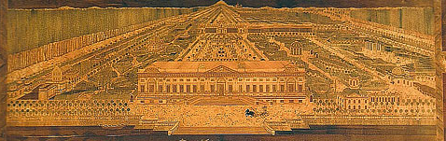 | The Note table, 1770s  It is the unique exhibit in the museum collection.  The surface of the table is an inlaid picture done of  various kinds of wood and representing the park  in Kuskovo . The work of surf craftsman Nikifor Vasilyev.  The signature of the master can be seen in a corner on the  right.

Exercise 3: Describe the exhibit.
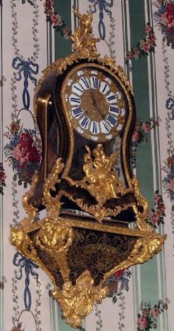 | The Wall clock, 1st half of the 18th century  The wall clock is the unique exhibit in the museum  collection. It was made in France at the workshop of the  famous craftsman Andre Charles Boule. The clock case is  decorated with a tortoise-shell.

Exercise 4: Describe the portrait using the words.
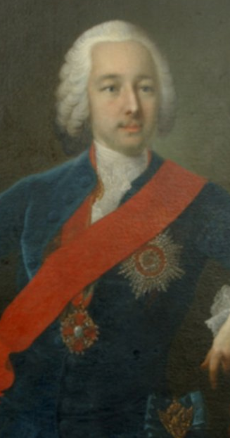 | The Portrait of Piotr Sheremetev  This canvas is one of museum’s masterpieces painted in oils by  the famous German artist Georg Christophr Groot.  The portrait depicts the master of this country house.  It is the ceremonial portrait painted from nature .  The sitter is represented as a charming young aristocrat .  elegantly dressed in а blue suit with the red ribbon and  the Order of St. Ann . From the Sheremetev collection .

Exercise 5 Describe the portrait
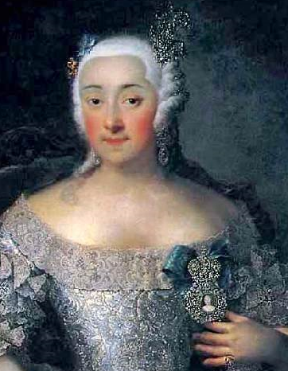 | The Portrait of Varvara Sheremeteva  The Portrait of Varvara Sheremeteva is a copy prom the G. C.  Groot original. The portrait depicts the wife of the master of  this house. It is the three quarter length portrait painted  in oils. The sitter is represented as a charming young lаdy  elegantly dressed. From the Sheremetev collection.

Exercise 6: Сhoose any picture in the Picture room. Describe the picture and offer to your friends to find it.
Useful phrases

portrait | the picture is executed  in bright (dark) tones | in the foreground
self-portrait | three quarter length | in the background
landscape | shoulder-length | to the left (right)  of the picture
still life | full-length | in the distance

