Musk Oxen
Musk oxen are arctic animals. They have thick hair that grows 2 feet long and almost touches the ground. This hair keeps musk ox warm during cold winters. Musk oxen live in Canada, Alaska, Greenland, Siberia and Norway – farther north than any other hoofed animal. Musk oxen are herbivores. Not much grows in their cold climate, but they eat moss, roots and lichen found under the snow. In the summer, they add grass and arctic flowers to their diet. Musk oxen travel in herds of 10 to 20 oxen.
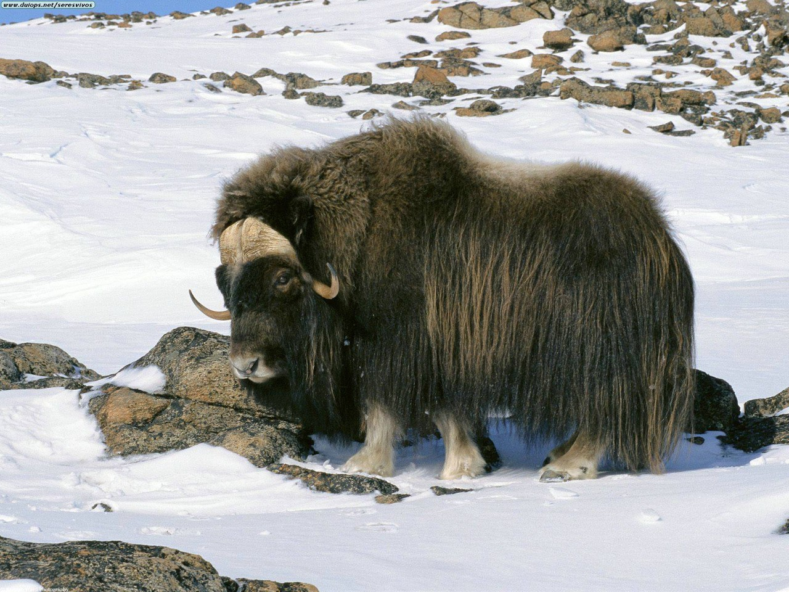
• Musk oxen are big and strong. They can weigh as much as 850 pounds.
• Musk oxen live about 12 to 20 years.
• Musk oxen are hunted by arctic wolves and occasionally polar bears.
• Musk oxen have curving, pointed horns.
• When threatened, musk oxen gather in a circle with their heads facing out. Their babies are protected in the middle of the circle. They use their strong horns to keep predators away from the babies.
• Humans hunted musk oxen for their meat and fur. The animals were almost extinct. Now they are protected. It is against the law to hunt them.
• Musk oxen have two glands under their eyes that produce musk, which is a strong odor.
Источник: http://easyscienceforkids.com/all-about-musk-oxen/

