It’s a bird!
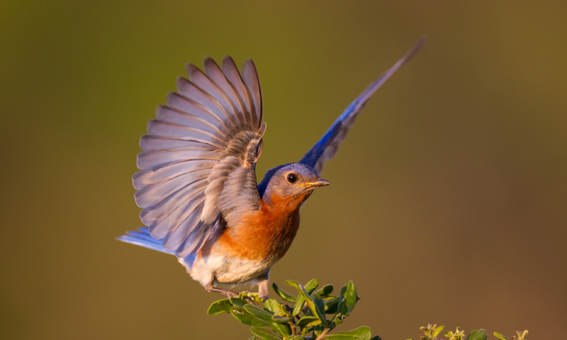
A bird is a warm-blooded animal with two legs, wings and a hard beak.
Birds have three remarkable traits that make them different from other animals: feathers, hollow bones and hard-shelled eggs.
Feathers make birds special. No other animal has feathers! Feathers help birds fly, protect their skin, and keep them warm and dry. Feather colors help the bird identify their species and attract mates.
Birds have unique bones that are hollow like a straw but have strong inside support structures. These hollow bones make the bird lighter and help them fly. A few birds don’t fly, like the penguin and the ostrich.
Birds hatch or are born from hard-shelled eggs that are laid by an adult bird. The hard shell keeps the inside of the egg moist and allows the parent bird to sit on the egg to keep it warm during incubation. The egg shell also has microscopic pores that allow oxygen to enter the shell so the baby bird can breathe before it hatches.
What are three traits of a bird?
How do feathers help birds?
How do hollow bones help birds fly?
How do hard shells help birds?

Источник: Vickie Henderson «Discover Birds. Activity Book» 2012 TN Ornithological Society and Vickie Henderson http://www.tnwatchablewildlife.org/files/DiscoverBirds_1_Intro.pdf

