Worksheet
Introduction
1. Describe the exterior of the museum building.
- Is it a modern or an old construction?
- Does it blend with the surrounding area or standout?
- Does it look like a museum from the outside? Why or why not?
- Are there any architectural, sculptural or other indications of the type of objects
displayed inside?
____________________________________________________________________________________________________________________________________________________________________________________________________________________________________________________________________________________________________________________________________________________________________________________________________________________________________________________________________________________________
2. What kind of museum is the Museum of A.N. Scriabin? Tick the right variant and give the definition:
 | Art museum |  | History museum |  | Natural history museum
 | Maritime museum |  | Virtual museum |  | Historic house museum

____________________________________________________________________________________________________________________________________________________________________________________________________________________________________________________________________________________________________________________________________________________
3. Alexander Scriabin is the great Russian composer, pianist, philosopher. He was born on December 25, 1871 according to the Julian calendar. What is the date of the birth of the composer according to the Gregorian calendar we use today? (The discrepancy between the Julian and Gregorian calendars is 13 days).
____________________________________________________________________

Scriabin’s apartment is a typical example of a city apartment of the beginning of the 20th century. There are several rooms in the flat, including an entrance hall, a study, a drawing room, a dining room, where Scriabin liked to relax and entertain his friends, and a bedroom.
Study
- To the left of the entrance door you can see some photos. Look at the photos. a) What profession did A. Scriabin dream when he was 10 years old? Where did he enter in 1882?
________________________________________________________________________________________________________________________________________
b) A. Scriabin studied the piano from an early age, taking lessons with Nikolai Zverev. What educational institution did he enlist in 1888?
________________________________________________________________________________________________________________________________________

- There are three different types of armchairs in the study. Match the words with the definitions and fill in the chart.
 | NAME |  | DEFINITION
1 | Wing back chair (grandfather’s chair) | A | A chair built on two pieces of curved wood so that it moves forwards and backwards/ a chair that has two curved pieces under it, so that when someone sits on it they can move it backwards and forwards.
2 | Rocking chair | B | A chair allows the users to adjust their seating position by changing the angle of the back.
3 | Adjustable chair on wheels | C | An upholstered armchair with high solid back and angled sides/ a comfortable chair with a high back that has pieces pointing forward at the top corners.

NUMBER | LETTER | PHOTO

What kind of chair was the most unusual at the beginning of the 20th century?
____________________________________________________________________

- Look through the books in the bookcase.
a) What languages could Scriabin read?
________________________________________________________________________________________________________________________________________
b) What kinds of books was A. Scriabin interested in?
 | Philosophy |  | Art |  | Poetry
 | Science fiction |  | Fiction |  | Children's literature

- Furnishing his apartment, Scriabin preferred the most popular style of his time, Art Nouveau. It is characterized by flowing asymmetrical lines and patterns of flowers and leaves.
Try to determine the interior items that belong to this style and take photos of them.
Object | Photo

- The pride of the study is the world’s first machine to perform the “Prometheus: The Poem of Fire” (1910) designed by Scriabin himself and made by Professor Alexander Mozer. It was mostly used as a home amusement device to accompany Scriabin’s improvisations at the piano with multicoloured lights.
Scriabin became the founder of a new art movement. It is _____________________.
Drawing room
- Two large canvases are copies of the works by an Italian painter Correggio (1489–1534). They were executed by N.P. Shchetinin. What art style do these pictures belong?
 | Renaissance |  | Art Nouveau |  | Impressionism
- Find the portrait of the father, Nikolai Scriabin. He followed a military path and served as a military attaché. Look at the portrait and try to define which country did he worked?__________________________________________

- There is the drawing by Boris M. Kustodiev (1878–1927) "Scriabin's Last Recital in Petrograd, April 2/15, 1915". Find it, take a photo and write its description.
____________________________________________________________________________________________________________________________________________________________________________________________________________________________________________________________________________________________________________________________________________________

Entrance hall
- Read the description, find the object and write its name.
It turns everything around but does not move. ______________________________
- What kind of lamp is in the hall? Tick the right variant and give the description:
 | Chandelier |  | Torch |  | Lantern

________________________________________________________________________________________________________________________________________________________________________________________________________________________________________________________________________________
- Define a telecommunications device that permits two users to conduct a conversation when they are too far apart to be heard directly here. What is it? ______________________________________________________________
Do the task and you will know what Scriabin’s number was.
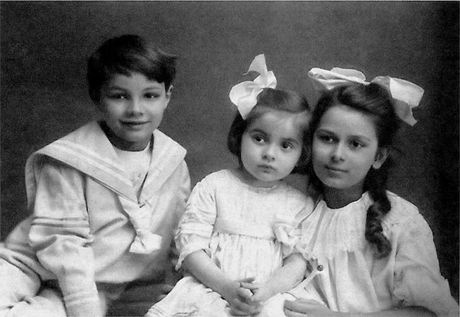 | Divide the number of the composer's birth year (the Gregorian calendar)  by two. | Multiply the date of Scriabin’s last recital (the Gregorian calendar) by two.
Look at the picture. How many children can you see in the picture?

Using the information from the Worksheet, create an advertising leaflet for the Museum of A. N. Scriabin.

