Урок английского языка в Музее Победы для медиаклассов
People’s activities during the World War II
Case
Visit the English version of the Museum’s website.
https://victorymuseum.ru/for-visitors/museum-for-china/en/
Use the information provided to answer the following email you received from your English-speaking friend Debby.
From: Debby@mail.uk
To: Russia_friend@ege.ru
Subject: The Victory Museum
…I’m really looking forward to my trip to Moscow! I’m especially interested in visiting the Victory Museum. How can I learn about the battles of the Great Patriotic War in the museum? Is there any information on the weaponry used during WWII? I’m going to travel with my parents and my 7-year-old brother. Will we be able to go on a guided tour?
By the way, I’ve decided to become a defence correspondent…

Write an email to Debby. Use the information leaflet below to answer her questions. Ask three questions about her future profession.
Write 100 – 140 words. Remember the rules of email writing.
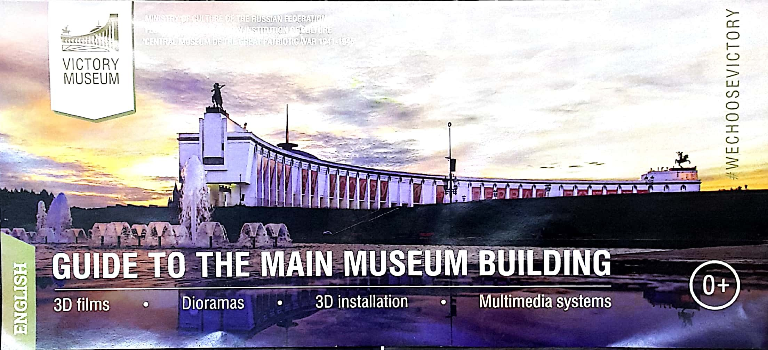
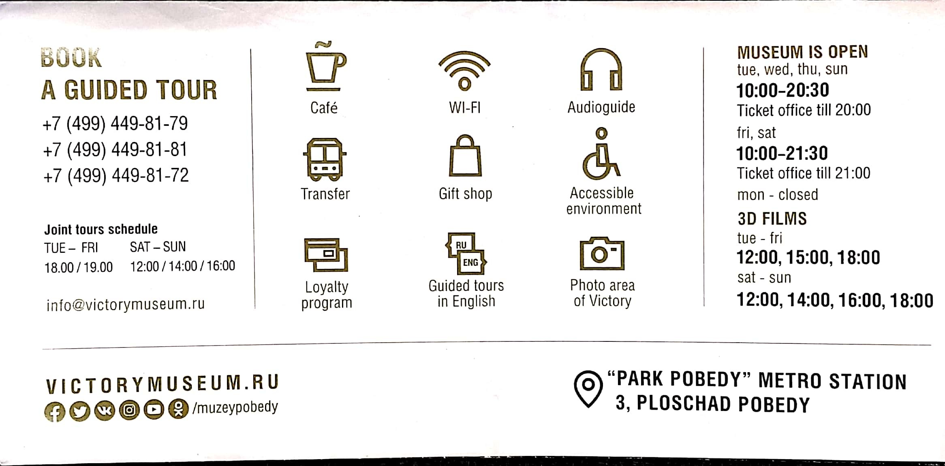
Кейс 2 (углубленный уровень)
This task is suitable for those aspiring to deal with journalistic or media-related translation. The students use the QR-code or the link below to see the text.
https://drive.google.com/file/d/1SLjLM6-lO3zOjnfSpeiRvicwg0TBdd61/view?usp=sharing

The students need to read an article on the Battle of Stalingrad and choose a passage for translation into English. Their work on the translation can be based on the following plan.

- Analyze the text:
- which grammar structures will you need to use?
- Which words and phrases do you need to look up?
- Are there any style and register peculiarities?
- Make a glossary of necessary vocabulary.
- Write a draft of the translation.
- Do error correction.
- Exchange translations with your peers, assess each other’s works and provide feedback. Consult with your English teacher. Edit the translation based on your peers’ and teacher’s recommendations.
Possible ways of organizing work and presenting results:
- All students translate the same passage. A contest for the best translation is organized.
- The whole article is divided equally among the students. The ultimate goal is to get a consistent translation of the article.
- All students translate the same passage. A contest for the best translation is organized.
- The whole article is divided equally among the students. The ultimate goal is to get a consistent translation of the article.

