Task № 1
Read the text.
There is a pavilion in Tsaritsyno Park called “Nerastarkino”. It was built in 1803 by V.S. Valuev for visitors’ recreation following the opening of Tsaritsyno for the public by Aleksandr I.
The pavilion is located on the top of a reclined coastal slope in the southern part of the park, just behind Bolshoi Avenue. From here there is a picturesque view of the pond and the "Ruined Arch" on the island. The pavilion is a typical park-style gallery in the style of classicism, and it has two elongated facades. A wide through passage occupies the entire central part of the facades. The passage is decorated with strict Doric (Tuscan) porticos with attics. The gallery is overcovered with a low dome. There is a small basement on the ground floor of the pavilion. The walls are made of red, well-burnt bricks. In publications of the beginning of the 20th century, the pavilion was called the “Temple of Melancholy”.

Answer the questions:
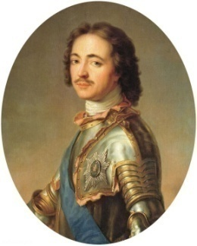
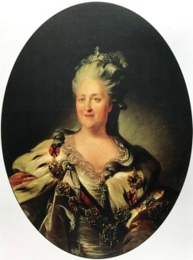
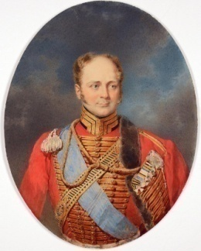
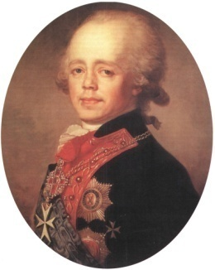
1. Who of the Russian rulers opened Tsaritsyno Park for public visiting?

Paul I Peter I Alexander I Catherine II

2. What alternative names of the pavilion “Nerastarkino” are mentioned in historical publications? Write them down: _____the “Temple of Melancholy”____________________________________________________

Task № 2
Read the text.
“Temple of Ceres” (“Golden Sheaf”) is a garden and park pavilion on the southern edge of the landscape part of Tsaritsyno park. It was built in 1805 by I.V. Egotov. In 1806 the sculpture of Ceres with a gilded sheaf in its hands was installed on the pedestal in the centre of the pavilion. Ceres was the ancient Roman goddess of agriculture and harvest. This is the way the name of the pavilion appeared. The temple has a form of rotunda which consists of eight columns of the Ionic order overcovered with a dome and standing on a three-stage stylobate. The dome of the gazebo is decorated with a parapet-balustrade and a metal sheaf of ears. The type of such a rotunda gazebo was widespread in the garden and park architecture of classicism in the second half of the 18th - first third of the 19th century.

Answer the questions:
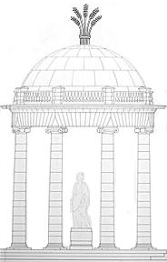
1. Mark following details in the picture:
1) column;
5
2) dome;
3) stylobat;
2
4
4) parapet-balustrade;
5) sheaf;
6) sculpture.

1
6
2. Ceres is the goddess of:
3
a) war;
b) trade;
c) farming;
d) beauty.
Task № 3
Read the text.
The “Ruined Arch” (“The Residence of the Mermaids”, “the Mermaids’ Gate”) is one of the earliest buildings in Tsaritsyno Park. The “Arch-ruin” was built by I.V. Egotov supposedly in 1804. Its role is purely ornamental. The island with the Arch is situated on the Upper Tsaritsynsky pond in front of Nerastankino pavilion. The building of the Arch was started after the deepening and widening of the upper part of the pond. The artificial island that existed here, was enlarged and divided into two parts by a narrow canal. Built from brick and fronted with white stone, the Arch was thrown over the canal and connected its shores. Initially, as seen on the plans of the first third of the 19th century, the building was completed with a tower with a fluttering pennant.

Choose how the arch looked in the first third of the 19th century:

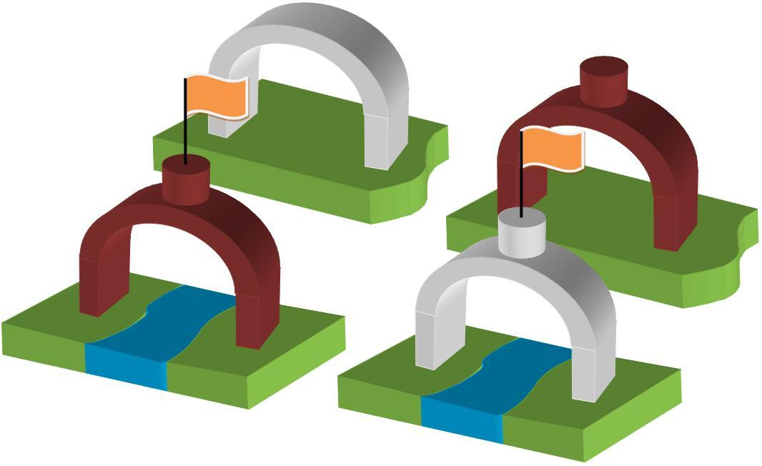

Task № 4
Read the text.
“Milovida” is a park pavilion in the landscape part of Tsaritsyno Park. It was built by I.V. Egotov in 1803. The Pavilion is situated at the crossing of Blind avenue and Morning path. It is a gallery with a semicircular vault. Sixteen columns of the Doric order support the vault. The cylinder of the false arch was painted with caissons in the technique of grisaille with glue paints. The walls of the pavilion are made of red, well-flamed bricks. Initially, the upper part of the pavilion was built of vertically set logs with a diameter of 16 cm, tightly fitted to each other.

Answer the questions:
1. In what year was the pavilion built? ____1803____________
2. How many columns support the vault? ____16______________
3. What materials were used during the building of the pavilion? Name them. ____________ glue paints, logs_____________________________________

4. Look at the picture. What can you see in it? When was this photo taken? Prove your suggestion.
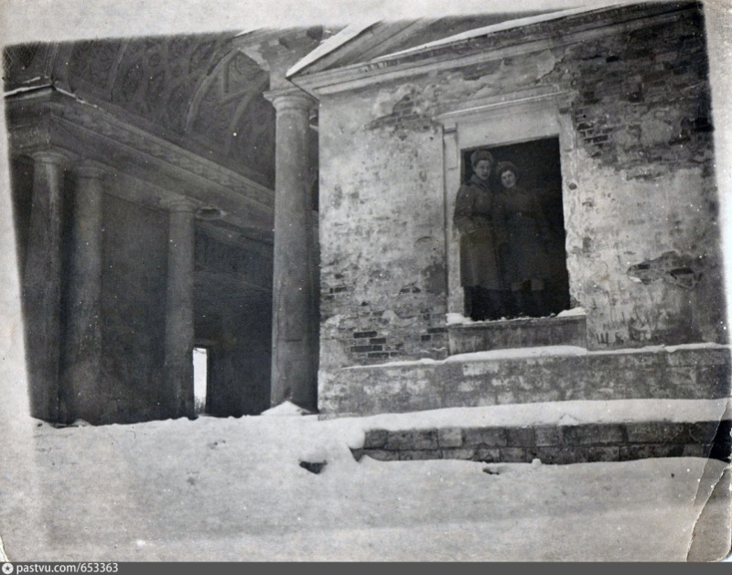

Task № 5
Read the text.
“Sculptural” gate was built in 1777–1778 by Vasiliy Bazhenov. It is one of the first buildings of Tsaritsyno ensemble. The gate shows the fictitious border between the palace part and the park part of the estate. The gate is called “sculptural” because of the intricate forms and decor. The second name of the gate is the “Grape” gate. This name appeared in the middle of the 20th century because of white-stone decor in the opening of the arch, which looked like a vine shoot.
In 1825 the gate was decorated with four ornamental vases, two white-stone Cupido statues, and two ceramic pug dogs. By the middle of the 19th century, the majority of sculptures had disappeared. The parts of parapet and white-stone obelisk had disappeared by the beginning of the 20th century.

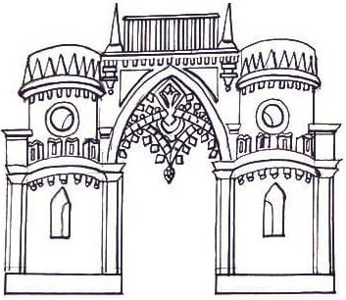
Draw the missing elements that existed in 1825.

Task № 6
Read the text.
The Gallery-fence with a gate is a decorative building that separates the central palace part of the estate from the garden part.
It was built by V.I. Bazhenov in 1784–1785. This building is located between the Kitchen building and the Grand Palace of the architect M.F. Kazakov. During the construction period of the Grand Palace, the southern end of the Gallery was demolished and re-led to its north-eastern tower.
The figured “prickly” arch is one of the most remarkable architectural details of the ensemble.
The image of the arch with thorns and the gate-fence probably also contains Christian symbols of “thorns” waiting for a person during the transition from the worldly sinful life to the salvation of Eden.
Answer the questions:
1. Who is the architect of the gallery? ___ V.I. Bazhenov_________________
2. Who is the architect of the Grand Palace? ___M.F. Kazakov____________
3. Mark on the map the location of the Kitchen building (Bread House) and the Grand Palace. What is situated in the place marked • ?
_____________________
_____________________
_____________________
_____________________
_____________________
_____________________
_____________________
_____________________
_____________________
_____________________

