Group Names for Birds
Complete the expressions with the words gaggle, colony, parliament, bouquet, flight, company.
A _______________ of owls | 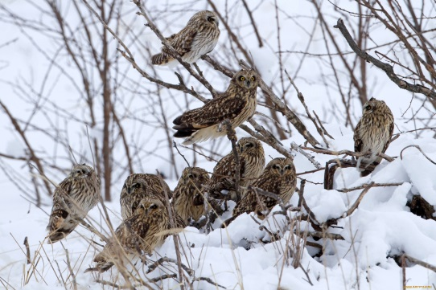
A _______________ of geese | 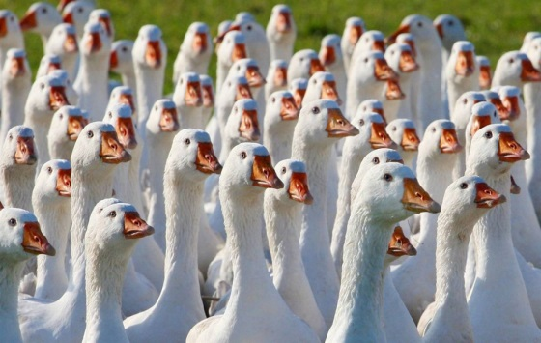
A _______________ of parrots | 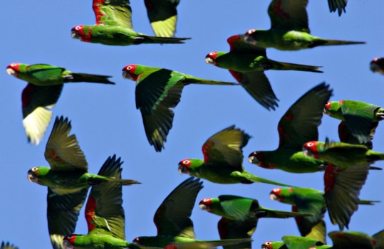
A _______________ of penguins | 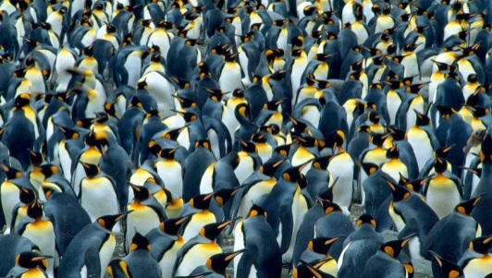
A ______________ of pheasants | 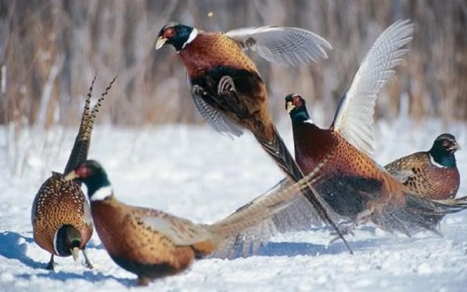
A _______________ of swallows | 