Worksheet
- This is a map of the world. Mark the areas where the animals from the worksheet can be found in the wild.
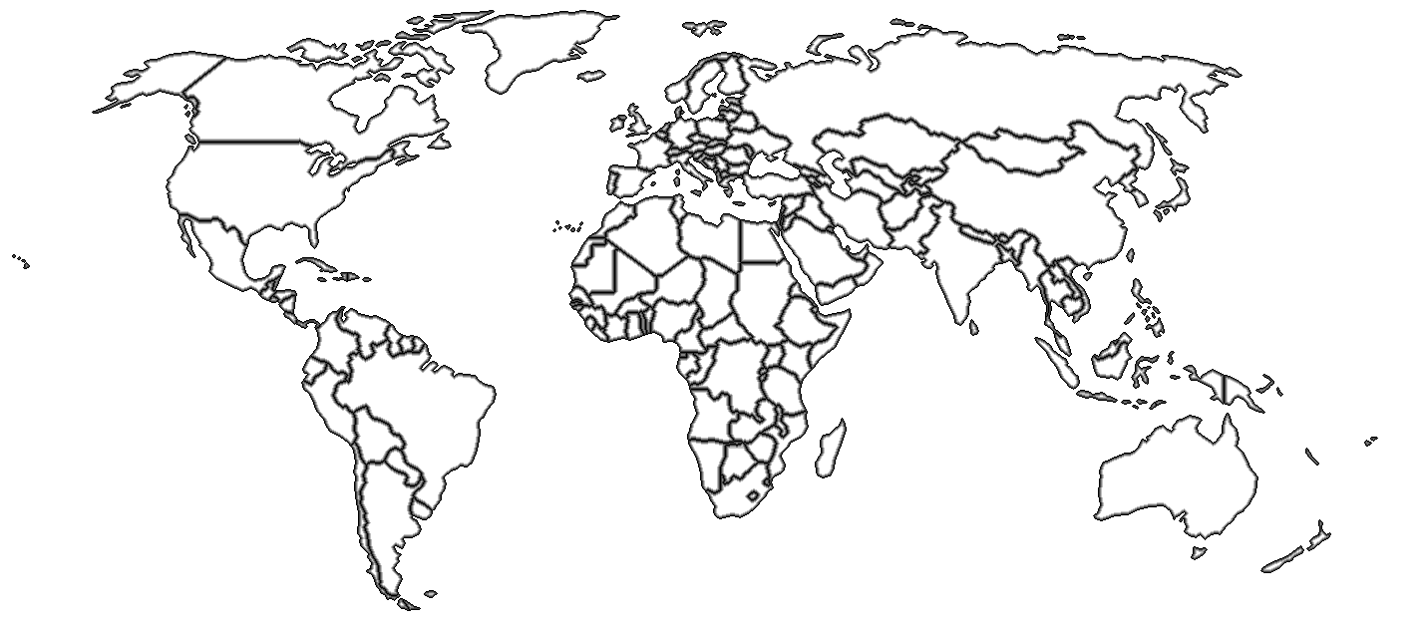

II. Do the following tasks.
Birds of prey
- Match the words head, eye, beak/bill, wing, tail, talon, foot, breast with the parts of the body.
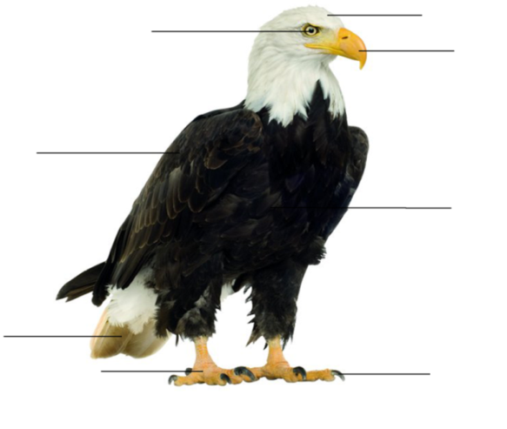
- What is a raptor? Choose the right variant:
- a bird that eats seeds and grains;
- a bird that catches and kills live animals for food.

- Which raptors can be found in the Moscow Zoo?
________________________________________________________________________________________________________________________________________________________________________________________________________________________________________________________________________________
- What do they eat?
___________________________________________________________________
- How do they get their food in the wild?
___________________________________________________________________
- What special adaptations do these birds have to be good hunters?
___________________________________________________________________
- Take photos of two raptors. Fill in the table and compare two raptors using the Degrees of Comparison of Adjectives.
Name of the bird
Photo
Body size
Beak/bill
Body colour
Wings
Tail shape
Talons
Sounds
Diet
________________________________________________________________________________________________________________________________________________________________________________________________________________________________________________________________________________

Cheetahs
- Match the words head, eye, ear, nose, back, front leg/foreleg, hind leg, tail, paw, claw with the parts of the body.
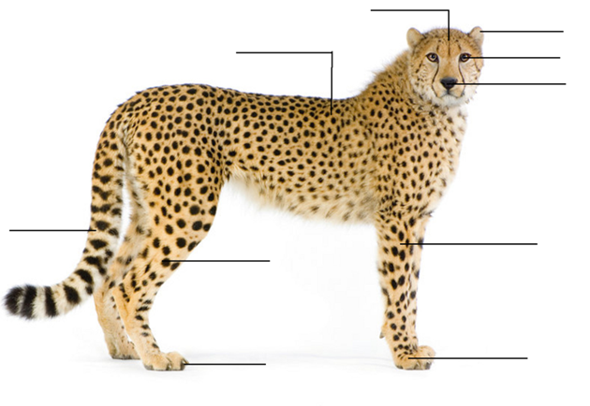
- Fill in the box.

Scientific Name
Name
Length
Weight
Diet
Numbers of cubs
Speed
Geographical Range
Habitat

- Write 5 words that characterize cheetahs.
____________________________________________________________________________________________________________________________________________________________________________________________________________
- What colors does a cheetah have on its body?
____________________________________________________________________________________________________________________________________________________________________________________________________________
- Why does a cheetah have spots? _____________________________________________________________________________________________________________________________________________________________________________________________
- Take some photos of the cheetah.

- What is the cheetah doing during your visit?
____________________________________________________________________________________________________________________________________________________________________________________________________________________________________________________________________________________________________________________________________________________
Musk oxen
- What animal family does the musk ox belong to? _______________________________________________________________
- Do musk oxen sleep standing up or lying down?
______________________________________________________________
- What do they eat? Does this make them carnivores or herbivores? Explain.
_______________________________________________________________
- Do musk oxen migrate or stay year-round in one place?
_____________________________________________________________
- What is special about the musk ox’s fur?
_______________________________________________________________
- Do they stay in groups or do they like to be by themselves?
_______________________________________________________________
- When predators attack, how do they defend themselves?
_______________________________________________________________
- Look at the musk oxen, read the description, find the mistakes and correct them.
Musk oxen are short-haired animals with a very long tail. They don’t have horns. They are 60 сm high and weigh about 100 kg. Cows are bigger than bulls. Musk oxen are found in South America and Africa.
________________________________________________________________________________________________________________________________________________________________________________________________________________________________________________________________________________
Tapirs
- Observe the tapirs at the exhibit and take photos.

- Even though tapirs look very similar to pigs, they are actually related to _______________________________________________________________
Tapirs are________________, they eat grasses, aquatic plants, leaves and fruits
of low-growing shrubs.
Tapirs use their flexible ______________ (proboscis) almost like a finger, to
pluck vegetation from low hanging trees and shrubs.
Tapirs are good divers and__________________________________________.
Main predators of tapirs include_____________________________________.
- What is the tapir doing during your visit?
____________________________________________________________________________________________________________________________________________________________________________________________________________________________________________________________________________________________________________________________________________________

- Classify each animal as a consumer: herbivore [ˈhɜːbɪvɔː]( травоядное), carnivore [ˈkɑːnɪvɔː] (плотоядное животное ), omnivore [ˈɒmnɪvɔː] (всеядное животное )
herbivore | carnivore | omnivore

- Animal cinquain
Use the lines below to write a cinquain poem about an endangered animal.

Animal cinquain

_______________
(1 word — an animal)

_______________ _______________
(2 words that describe it)

_______________ _______________ _______________
(3 words expressing action)

_______________ _______________ _______________ _______________
(4 words telling what you feel about it)

_______________
(sum up with 1 word)

- Using the photos and the information from the worksheets make “Animal fact book”.

