Vladimir Vysotsky: from Here to Eternity

Фамилия, имя ____________________________________________________________________

Схема движения группы: экспозиция «Начало пути», экспозиция «Любовь и дружба», экспозиция «Кино и театр», экспозиция «Песни и стихи».

- Экспозиция «Начало пути»

№ 1. Youth

Study the exhibits of Hall 1 – The Starting Point – and complete the timeline of Vladimir Vysotsky’s youth with the dates.

Do you think the historic period when Vysotsky was young influenced his work as a poet and an actor? Support your answer with the evidence found in the exhibition. Discuss with a partner/group.

- Экспозиция «Любовь и дружба»

№ 2. Travel

Move on to the next hall – Love and Friendship.
Study the showcases devoted to the poet’s travelling and do the following task in two groups.

Group A

Study the map where Vysotsky marked the places he had visited. Then read poems I, VI and VIII from his Road Diary series.

Use the QR-code to access the poems:

Which four countries did he visit during his road trip in 1973? Are they the same countries today?

Draw his approximate route and prepare a brief report to share with the other group.

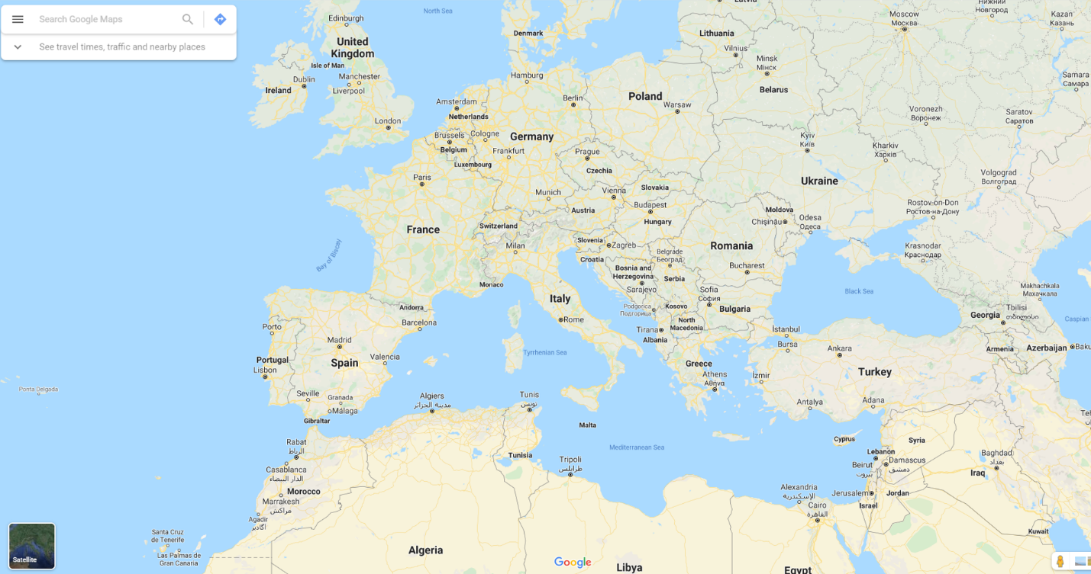

Period

Route

Notable facts

Group B

Study the map where Vysotsky marked the places he had visited. Then read the interview with Feliks Dashkov, who used to be captain of the Belorussiya cruise ship, about his two trips with Vysotsky in 1975 and 1976.

Use the QR-code to access the interview script:

How many countries and continents did they visit?

Draw their approximate route and prepare a brief report to share with the other group.

Period

Route

Notable facts

Share information with the other group. Compare your maps with each other and Vysotsky’s map. Which places are left out? When do you think he visited them and why? Use the museum exhibits to obtain more information. Present your ideas to your teacher and ask for verification.

- Экспозиция «Кино и театр»

№ 3. Cinema

Move on to the next hall – Cinema and Theatre.
Study the two posters. Have you seen these films?

If yes, do the posters express the ideas of the films in your view?
Why/why not?
If no, what do the posters tell you about the films? Would you like to watch them? Why/why not?
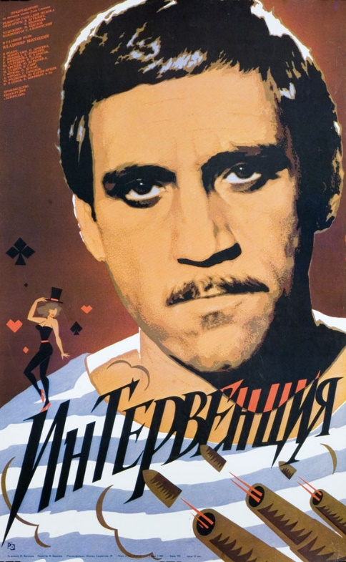
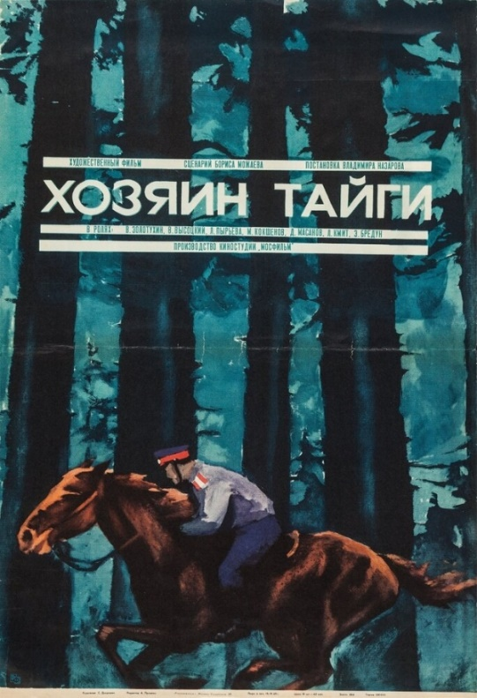

Work in pairs.

Student A

In 1,5 minutes be ready to compare and contrast the pictures:
• give a brief description of the picture (action, location);
• say what the pictures have in common;
• say in what way the pictures are different;
• say which of the posters better shows what the film is about;
• explain why.
You will speak for not more than 2 minutes (12–15 sentences). You have to talk continuously.

Student B

Listen to your partner and assess his or her talk using the checklist:
Organization (introduction, conclusion, structure, logic)
Brief description
Similarities
Differences
Which is better
Why
Language accuracy (grammar, vocabulary, linkers)

№ 4. Theatre

Are you a theatre lover? Why/why not?
How are theatre posters different from the cinema ones in terms of design and information?

Work in pairs. Student A would like to learn more information about a play. Student B is a theatre attendant and provides necessary information. Role-play one of the following situations.

1
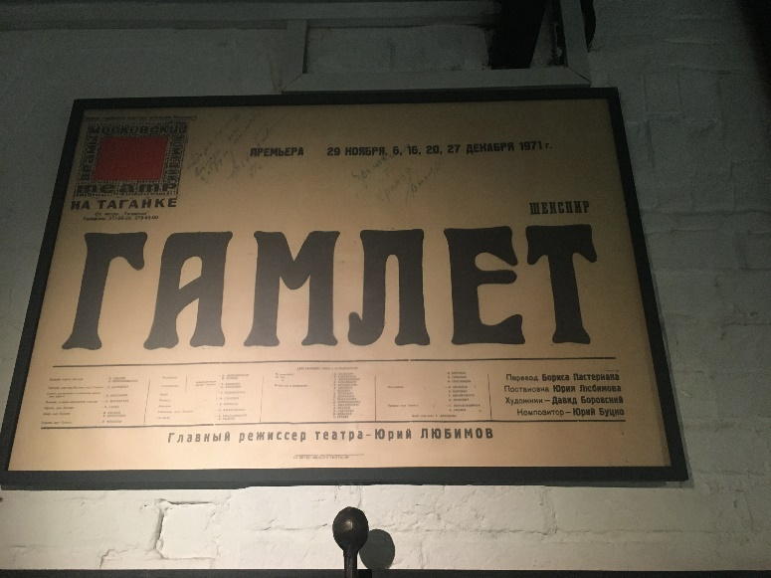
Student A. You are considering seeing a play and you'd like to get more information. In 1.5 minutes, you are to ask questions to find out the following:
1) the name of the theatre;
2) location;
3) dates;
4) producer;
5) actors and actresses.

Student B. You are to provide your partner with the answers. Study the poster to find the necessary details. You have 1.5 minutes to get ready.

2
Student A. You are considering seeing a play and you'd like to get more information. In 1.5 minutes, you are to ask questions to find out the following:
- the name of the theatre;
- the name of the play;
- producer;
- composer;
- dates available.

Student B. You are to provide your partner with the answers. Study the poster to find the necessary details. You have 1.5 minutes to get ready.

3
Student A. You are considering seeing a play and you'd like to get more information. In 1.5 minutes, you are to ask questions to find out the following:
- where;
- when;
- number of acts;
- tickets available;
- actors and actresses.

Student B. You are to provide your partner with the answers. Study the poster to find the necessary details. You have 1.5 minutes to get ready.

4
Student A. You are considering seeing a play and you'd like to get more information. In 1.5 minutes, you are to ask questions to find out the following:
- the name of the theatre;
- special occasion;
- telephone number;
- the type of play;
- the time of the performance.

Student B. You are to answer five questions. Use the information on the poster. You have 1.5 minutes to get ready.

№ 5. Poster Design

Look at the poster of the film A Bad Good Man. Have you seen it?
If yes, what is it about and how can you explain the title?
If no, what might it be about? Would you like to see it? Why/why not?

Study the poster and read the description. Think of the word which best fits each gap and complete the text.

Look __________ this colourful poster. It shows us different people. _________ the foreground you can see a woman wearing an elegant hat with a pink _________ and kissing a man wearing a _________ suit. Just _________ them you can see two men discussing something. They _________ wearing sea captain caps and white jackets. The man on the _________ is wearing a uniform.
_________ the background you can see two men as well. The man _________ on the rock is wearing a grey jacket, brown trousers and a white cap. The man standing _________ to him is wearing a long white robe and a _________ hat. He is _________ a tree branch in his hand. They _________ look thoughtful.
Further still, you can see a wonderful seascape. _________ looks fantastic.
I decided to show you this photo because I would like to recommend this fascinating film _________ you. I hope you’ll watch it soon!

Choose a poster of the film you’d like to see. Describe it to your partner so that he or she can find it in the exhibition hall.
Was it easy for you to guess your partner’s choice? Why/why not?
Do you and your partner have similar tastes?

№ 6. Hamlet

Have you read Hamlet by W. Shakespeare or seen it on stage?
If yes, what impression did it make on you? Why?
If no, would you like to read and/or see it? Why/why not?

Watch a video showing Vladimir Vysotsky as Hamlet.

How would you characterize his version of Hamlet? Choose the best adjectives to describe the character and support your view with the details you’ve noticed in the video (gestures, tones and intonations, etc).

contemplative, playful, aggressive, calm, nervous, fidgety, dreamy, uncertain, depressed, decisive, violent, secretive, relaxed, excited, passive, reserved, volatile

What do you think of Vysotsky’s interpretation of Hamlet?
Share your ideas with the group. Explain your opinion. To what extent do you agree with each other?

Hamlet is a vast topic for studying and discussion. If you are interested in learning more about this play and its various interpretations, do the Case Study.

- Экспозиция «Песни и стихи»

№ 7. Songs and Poems

Study the chart showing Vysotsky’s creative productivity. What kind of chart is it:

A) a line graph;
B) a pie chart;
C) a bar chart;
D) a Venn diagram.

Why is it suitable to present such data? Which of the other charts can be used for the same purpose?

Read the description and fill in the missing words from the box.

fluctuated, slight, rise, mirrored, dropped, correspondingly, equal, witnessed
Vladimir Vysotsky started his musical career with only one song in 1960. There was a ____________ in the number of songs in 1961 and 1962 from 8 to 11 but in 1963 it ____________ to 9.
The year 1964 ____________ a dramatic increase in the number of songs which was ____________ to 29. During the decade from 1964 to 1974, the number of written songs ____________ from 22 to 28. The year 1973 brought the largest number of songs (52).
Interestingly, the number of songs in the years 1966, 1968, and 1971; in 1961 and 1977; 1979 and 1980, 1962, and 1979 ____________ each other with the numbers of songs 31, 8, 3, and 11 ____________.
From 1975 to 1978 there was a ____________ fluctuation from 16 to 11 songs followed by a drop to 3 songs.

How can you explain the changes in Vladimir Vysotsky’s creative productivity? Which events of his life might have caused them? Use the evidence to support your answers among the exhibits.

№ 8. Alice in Wonderland

Find the machine that plays recordings from the Alice in Wonderland radio play.
Listen to the songs Alice’s Fall (Падение Алисы) and The Antipodes’ Song (Песня антиподов). Which events of the story by Lewis Carroll do they describe?

Read the corresponding extract from Alice’s Adventures in Wonderland by Lewis Carroll.

CHAPTER I.
Down the Rabbit-Hole
quoted from THE MILLENNIUM FULCRUM EDITION 3.0

*the unabridged text with the original spelling
<…>
In another moment down went Alice after it, never once considering how in the world she was to get out again.
The rabbit-hole went straight on like a tunnel for some way, and then dipped suddenly down, so suddenly that Alice had not a moment to think about stopping herself before she found herself falling down a very deep well.
Either the well was very deep, or she fell very slowly, for she had plenty of time as she went down to look about her and to wonder what was going to happen next. First, she tried to look down and make out what she was coming to, but it was too dark to see anything; then she looked at the sides of the well, and noticed that they were filled with cupboards and book-shelves; here and there she saw maps and pictures hung upon pegs. She took down a jar from one of the shelves as she passed; it was labelled “ORANGE MARMALADE”, but to her great disappointment it was empty: she did not like to drop the jar for fear of killing somebody underneath, so managed to put it into one of the cupboards as she fell past it.
“Well!” thought Alice to herself, “after such a fall as this, I shall think nothing of tumbling down stairs! How brave they’ll all think me at home! Why, I wouldn’t say anything about it, even if I fell off the top of the house!” (Which was very likely true.)
Down, down, down. Would the fall never come to an end? “I wonder how many miles I’ve fallen by this time?” she said aloud. “I must be getting somewhere near the centre of the earth. Let me see: that would be four thousand miles down, I think –” (for, you see, Alice had learnt several things of this sort in her lessons in the schoolroom, and though this was not a very good opportunity for showing off her knowledge, as there was no one to listen to her, still it was good practice to say it over) “– yes, that’s about the right distance – but then I wonder what Latitude or Longitude I’ve got to?” (Alice had no idea what Latitude was, or Longitude either, but thought they were nice grand words to say.)
Presently she began again. “I wonder if I shall fall right through the earth! How funny it’ll seem to come out among the people that walk with their heads downward! The Antipathies, I think –” (she was rather glad there was no one listening, this time, as it didn’t sound at all the right word) “– but I shall have to ask them what the name of the country is, you know. Please, Ma’am, is this New Zealand or Australia?” (and she tried to curtsey as she spoke – fancy curtseying as you’re falling through the air! Do you think you could manage it?) “And what an ignorant little girl she’ll think me for asking! No, it’ll never do to ask: perhaps I shall see it written up somewhere.”
Down, down, down. There was nothing else to do, so Alice soon began talking again. “Dinah’ll miss me very much to-night, I should think!” (Dinah was the cat.) “I hope they’ll remember her saucer of milk at tea-time. Dinah my dear! I wish you were down here with me! There are no mice in the air, I’m afraid, but you might catch a bat, and that’s very like a mouse, you know. But do cats eat bats, I wonder?” And here Alice began to get rather sleepy, and went on saying to herself, in a dreamy sort of way, “Do cats eat bats? Do cats eat bats?” and sometimes, “Do bats eat cats?” for, you see, as she couldn’t answer either question, it didn’t much matter which way she put it. She felt that she was dozing off, and had just begun to dream that she was walking hand in hand with Dinah, and saying to her very earnestly, “Now, Dinah, tell me the truth: did you ever eat a bat?” when suddenly, thump! thump! down she came upon a heap of sticks and dry leaves, and the fall was over.
<…>

Complete the table below summing up the differences and similarities between the book and the radio play.

Accurate Interpretation | Creative Interpretation | Added or missing details

Compare notes. Do you think the play gives the right impression of the story? Does it stimulate listeners to read the book? Which text do you find more appealing? Why?

№ 9. Vysotsky in New-York

In 1979, Vladimir Vysotsky came to the USA, which was an important occasion for both the poet and the US audience. He was invited to give concerts and interview. That, of course, called for professional translation.

Here, you can try yourselves as translators.

In groups, translate the following words and find at least one synonym to each of them both in English and Russian.

Word | Translation | Synonyms (R + E)
conventional
violate
unpatriotic
protest (n)
goal
accomplish
public (n)
познакомиться
интересный
сниматься в кино
изумительный
сочинять
выступать
зал

Compare your notes with other groups and select the best options.

Watch the show with Warren Beatty devoted to Vysotsky’s visit to the USA. How different is the translation in the subtitles from your ideas?

There are differences between translation and interpretation. The key differences between interpretation and translation are found in each service's medium and skill set: interpreters translate spoken language orally, while translators translate the written word. Both translation and interpretation are fine arts of balancing the character of the original language and giving it a new life in a fresh language.

Listen to the characteristics of Vladimir Vysotsky given by Warren Beatty in 1979. Read the Russian subtitles. Fill in the gaps with the words from the video.

Two weeks ago on “60 minutes” a leading Soviet dissident Vladimir Bukovsky ___________ the Soviet Union as one huge ___________ . Recently, it seems, a new Soviet dissident ___________almost every day. According to these dissidents led by the Nobel Prize winner Andrei Sakharov, Russia is ___________ the Helsinki Accords by denying the citizens basic ____________. In light of all this, it surprised us to hear that somebody sings antiestablishment songs in that very established communist country. His name is Vladimir Vysotsky. Some people call him the Bob Dylan of the Soviet Union. Vysotsky is a famous actor in Russian movies and on the stage. That’s his conventional side but he also writes and sings ___________ satirical poems about life in the Soviet Union. He said that what he writes and sings is not unpatriotic, so he doesn’t classify himself as a political _____________. But there is no doubt; Vysotsky is a strong critic of his society.
The Soviet authorities, it seems, don’t know of anything to do about him. They didn’t know what to do about him when he got on the plane recently and came to New York. One of his strongest statements is a song called «Я не люблю» – “Things that I don’t like”, such as “...I don’t like ________ cynicism, I don’t like strangers reading my mail. I hate ___________ and ___________. I don’t like people being shot in the back or in the front. I am upset when the innocent suffer.”
In a way, Vysotsky plays a dangerous game, but he seems confident that he will get away with it. He’s not ____________ but he’s also not _____________. Appearing on our program was a __________ act.

Compare the Russian subtitles in the video to the original words of Warren Beatty. Are they different? In what way? Discuss in groups.
Why do you think there is such a great difference?
Why does translation sometimes not strictly correspond to the original text? What are the most important features of a well-translated text?

Why do you think Vladimir Vysotsky was able to leave the country and had some privileges even though he criticized the Soviet authorities in his lyrics?

№ 10. Interpreting

Now, try yourselves as interpreters.

Listen to the extract from Vladimir Vysotsky’s message to Warren Beatty filmed in MSU in 1979 and translate it in groups. Remember that real interpreters do not actually write the full text, they make notes and improvise if necessary.

Present your translation to the other group. While listening to the opponent team, fill in the checklist. Compare the results.

Group | Accuracy | Style | Use of English (grammar/vocabulary/expressive means)

Vote for the best translation that has the potential to be used as a museum resource for foreign visitors.

№ 11. Creative Writing

You might be surprised to find out that there is the Vladimir Vysotsky Centre for Russian Studies, a Research Centre of Russian Language and Culture within the School of Humanities, Language and Global Studies at the University of Central Lancashire in the UK.

Use the QR-code to access the official website:

One of the fundamental questions the Centre is attempting to answer is:
How does the phenomenon of Vladimir Vysotsky resonate with the concept of Russian character and embody its essential traits?

Use the information and ideas obtained during the lesson to write a discursive essay or a reflective article dwelling on this.

Use the QR-codes to freshen up your knowledge of essay and article writing rules with the BBC lessons:
Discursive Essay Writing

Reflective Article Writing

Share your works within the class and hold a class discussion on the issues and opinions raised.

Consolidation

Think of what you’ve learnt and what you can do now. What would you like to improve in the future?

Brush up your vocabulary and knowledge obtained during the lesson with the Final Test!

