History of the Moscow Zoological Park
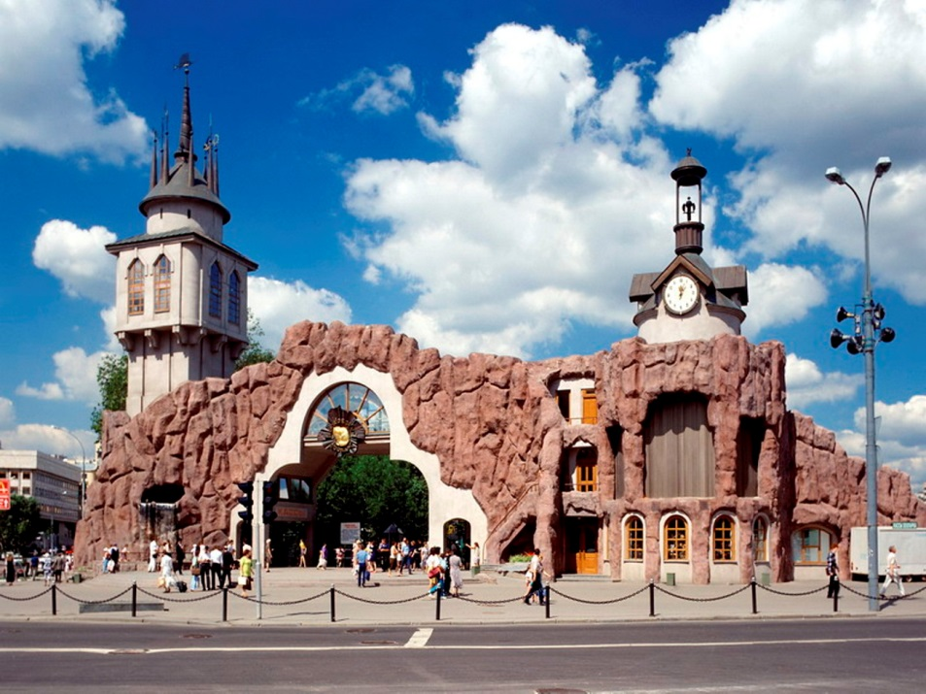

The Moscow Zoological Park has come a long way from a small Zoological garden to the large scientific, educational and conservation institution of today.
The Moscow Zoological garden was founded by the All-Russia Emperor Society for Acclimatization of Plants and Animals in the middle of XIX century; it was opened for visitors on 31st of January (13th of February) 1864. Anatoly P. Bogdanov, Professor of the Moscow State University, was one of the founders and organizers of the Zoological garden. The foundation of the Zoological garden was very important for the cultural life of Moscow since it was the first attempt to establish a scientific institution of such a sort – “a living museum outdoors”, as Professor Bogdanov said. Besides, for those days it was the unique experiment aimed at the creation of the Zoo in quite severe climatic conditions, as it was in Central Russia. The members of the All-Russia Emperor Society believed that the primary goals and purposes of the Zoological garden were the following:
– Collecting alive specimens of higher vertebrates (firstly – the animals of Russian fauna) for scientific observations;
– Establishing the collection of typical animals that could serve educational purposes, i.e. distribution of Zoological knowledge among the wide public communities;
– Carrying out scientific experiments and observations of important animals, especially of the domestic animals of Russian breeds.
The Zoological garden was financed by the entrance fees and sponsored by private donations, including contributions by the Emperor's family. In the first years people were glad to visit the Zoological garden, the annual number of visitors coming up to ten thousands. People could see a significant collection of animals that numbered in 1864–1865 134 specimens of domestic animals and 160 specimens of the wild animals. However, the incomes did not cover the expenses of the Zoological garden, which was facing serious problems with lack of money needed for acquiring and management of animals, repair of old building and construction of new facilities, cages and enclosures. Since the City Government refused to give support to the Zoological garden, the Society had to grant a lease to a private company – the Ryabinins' family. For the three years of running the Zoological garden the Ryabinins' family had brought it to ruin, having transformed it into merely an entertainment establishment. In 1878, the Zoological garden was returned at the disposal of the Society for Acclimatization of Plants and Animals, and fund raising activity started again. The Society managed to revive the activity of the Zoological garden for a while, and even to buy a number of animals, but in 1905, it found itself in the very centre of the major revolution battles. It was badly damaged: the buildings were ruined, the library was set on fire, many animals perished. Again, the Society was forced to turn the Zoological garden over to private owners.
Following the October Revolution of 1917, the Society ceased to exist, and in 1919 the Zoological garden was nationalized. In 1922, it was transferred to the authority of Moscow City Council and since then it has been supported by the City Authorities. The Zoological garden territory was almost doubled.
In 1926, the Zoological garden was renamed “Zoological Park”. At that time the sphere of the Zoo activities extended, the animal collection increased in the numbers, new departments were established, such as scientific research and educational units, scientific veterinary, biological and nutrition laboratories; the Moscow Zoo Circle of young biologists was also founded. New exhibits, quite modern for those days, were established on the recently joined “New” territory. People could stroll along the walkways in the spacious enclosures amongst fallow and sika deer. One of the most interesting exhibits of the Zoo had an exotic name “Animal Island”. It was a high stony rock surrounded by a deep-water ditch that separated the visitors from bears, tigers, lions and other large beasts of prey, which were inhabiting the “Island”. The Zoo functioned even during the years of the Second World War. More than six million people visited the Zoo from 1941 to 1945. During that period a Zoocomplex, industrial enterprise, and the Durov Animal Theater were a part of the Zoo. After the end of the War these organizations had separated from the Zoo and became independent. In the late 1960-s the Zoo was transferred to the authority of the Central Administrative Board of Culture. The number of Zoo animals had grown up to 3.5 thousand specimens of 500 species and subspecies.
The Moscow Zoo was becoming one of the larger scientific and educational institutions of Moscow and the favorite recreational place for the habitants of Moscow and city visitors. The Zoo staff carried out many forms of educational activities with the purpose to distribute knowledge in the field of natural history and to promote an increase in public awareness of the necessity for wildlife conservation. The Zoo assisted the schoolchildren and students with studying biology, actively participated in scientific research, and contributed in the periodicals and scientific publications. In 1970–90-s, the Moscow Zoo took an active part in international wildlife conservation activities having become the member of many European and International Breeding Programs under which it exchanged its rare and endangered animals, shared experience and information. The Zoo specialists attended international conferences and meetings and exchanged visits with their foreign friends. The Moscow Zoo was very successful in the conservation of endangered species of animals, but by the end of 1980-s the Zoo's condition became a cause of alarm as the facilities, enclosures, and technical equipment were deteriorating with time. The necessity for urgent measures needed to improve the management of the animals was evident. A history of the development of the project of the reconstruction of the oldest Zoo in Russia is quite long and complicated, as the first plans of the reconstruction have been worked out as long ago as in the 1970-s. Unfortunately, due to the economic and social problems the most part of the ideas and intentions never became a reality. Truth, a partial reconstruction of the main entrance, Monkey house, “Animal baby background” and Lion house had been accomplished in that period, but for many years the dreams about the foundation of a new Zoo in another region of Moscow has been remaining just “castles in the air”, as well as the projects of the general reconstruction of the Zoo. At last, in the beginning of 1990-s the new government of Moscow headed by the City Mayor Yuri M. Luzhkov made a decision to start a general reconstruction of the Moscow Zoo, and the total reconstruction had finally started in 1990. According to the timetable of the project, the first stage of the reconstruction was to be completed by 1997, to the 850-th Anniversary of the City. The team of architects developing the reconstruction project was headed by Anatoly A. Andreev who has been involved in the Zoo design and architecture since the 1970-s. The main principles that were assumed as a basis of the project were the following:
- preservation or partial reconstruction of the historically valuable buildings and water pools;
- arranging additional insulation for the protection of animals and visitors from the noise of city streets;
- expansion of the old Zoo territory due to the joining of adjacent sites and buildings.
The architects and builders have succeeded in achieving their aims. Almost 4 additional hectares of space has been joined to the former 16.8 hectares. With some minor exceptions, all important Zoo constructions have been preserved, including the ones that actually were dilapidated. The building of the first new facilities was completed in 1993, those were: the passage bridge with the adjacent enclosures for Japanese Macaques, Pinnipeds, raccoons and birds; an enclosure for large birds of prey; and a complex of enclosures for smaller and middle cats (Leopards, Pallas cats, Lynx). The passage bridge has connected two territories of the Zoo (“Old” and “New”) which allows visitors to avoid crossing Bolshaya Gruzinskaya Street with its heavy traffic. The birds of prey exhibit, built on the side of a large pond, consists of a few enclosures covered with net and placed around an artificial 10-meter high rock. Moving the birds of prey may cause many problems but some of the Eagles at the Zoo have already started to breed in their new enclosures.
Following the mentioned facilities, the reconstruction of one of the most remarkable expositions of the Moscow Zoo – “Animal Island” – was carried out. The architects were able to preserve this wonderful construction in its historic appearance where the animals are being kept in the environment that is very similar to their natural habitats; Amur tigers, Striped hyenas, African wild dogs and Asian black bears are doing well and even started breeding on the “Island”. <…> A pair of Asian lions arrived to the “Animal Island” under the EEP Breeding Program; the male was born in Helsinki Zoo, and the female originates from Chester Zoo in UK. The second floor of the rock is occupied by the exposition of “Exotarium” with small sea water aquariums.
In 1994–1995, many more Zoo facilities were reconstructed: the large pond for waterfowl and flamingo, Przewalski's horse and antelope expositions, enclosures for Spectacled bears and Cheetahs, “Tur hill” for mountain ungulates, and “Polar World” housed Polar bears and other polar animals. In 1994, two large buildings were put into operation – administration office and research and veterinary complex, and also the islands for Gibbons were constructed on the small pond.
New enclosures have been built near the main entrance: Wallabies and Emus feel quite comfortable in their “Australian” exhibit, and Capybaras living in the “South America” expositions have already given their first offspring. In 1996, the main entrance itself with a small waterfall and “speaking” clock was constructed. The building of the Bird World and enclosures and pool for penguins was also completed in 1996. In the same period of time, the old dilapidated Elephant House was torn down in order to allow the building of a new Elephant facility in its place. Four African and four Asian elephants (including 1-year old Asian elephant baby) were moved into another facility for their temporary holding, which was a completely renovated building of the former tram station. <…>
The new “Children Zoo” was opened on the “Second” territory of the Zoo where the children can see the live characters of their favorite fairy tales surrounded with wonderful sculptures, and enjoy riding small ponies.
Over 50 facilities have been reconstructed and built during the whole period of reconstruction. This large-scale process became possible only due to the support of the Moscow Government and the City Mayor Mr. Luzhkov. In 1996, about 200 hectares of ground in 100 kilometers from Moscow (near Volokolamsk city) were given to the Moscow Zoo for the establishing a Breeding Station for rare and endangered species of animals. The natural landscape of the territory with woods, hills and water reservoirs in combination with ecological pureness of the region create the most beneficial conditions for the establishing a large conservation center. The enclosures for cranes, birds of prey, cheetahs and leopards are already constructed and are now inhabited by some of Zoo animals.
The general reconstruction of the Moscow Zoo represents a unique event when the renovation and reconstruction of almost all the Zoo facilities was completed within a so short period of time. In these difficult circumstances the staff of the Moscow Zoo did everything possible in order to save the valuable collection of the Zoo animals. We are glad that the Moscow Zoo have been totally renovated by the 850-th Anniversary of Moscow and now the visitors have an opportunity to see one of the most interesting animal collections in the world at the “rejuvenated” Moscow Zoo.
Автор: Vladimir V. Spitsin, Director of Moscow Zoo
Источник: http://moscowZoo.su/about-Zoo/history/

