Humboldt Penguin Interesting Facts
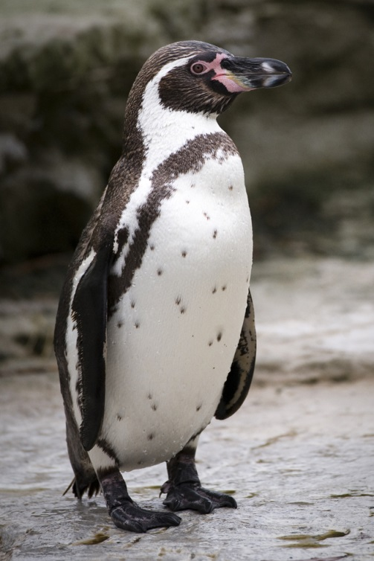
- The penguin and the oceanic current were named after Alexander von Humboldt, a well-known 18th century explorer.
- One of the most interesting Humboldt penguin facts is that the bird is quite shy in nature and never hunts in big groups. They prefer searching for food small numbers.
- The scientific name of the Humboldt penguin is Spheniscus humboldti and it is also known as Peruvian penguin. This penguin can only be seen in South America and it is mainly seen in coastal areas of Peru and Chile.
- Humboldt penguins stand at least 65–70 sm tall and weigh around 5 kg. The life span of Humboldt penguin in the wild is 15 years while in captivity the penguin can live for almost 30 years.
- Adult Humboldts have a white front and a black-brown back and head. Humboldt penguins also showcase another color; pink. These penguins have pink patches on their face, feet and on the underside of their wings. These pink patches play a very important role in keeping the body temperature cool during warm temperatures.
- Their diet consists of small fish such as anchovies and sardines. To make hunting easy, they prefer hunting in small groups. Humboldts circle around their prey and the attack from all sides.
- There is no set time for mating for Humboldt penguins. They can start mating any time of the year. It all depends on the availability of the food, more the food the more they will engage in it.
- Humboldt penguins make nests or burrows in caves, in cracks of big rocks, or sometimes in open spaces. A female Humboldt penguin can lay 1, 2 or 3 eggs with both parents taking turns for incubation of eggs for 40 days.
- Once the offspring is born, both parents take turns and go hunting. After about 75 days, both the parents leave the baby Humboldt alone and look for food together.
- Like every other species, Humboldt penguins have excellent eyesight on land and under water. With the help of their wings, these penguins can swim as fast as 15 km per hour.
- While being on land or under water, they have to be careful from predators like sea-lions, sharks, leopard seals, killer whales, petrels.
- The current status of Humboldt penguin is threatened due to the rise in fishing activities. In addition to fishing, hundreds of penguins are killed every year when they get entangled in fishing nets and due to ocean pollution.
Источник: http://www.buzzle.com/articles/humboldt-penguin-facts.html

