







MORNING OF THE SPACE ERA





The first flights to space

1957-1960

The first manned flight 12.04.1961

QUEST MAP

The first walk in outer space

18.03.1965

# SPACE GLOSSARY

ARTIFICIAL SATELLITE

LANDING CAPSULE SPACESUIT AIR LOCK

LAUNCH



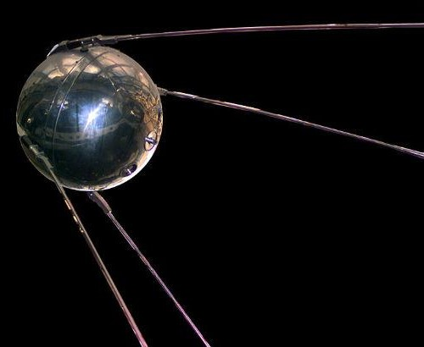 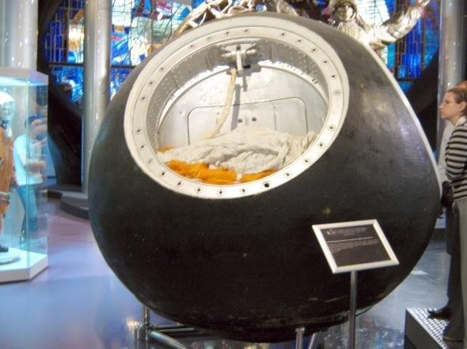 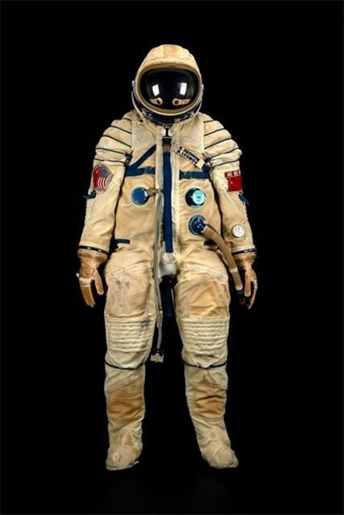 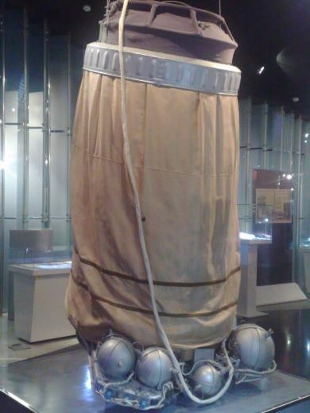 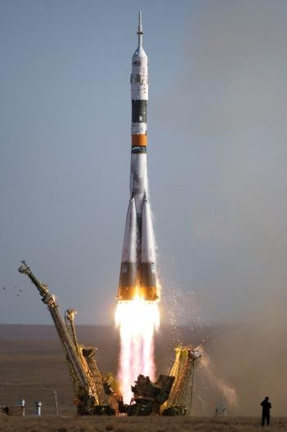

# SPACE GLOSSARY

