WORKSHEET В
Museum website: http://kuskovo.ru
Virtual tour: http://vr360.ru/kuskovo/03/

Exercise 1. Read the description and find the name of the reception room. Underline appropriate words the elements of the décor and the furniture that you can see in this room. Describe the room.
The palace drawing room got its name from the carpets (tapestries) hung on the walls of the room. These depict European specimens of parks and gardens. Made in Flanders at the end of the 17th century.

crystal chandelier ● musical instrument ● porcelain Chinese vase ● card table ● grandfather clock ●
- marble busts ● fireplace ● Flemish tapestries ● crystal girandole ● portraits of the Sheremetev children ●
tiled stove ● console table ● parquet floor ● portrait of Catherine I● mirror panel in carved and gilded frame
Useful phrases
In front of you is...  To the left of the door…  On your right you can see... | The particular interest in this room is…  The room is also remarkable for… The door leads into the next room... | The portrait in the middle shows…  The first painting on the left shows.. I'd like to point out...

Exercise 2. Find the exhibit and describe it using the words.

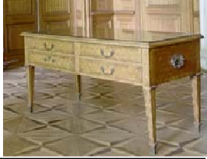
It is a . in the museum’s furniture collection. The surface of the table is an inlaid done of various kinds of and representing
in Kuskovo. The table was made in by the Nikifor Vasilyev. The signature of the master can be seen in a corner on the right.
- picture ● The unique exhibit ● wood ● 1770s ● the park ● surf craftsman ● table ●

Exercise 3. Describe the exhibit using the words.
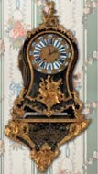
It is a
- 1st half of the 18th century ● craftsman ● workshop ● Andre Charles Boule ● tortoise-shell ●
  - Wall clock ● is decorated with ● famous ● France ● clock case ●

Exercise 4. Describe the portrait using the words.

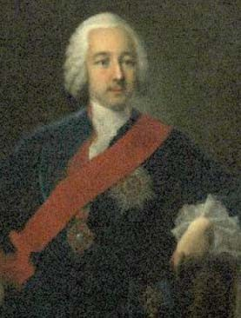
The Portrait of Peter Sheremetev

This canvas is one of museum’s masterpieces painted in by a German Georg Christofor Groot.
The portrait depicts of this country house. It is the

portrait painted from

The sitter is represented as a charming

elegantly dressed in a with the red ribbon and the Order of

. From Sheremetev’s

- the master ● blue suit ● St. Ann ● oils ● young aristocrat ● artist ● ceremonial ●
  - famous ● nature ● collection ●.

Exercise 5. Describe the portrait.

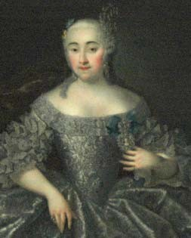
The Portrait of Varvara Sheremeteva

- charming ● G.C. Groot ● half - length ● young lady ● wife ●
  - of the master ● copy from the original ●

The teacher:

