1. Lost in Translation

“A Tale of Nonsense” is a satiric “roman à clef” of avant-garde writer and artist Yury Annenkov.

This book is a short story cycle about Russia of the 1910s-1920s. It consists of five chapters, has no linear plot and acquaints with a lot of characters, who had real prototypes among the author's friends.

Roman à clef is a novel about real life events that is overlaid with a façade of fiction. The fictitious names in the novel represent real people, and the “key” is the relationship between the nonfiction and the fiction. This metaphorical key may be produced separately (typically as an explicit guide to the text by the author) or implied, through the use of epigraphs or other literary techniques.

So, tov. Grudsky was probably Ilya Schneider, a journalist and translator.

2. A little passport amendment

«– Could you correct something here?
I didn’t understand, but she stood in front of me, smiling shyly, and pointed the finger at the date of her birth, written in black ink...
– Well, I have the ink, – I said, – but I think, it is not necessary...
– It’s for Yesenin, – she replied. – We don't perceive this fifteen-year difference [seventeen-year difference in fact], but it's designated here... and tomorrow we will give our passports to the strangers... It may be unpleasant for him... And I won't need a passport soon. I'll get another one.
I corrected the numeric.

The Soviet institutions cut the red tape as quickly, as long the foreign embassies postponed the issuance of the visas.»

(Ilya Schneider. Meeting Yesenin)

Schneider could make this correction because there was no lamination in those days. Students can see the foreign passport of Yesenin in the glass case and realize, that people could make some changes into the document, if they had such a necessity. Of course, it was illegal and punishable.

3. “Paint It Black”

The Black Man isn’t a Negro Revolutionary, it’s poet’s alter ego: he had seen himself in the mirror, which he broke. Students can understand it, reading the given fragment of the poem.

Black eye – синяк под глазом; black box – «черный ящик»; black sheep – изгой, «паршивая овца»; blackshirt – фашист-«чернорубашечник»; black hole – «черная дыра».

4. “The Land of Scoundrels”

Lev Trotsky was the prototype of Commissar Chekistov. He masterminded Trotskyism, his own doctrine within the framework of Marxism.

Vladimir Cherniaev, a Russian historian, sums up Trotsky’s main contributions to the Russian Revolution:
«Trotsky bears a great deal of responsibility both for the victory of the Red Army in the civil war, and for the establishment of a one-party authoritarian state with its apparatus for ruthlessly suppressing dissent... He despised “bourgeois democracy”; he believed that spinelessness and soft-heartedness would destroy the revolution, and that the suppression of the propertied classes and political opponents would clear the historical arena for socialism.»

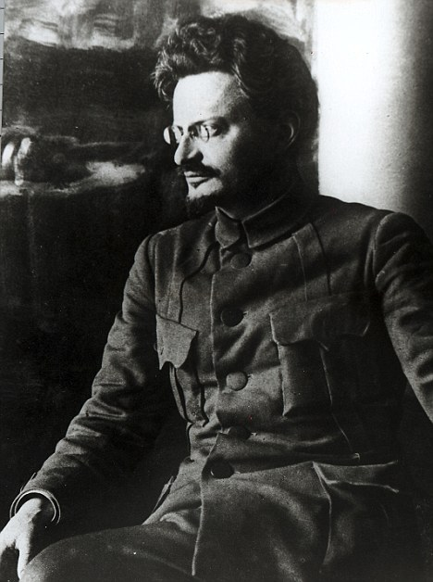
Nestor Makhno was the prototype of Nomakh. He was an anarchist revolutionary and the commander of an independent anarchist army in Ukraine from 1917 to 1921.

«Nestor Makhno was the son of a joiner in the village of Gulyai Polye, in the province of Yekaterinoslav. From childhood, when he had to go to work in the village shop, he had always been beaten and had always been surly and ill-tempered. […] He then gathered a gang of boys. […] He became acquainted with Anarchism […] in the convict prison.
[…] He was released by the February revolution and again appeared in Gulyai Polye, where the peasants […] had driven out the landlords and divided up the land. He immediately advocated a radical policy to promote a “free peasant order of things”.»

(Aleksey Tolstoy. The Road to Calvary)
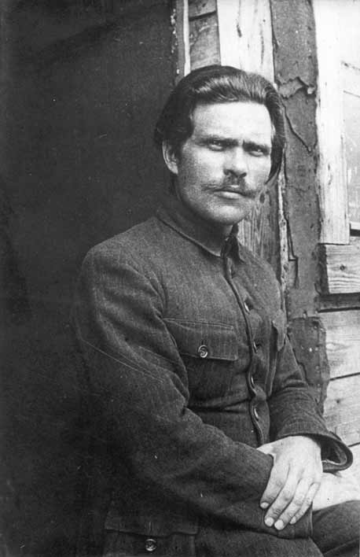

5. "Flow, song!"

Students can find the letter to Litvinov in the glass case and read it or they can guess that the lyrics of the song contains a hint:
The Internationale will be the human race.
“The Internationale” is a left-wing anthem. It has been a standard of the socialist movement since the late nineteenth century, when the Second International adopted it as its official anthem. The title arises from the “First International”, an alliance of workers, which held a congress in 1864. The author of the anthem's lyrics, Eugène Pottier, an anarchist, attended this congress.
It was the anthem of the USSR from 1922 to1944.

6. Dubious glory

«Once I saw a delivery boy, and my photos were on all the newspaper covers. I felt my heart skip a beat. This is glory, which crossed the ocean! I bought about a score of newspapers, according to the number of those whom I could make such gifts. I asked someone to translate the signature under the portrait. Then I heard:
“Sergei Yesenin, a Russian peasant, the husband of the famous, incomparable, charming dancer Isadora Duncan, whose immortal talent...” and so on …»
I had been so angry that I tore this newspaper into small pieces and could not calm down for a long time. So much for glory! That night I went down to the restaurant and drank heavily, I remember. I drank and cried. I really wanted to come back home.»

(Vsevolod Rozhdestvensky. Recollections of Yesenin)

Why do you think Duncan decided to leave her Moscow dancing school and go on a foreign tour?

She wanted to:

- get a certificate of right to inheritance of sth.
- raise money for her dance school
- publish Yesenin's verses abroad
- distract the poet’s attention from a bad company in Moscow
- save Yesenin from repressions
- settle abroad with Yesenin forever
- another variant:______________________________________________________

7. “America the Beautiful”

Sergei Yesenin visited plenty of American cities.
Here is his path: New York City (state: New York), Boston (Massachusetts), Chicago (Illinois), New York City, Indianapolis (Indiana), Louisville (Kentucky), Milwaukee (Wisconsin), Kansas City (two cities of the same name on border of states Kansas and Missouri), St. Louis (Missouri), Memphis (Tennessee), Detroit (Michigan), Cleveland (Ohio), Baltimore (Maryland), New York City, Toledo and Toronto (Ohio), New York City.

(I suppose, that Students should have at least one printed map of the USA.)

