The temperate deciduous forest
Лиственный леc
It is quite common in many parts of the world. This is a forest habitat. You know you’re in a forest habitat when everywhere you look there are trees all around you! Many of you may have seen forests like this before. You may be familiar with some of the plants and animals that live here.
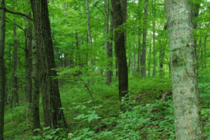
There are many different kinds of forests in the world. A deciduous forest grows in an area that has four seasons, including a warm summer and a cold winter, and receives steady rainfall (осадки) throughout the year. А deciduous forest is full of deciduous plants – trees, bushes, and shrubs that lose their leaves every autumn, then grow leaves again when the temperatures start to rise in the spring. A deciduous forest is made up of broadleaf trees like oak, maple, beech, and elm. These trees grow very tall and are thickly covered with wide leaves. Under these taller trees, there are young trees, as well as shrubs and bushes and other plants. Closer to the ground shorter plants like grasses and wild flowers grow.
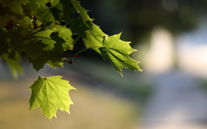 |  | 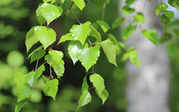 |  | 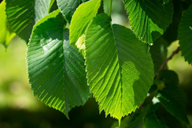 |  | 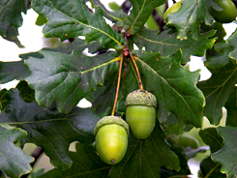
maple |  | birch |  | elm |  | oak
Owls, woodpeckers, mice, and foxes make their homes in the branches or around the roots of trees. Down on the forest floor there are all kinds of shrubs, the fruits of which are food to many different species of animals, including rabbits, chipmunks, deer, and bears. On the ground there are wild flowers and grasses. These plants, which cover the forest floor, are home to many types of insects and are food to grazing animals such as deer and mice.

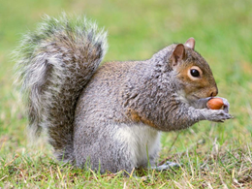
A gray squirrel is a little animal with a white chest and a long, bushy tail. Squirrels live in holes in the trunks of trees or in nests high up in trees. Their nests are built from twigs, leaves, moss, and grass. Squirrels use their strong back legs and sharp claws to help them leap from tree to tree.
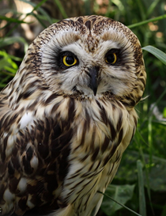
Squirrels spend most of their time looking for food. The squirrel eats mostly acorns from the oak tree, but it also eats nuts, mushrooms, berries, seeds, and even bird eggs and insects.

Owls live in a hole in trees. The owls eat small animals like mice, insects, and even other birds. Owls have very good hearing and excellent eyesight, which allows them to find their food easily in the thick forest. Owls are nocturnal, which means they only come out at night.

Источник: «Animals and Habitats. Tell It Again!™ Read-Aloud Anthology».
New York 1995

