Capybara
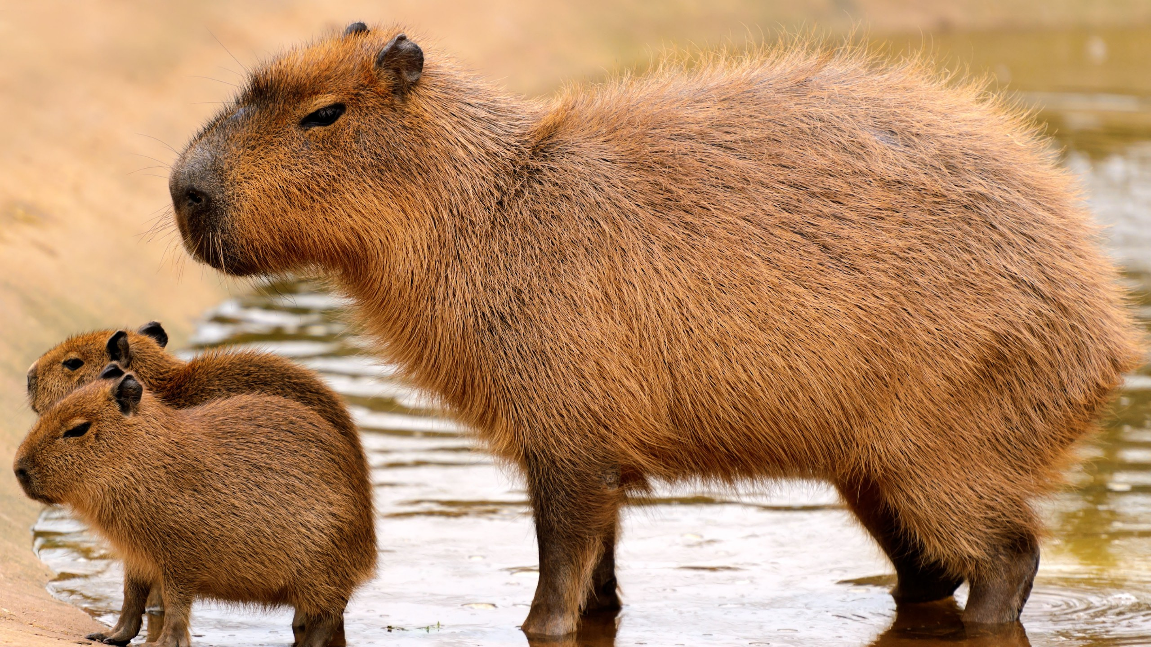
The capybara is the world’s largest rodent. It is about 50 cm tall at the shoulder, 130 cm in length, and 35–70 kg. Capybaras spend a lot of time in the water. They inhabit southern Central America and northern South America in both savannas and rain forests near ponds, rivers, or lakes. Capybaras retreat into waters to escape from predators like jaguars, anacondas, caimans, pumas, ocelots, and harpy eagles. Their webbed feet help them maneuver in water and traverse soft, muddy ground. Their eyes, ears, and nostrils are all found near the top of the animal’s head, allowing them see and breathe while swimming. They feed on grasses and aquatic plants, consuming 3–3.5 kg a day. Very social animals, capybaras live in small family groups of about 10–20. In the mornings, they usually rest, during the midday heat they roll around in the water and mud to keep cool and then graze in throughout the day and night.
They never sleep for long; they take short naps day and night. A Capybara can sleep underwater, keeping its nose just at the waterline. Capybaras make strange sounds, purrs and warning barks. They communicate through scent and barking noises. The young constantly make a purring cry, which probably keeps the mothers nearby. Predators include jaguars, foxes, birds of prey and wild dogs. If a predator is spotted, a capybara will bark to warn the others. Capybaras can live 8–10 years in the wild, and around 12 years in captivity.

Источники: http://www.animalfactguide.com/animal-facts/capybara/
http://explorationnation.com/index.php/k-3-sample

