Glossary
Study the words and their definitions
Volume, n [countable] (written abbreviation vol.)a) a book that is part of a set, or one into which a very long book is divided.
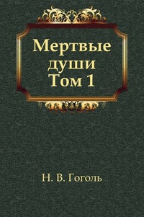

To burn, v (burnt-burnt) to destroy or damage something with fire.
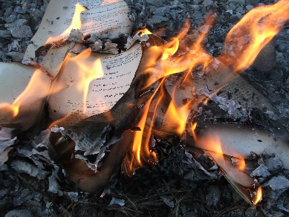

Mansion, n – a very large house.

To spread, v – to become known about or used by more and more people.
To reign, v – the period when someone is king, queen, or emperor.
The Empire style – is an early-nineteenth-century design movement in architecture, furniture, other decorative arts, and the visual arts, representing the second phase of Neoclassicism.
Arch, n (countable) – a structure with a curved top and straight sides that supports the weight of a bridge or building.
To influence, v – the power to affect the way someone or something develops, behaves, or thinks, without using direct force or orders.

Abroad – adv., in or to a foreign country.
Overcoat, n – a long thick warm coat.
A chest – n, a large strong box that you use to store (keep) things in or to move your personal possessions (things) from one place to another.
Herbarium – n, collection of dried leaves, plants etc.
Whim, n (countable) – a sudden feeling that you would like to do or have something, especially when there is no important or good reason.

Feelings
Angry – feeling strong emotions, which make you want to shout at someone or hurt them because they have behaved in an unfair, cruel, offensive etc. way, or because you think that a situation is unfair, unacceptable.
Annoyed – slightly angry.
Cheerful – happy, or behaving in a way that shows you are happy.
Disappointed – unhappy because something you hoped for did not happen, or because someone or something was not as good as you expected.
Embarrassed – feeling uncomfortable or nervous and worrying about what people think of you, for example because you have made a silly mistake, or because you have to talk or sing in public.
Furious – very angry.
Happy – having feelings of pleasure, for example because something good has happened to you.
Indifferent – not at all interested in someone or something.
Joyful – very happy, or likely to make people very happy.
Peaceful – quiet and calm without any worry or excitement
Relaxed – feeling calm, comfortable, and not worried or annoyed.
Excited – happy, interested, or hopeful because something good has happened, is happening or will happen.
Pleased – happy or satisfied.
Annoyed – slightly angry.

