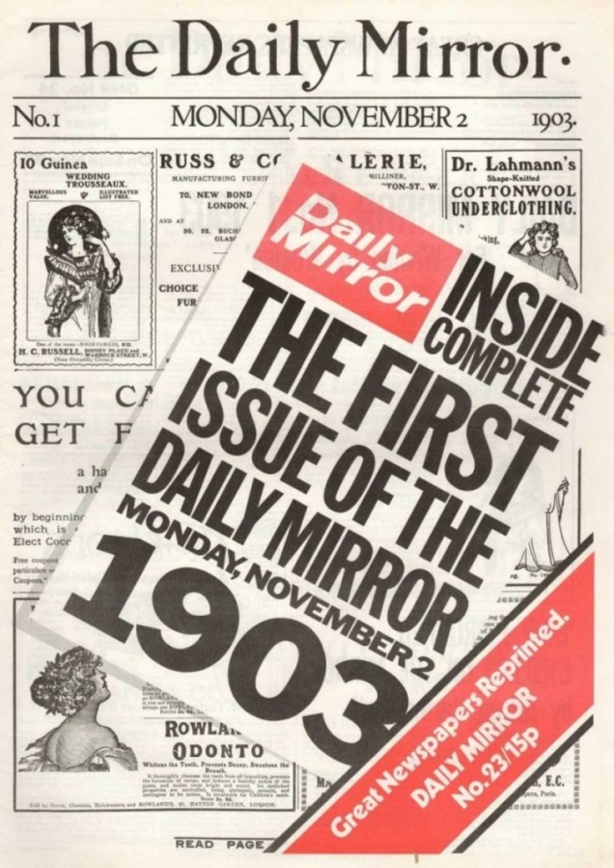
Imagine you are the reporter who writes about the life of outstanding people for a British national daily tabloid “Daily Mirror”. Write a short article (150−250 words) about a great Russian composer and pianist Alexander Nikolayevich Scriabin.

https://st.violity.com/auction/uncos-images/13/bd1a76878a2f3dcabd4a7e076f47f01b.jpg

